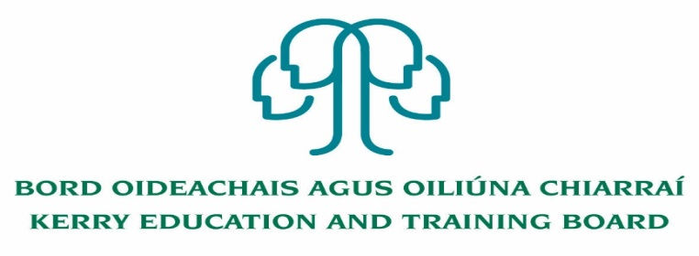

Youthreach Resource Worker
JOB DESCRIPTION

Job Title: Fixed Tern Resource person post – Learning Support

Employer: Kerry Education and Training Board

Responsible to: Killarney Youthreach Co ordinator

Base of work: Killarney Youthreach

Hours of attendance: 35 hours per week

Duration: Fixed Term

Work with: Killarney Youthreach Team

Job Summary: Work with the Project Co-ordinator and other Resource Staff in creating an atmosphere and environment where the participants can realise their full potential while on a Youthreach Programme.

Key Duties & Areas of Responsibility will include:

- Curriculum development, delivery and quality assurance of the programme with specific responsibility for coordination and implementation of Learning Support and ESOL.
- To identify the specific learning support needs of students by assessing, implementing and evaluating individual student learning plans.
- To prepare, develop and deliver in accordance with the criteria set out by QQI in terms of Communications at Level 3 and Level 4, and in accordance with National Guidelines. To teach students Literacy Skills and assess Literacy Skills. To develop and lead out Individual Learning Plans for all students to the staff team.
- Direct class contact in keeping with the programme needs as timetabled.
- Actively participate in the development and implementation of a Centre Development Plan and participate in the internal evaluation process as set out under the Youthreach Quality Framework.
- To work within budgets and monitor programme spending in co-operation with the Project Co-ordinator
- To maintain discipline in accordance within the agreed Code of Behaviour.
- To undertake administrative duties relevant to the position, including maintenance of records and provision of reports as required.
- To promote the work of the centre and develop contacts outside of the centre which are relevant to work.
- To provide locally agreed substitution cover for absent staff and to supervise participants as necessary during lunch breaks and at opening and closing times of the programme.
- To attend appropriate in-service training and participate in staff development and team maintenance activities as required.
- To actively participate in all Staff Meetings.
- To engage in other activities for the benefit of participants that may arise from time to time and as directed by the co-ordinator.
- To undertake other duties as may be requested

Essential Criteria
- 3rd Level Degree in Education, Youth Work, or a related field
- Ability and experience in the delivery of Communications and Literacy.
- Have specific skills e.g. learning support and ESOL qualification
- Experience in working with vulnerable young people in an informal education setting
- Experience of assessing literacy needs, devising, delivering and evaluating individual learning plans.
- Fluency in English, both written and verbal
- Experience in QQI assessment protocols and procedures
- Assessment experience using WRAT 5

Contract
- This contract is for 35 hours per week.
- Remuneration is in accordance with the Youthreach Resource worker salary scale approved by the Department of Education.
- Employment with Kerry ETB is subject to a satisfactory response from the Garda Vetting Unit being received in relation to any candidate under consideration and satisfactory reference checks being received.
- This post is subject to a probationary period.

Person Specification

Skills, competencies & attributes

Specialist Knowledge, Expertise & Self Development
- Evidence of professional knowledge in programme delivery and accreditation opportunities
- Clearly understands the role, objectives and targets and how they fit into the work of the department and the wider organisation.
- Experience in working with young people in a dynamic/engaging way using a variety of methodologies.
- Demonstrates the importance of policy and procedures in youth work practice
- Understands the boundaries of professional practice
- Develops the expertise necessary to carry out the role to a high standard and shares this with others
- Demonstrates knowledge of child protection policy and practice
- Awareness of current and emergent trends for young people in society and services
- Understands and shows commitment to the purpose of Kerry ETB and to work within the values, policies and procedures of the organisation and in the context of current legislation and regulations
- Has expertise in his/her field that is recognised and utilised by colleagues
- Reflects on own development personally and professionally

Programme development and delivery
- Experience in delivering QQI modules.
- Track record in designing, delivering and evaluating educational programmes
- Analytical skills with the capacity to absorb/organise new information to ensure well briefed on new topics
- Demonstrates the ability to apply basic teaching and learning methods with young people
- Recognises the importance of a group setting for young people.
- Understands the importance of health and safety within the workplace overall and with emphasis on the delivery of programmes and activities with young people.

Teamwork
- Experience of working effectively in a team environment
- Develops and maintains good working relationships with others, sharing information and knowledge, as appropriate
- Maximises the contribution of the team, encouraging ownership, providing support and working effectively with others
- Contributes to the development of policies in own area and the wider organisation

Interpersonal & Communication
- Communicates in a fluent, logical, clear and convincing manner verbally and in writing
- Is able to listen effectively and develop a two-way dialogue quickly
- Experience in motivating young people
- Maintains a strong focus on meeting the needs of service users
- Effectively influences others to take action
- Works to establish mutual understanding to allow for collaborative working

Drive & Commitment
- Is self-motivated and shows a desire to continuously perform at a high level
- Must be flexible and prepared to work outside normal hours as required.
- Has the ability to think logically, use initiative and work with minimum supervision.
- Have a flexible approach to the work in response to organisational change, development and review of best practice
- Through leading by example, fosters high standards of ethics and integrity

