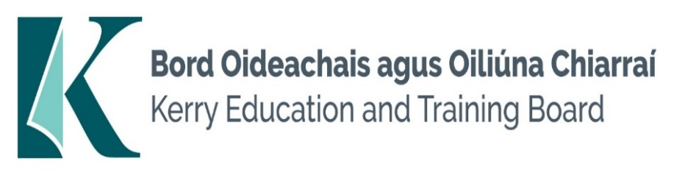

Kerry Education and Training Board (Kerry ETB) is a statutory education and training authority for County Kerry, established in accordance with the provisions of the Education and Training Boards Act 2013.

Kerry ETB is a provider of Primary, Post Primary and Further Education and Training services in Co. Kerry. The ETB has c. 1300 employees, an annual budget of c. €81 million, c.38 Centres of Education and Training with the organisations Head Office located in Tralee, Co. Kerry.

**Communications Support Assistant Post (Maternity Leave Cover)**

**Coláiste Gleann Lí, Tralee**

Applications are invited for a Communications Support Assistant post Maternity Leave Cover under the aegis of Kerry Education & Training Board **which may arise** in the school year 2025/2026 (all appointments are to Kerry ETB – centre of first assignment is indicated here for the assistance of applicants). A panel may be formed from this competition from which appointments may be made in 2025/2026.

**Essential Criteria**

* Minimum Level 6 in Irish Sign Language
* Ability to convert verbal instructions from teachers and peer contributions to sign language
* Ability to relay teacher instruction and curriculum to students
* Ability to communicate with staff and other students on curriculum issues on behalf of student
* Awareness and understanding of the post primary curriculum
* Ability to translate all verbal communications to Sign Language
* Ability to work as part of a team

**Desirable Criteria**

* Experience of working in mainstream post – primary
* Completed QQI Level 5 in a relevant area

--------------------------------------------------------------------------------------------------------------------------------------------------

Conditions of Service, Terms of Appointment, details regarding Qualifications and Salary Scale are in accordance with the regulations of the Department of Education.

Please complete application form which can be downloaded from this website www.kerryetb.ie/opportunities and return by email only to [jobs@kerryetb.ie](mailto:jobs@kerryetb.ie). No C.V.’s, only official application form will be accepted.

-------------------------------------------------------------------------------------------------------------------------------------------

Please complete an application form and **return by email only** to jobs@kerryetb.ie. No C.V.’s, only official application form will be accepted.

Applications must be received not later than **12 noon, Thursday 24th July 2025.**

*Ann O’Dwyer*

*Chief Executive*

**Kerry Education & Training Board services Gaeltacht areas.**

**Cuirfear fáilte roimh chomhfhreagras í nGaeilge.**

**Garda Vetting of successful candidates will take place prior to offer of employment.**

**Canvassing will automatically disqualify.**

**Short-listing will take place on the basis of the information provided in the application form. Depending on the qualifications and experience of applicants, short-listing thresholds may be higher than the minimum standards set out.**

###### Kerry Education & Training Board is an equal opportunities employer.

*“Building your future”*

