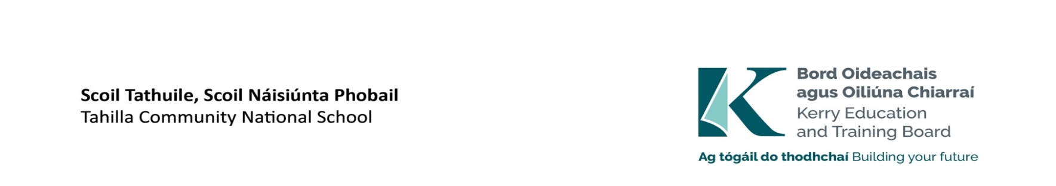



Applications are invited from suitably qualified persons for the following position **which may arise**

**Mainstream Class Teacher – Specific Purpose to cover Leave (commencing 27thAugust 2025 - 27thJune 2026)**

**Initial duties as a mainstream multi grade class teacher.**

**Third, Fourth, Fifth and Sixth class.**

**Kerry ETB Tahilla Community National School, Tahilla, Co. Kerry Roll Number- 05348S**

**Panel of Applicants**

An internal panel of suitable applicants may be set up to fill vacancies which may occur within a specific time period (four months for teacher posts and the duration of the school year for SNA posts) from the date on which the Board approves the successful candidate

**Additional information**

The successful candidate will be appointed to a mainstream position initially, however duties may be subject to change.

Essential Criteria:

Flexible thinking and adaptable approach to classroom management. Committed to the CNS ethos and openness to ‘Nurturing’ principles. Understanding of needs of neuro-diverse children and willingness to engage with their parents.

Desirable Criteria:

Experience teaching in a DEIS school setting, familiarity with DEIS initiatives, leading classroom-based initiatives and team teaching desirable. A willingness to promote and participate in the life and extra-curricular activities of the school. A willingness to engage in school planning. Experience of Multi-grade classroom teaching. Drama, music, keen interest in outdoor learning. Suim sa Ghaeilge freisin.

Candidates proposed for appointment with Kerry Education & Training Board must be registered in accordance with Section 31 of the Teaching Council Act, 2001.

Please complete application form which can be downloaded from our website [www.kerryetb.ie/opportunities](http://www.kerryetb.ie/opportunities%20and%20Education%20posts.ie) and return by email only to [jobs@kerryetb.ie](mailto:jobs@kerryetb.ie).

No C.V.’s, only official application form will be accepted.

Applications by **email only** to [jobs@kerryetb.ie](mailto:jobs@kerryetb.ie) must be received not later than 12 noon Tuesday 15th July 2025.

Provisional date for interview: Week of the 18th August 2025.

**Ann O’Dwyer  
Chief Executive Officer**

**Kerry Education & Training Board services Gaeltacht areas.  
Cuirfear fáilte roimh chomhfhreagras i nGaeilge.  
Garda Vetting of successful candidates will take place prior to offer of employment.  
Canvassing will automatically disqualify.   
Short-listing will take place on the basis of the information provided in the application form. Depending on the qualifications and experience of applicants, short-listing thresholds may be higher than the minimum standards set out.  
Kerry Education & Training Board is an equal opportunities employer.***“Building your future”*

