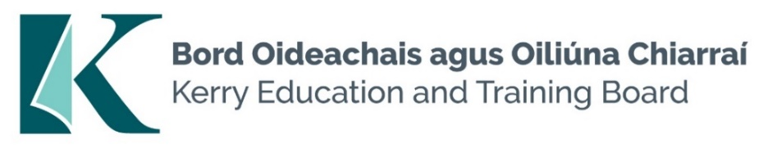

Kerry Education and Training Board (Kerry ETB) is a statutory education and training authority for County Kerry, established in accordance with the provisions of the Education and Training Boards Act 2013.

Kerry ETB is a provider of Primary, Post Primary and Further Education and Training services in Co. Kerry. The ETB has c. 1300 employees, an annual budget of c. €82 million, c.37 Centres of Education and Training with the organisations Head Office located in Tralee, Co. Kerry.

**Personal Assistant Pool**

Applications are invited for the following pool, under the aegis of Kerry Education & Training Board which may arise. All appointments are to Kerry ETB - centre of first assignment is indicated here for the assistance of applicants.

Please note an Applicant’s inclusion on the pool is not an offer of employment.

**Personal Assistant Pool**

**Centre of first assignment: Kerry College Campus - Various Locations**

Application form and further details i.e. Job Description and Person Specification are available from our website <https://www.kerryetb.ie/organisational-support-development/human-resources/job-opportunities/>

--------------------------------------------------------------------------------------------------------------------------------

*Please complete application and return by email only to* [*jobs@kerryetb.ie*](mailto:jobs@kerryetb.ie)*. No C.V.’s, only official application form will be accepted.*

No Closing date applies to this pool.

*Ann O’Dwyer*

*Chief Executive Officer*

**Kerry Education & Training Board services Gaeltacht areas.**

**Cuirfear fáilte roimh chomhfhreagras i nGaeilge.**

**Garda Vetting of successful candidates will take place prior to offer of employment.**

**Canvassing will automatically disqualify.**

**Short-listing will take place on the basis of the information provided in the application form. Depending on the qualifications and experience of applicants, short-listing thresholds may be higher than the minimum standards set out.**

###### **Kerry Education & Training Board is an equal opportunities employer.**

*“Building your future”*

