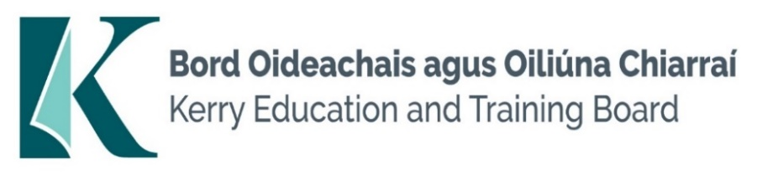

Job Description

Title: Permanent Accounting Technician Instructor

Grade: Career Grade

Reporting To: Assistant Manager

Division: Kerry College Monavalley Campus

Function of Job: To deliver professional training for all aspects of Accounting Technician programme and bookkeeping related programmes to the prescribed standards and in accordance with the relevant syllabus.

Duties and Responsibilities

- Instruct the learners in all aspects of Accounting Technicians Ireland related programmes and accounting/bookkeeping related courses i.e. practical skills, personal skills, related knowledge and best practice, to the prescribed standard and in accordance with the relevant syllabus and awarding bodies

- Prepare lesson plans, course notes, presentational material and handouts as appropriate

- Schedule, conduct, correct and mark assessment/tests in accordance with the relevant assessment programmes and carry out associated administrative tasks

- Provide appropriate additional instruction and schedule, conduct, correct and mark repeat assessments in accordance with the prescribed referral procedure

- Maintain prescribed course records

- Supervise learners and ensure that correct, quality standards and safety procedures are observed

- Supervise learners in respect of their timekeeping, attendance, behaviour and application

- Establish and maintain links with industry for the purposes of work placement and attaining employment.

- Ensure adequate security of tools, equipment, machines and materials located in the training area

- Ensure that equipment and machines are maintained in accordance with the manufacturers recommended maintenance schedule

- Plan and ensure the timely delivery of all course material

- Raise requests for the purchase and supply of course material and non-capital tools and equipment

- Ensure that course materials are used in an economical and cost effective manner

- Use new technology as appropriate to assist in delivering and administering training

- Any other duties as assigned by the manager

PERSON SPECIFICIATION

 | ESSENTIAL | DESIRABLE
MOTIVATION:  Knowledge of Post / Organisation  Personal Motivation  Work-related Achievements. | Have knowledge of the national developments relating to training, learning and qualifications  Have sufficient confidence in his/her ability to transfer the skills of the occupation as specified in the relevant curriculum/programme specification  Proven record of achievement | Have knowledge of modern training methods.  Ability to work as part of a team.  Previous training experience.
WORK EXPERIENCE  Specify particular experience/ skills required. | 5 years relevant post qualification experience | Good Industrial/commercial experience.  Instructing experience at level 6 award or higher award.
COMMUNICATIONS INTERPERSONAL SKILLS:  Verbal/presentation skills  Administrative, record maintenance and assessment skills  Special requirements  Disposition | Articulate, with the ability to communicate the relevant course information in a manner designed to motivate the learner.  Experienced in work related administrative skills (e.g. accounts, estimating, ordering materials, quality systems)  Having the necessary coping skills to deal with conflict, motivational & disciplinary problems associated with training.  The candidate will understand the totality of the job and be prepared for any unforeseen situations that may arise. | To display experience in using these skills  Experience in administrative role  Have worked with groups where interdependency was necessary.
EDUCATION:  General  Technical  Qualifications / Training | A good standard of general education.  A level 6 related qualification (major award)  Technical training to a standard that will allow the candidate to be competent in teaching all theoretical & practical aspects of the occupation/trade, including all related theory and interpersonal skills | A level 7 related qualification (major award)
CIRCUMSTANCES/  SPECIAL REQUIREMENTS  FOR THIS JOB:  e.g. Travel; Car Owner;  Driving Licence; Unsocial Hours;  Base etc. | A full driving licence and prepared to travel.  Flexible in undertaking new tasks due to ongoing change.

