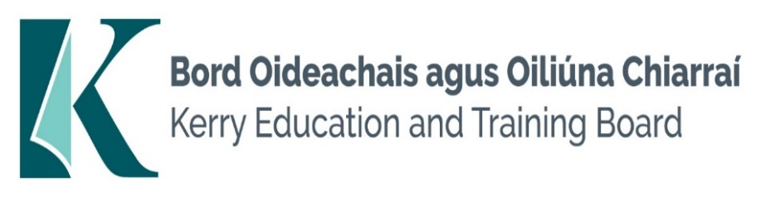

Kerry Education and Training Board (Kerry ETB) is a statutory education and training authority for County Kerry, established in accordance with the provisions of the Education and Training Boards Act 2013.

Kerry ETB is a provider of Primary, Post Primary and Further Education and Training services in Co. Kerry. The ETB has c. 1300 employees, an annual budget of c. €82 million, c.37 Centres of Education and Training with the organisations Head Office located in Tralee, Co. Kerry.

Job Opportunities

Applications are invited for the following post(s) which may arise. All appointments are to Kerry ETB – centre of first assignment is indicated here for the assistance of applicants.

Kerry College, Monavalley Campus, Tralee
Full time Permanent Grade III Clerical Officer x 1

Quality Assurance Unit, Centrepoint, John Joe Sheehy Road, Tralee
Full time Permanent Grade III Clerical Officer x 2

Kerry College, Admissions Office, Denny St., Tralee
Full time Permanent Grade III Clerical Officer x 1

Kerry Education and Training Board, Centrepoint, Further Education Unit
Full time Specific purpose (Maternity Leave post) Grade III post Clerical Officer x 1

-------------------------------------------------------------------------------------------------------------------------------------------

Please complete an application form and return by email only to jobs@kerryetb.ie. No C.V.’s, only official application form will be accepted.
Applications must be received not later than 12 noon, Thursday 16th May 2024.

Colm Mc Evoy
Chief Executive

Kerry Education & Training Board services Gaeltacht areas.
Cuirfear fáilte roimh chomhfhreagras í nGaeilge.
Garda Vetting of successful candidates will take place prior to offer of employment.
Canvassing will automatically disqualify.
Short-listing will take place on the basis of the information provided in the application form. Depending on the qualifications and experience of applicants, short-listing thresholds may be higher than the minimum standards set out.

Kerry Education & Training Board is an equal opportunities employer.
“Creating a Learning Society in Kerry”

