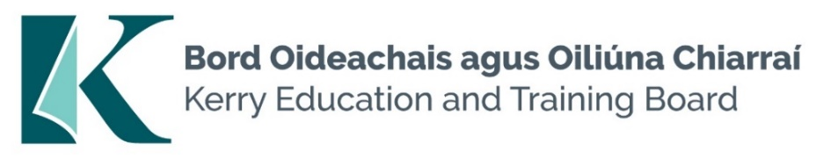

Kerry Education and Training Board (Kerry ETB) is a statutory education and training authority for County Kerry, established in accordance with the provisions of the Education and Training Boards Act 2013.

Kerry ETB is a provider of Primary, Post Primary and Further Education and Training services in Co. Kerry. The ETB has c. 1300 employees, an annual budget of c. €82 million, c.37 Centres of Education and Training with the organisations Head Office located in Tralee, Co. Kerry.

Teaching Posts

Applications are invited for the following Fixed Term/Specific Purpose teaching post(s), under the aegis of Kerry Education & Training Board which may arise in the school year 2024/2025 (all appointments are to Kerry ETB – centre of first assignment is indicated here for the assistance of applicants). All vacancies are subject to the Directors of Redeployment agreeing to the posts being filled, following completion of the 2024 Scheme. A panel may be formed from these competitions from which appointments may be made in 2024/2025.

Hours
Kerry College, Listowel Campus
KC 24.25.1 Childcare 7
KC 24.25.2 Guidance Counsellor 22

Kerry College, Clash Campus
KC 24.25.3 Physiotherapy (Career break cover) 6
KC 24.25.4 Childcare 4
KC 24.25.5 Communications (Maternity Leave cover) 22
KC 24.25.6 Construction Studies 22
KC 24.25.7 Creative Media 22

Candidates proposed for appointment with Kerry Education & Training Board must be registered in accordance with Section 31 of the Teaching Council Act, 2001.

Applicants are requested to submit Confirmation of Teaching Council Registration outlining subjects qualified to teach and proof of current registration with their application form.

Personal Assistants Panel

Applications are invited for Personal Assistants, under the aegis of Kerry Education & Training Board, which may arise in the school year 2024/2025 (all appointments are to Kerry ETB). An applicant’s inclusion on the panel is not an offer of employment

Kerry College Campus – Various Locations
--------------------------------------------------------------------------------------------------------------------------------------
Please complete application form which can be downloaded from our website www.kerryetb.ie/opportunities and return by email only to jobs@kerryetb.ie. No C.V.’s, only official application form will be accepted.

Applications by email only must be received not later than 12 noon Friday 3rd May 2024.

Please complete application form, including reference form, for the post(s) you are applying for.

Colm Mc Evoy
Chief Executive Officer

Kerry Education & Training Board services Gaeltacht areas.
Cuirfear fáilte roimh chomhfhreagras i nGaeilge.
Garda Vetting of successful candidates will take place prior to offer of employment.
Canvassing will automatically disqualify.
Short-listing will take place on the basis of the information provided in the application form. Depending on the qualifications and experience of applicants, short-listing thresholds may be higher than the minimum standards set out.

Kerry Education & Training Board is an equal opportunities employer.
“Creating a Learning Society in Kerry”

