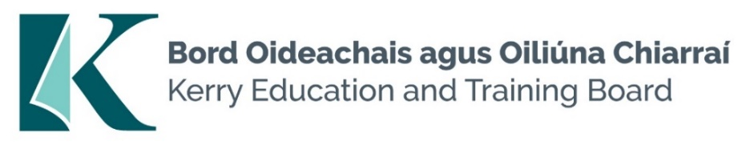

Kerry Education and Training Board (Kerry ETB) is a statutory education and training authority for County Kerry, established in accordance with the provisions of the Education and Training Boards Act 2013.

Kerry ETB is a provider of Primary, Post Primary and Further Education and Training services in Co. Kerry. The ETB has c. 1300 employees, an annual budget of c. €82 million, c.37 Centres of Education and Training with the organisations Head Office located in Tralee, Co. Kerry.

Teaching Posts

Applications are invited for the following Fixed Term/Specific Purpose teaching post(s), under the aegis of Kerry Education & Training Board which may arise in the school year 2024/2025 (all appointments are to Kerry ETB – centre of first assignment is indicated here for the assistance of applicants). All vacancies are subject to the Directors of Redeployment agreeing to the posts being filled, following completion of the 2024 Scheme. A panel may be formed from these competitions from which appointments may be made in 2024/2025.

Hours
Coláiste na Ríochta, Listowel
CNR 24.25.1 Irish 16
CNR 24.25.2 Biology (Career Break Cover) 16
CNR 24.25.3 Spanish (Career Break) 16
CNR 24.25.4 Physical Education (To cover Leave) (Experience of teaching English 10
or Maths is an advantage)

Causeway Comprehensive School
CWS 24.25.5 Business and Irish 20
CWS 24.25.6 English and History 19
CWS 24.25.7 Guidance Counsellor 11
CWS 24.25.8 Physics 22

Coláiste Gleann Lí
CGL 24.25.9 Construction Studies (Career Break Cover) 22
CGL 24.25.10 Geography (Job share cover) 11
CGL 24.25.11 Irish (Maternity Leave cover) 22
Coláiste na Sceilge
CNS 24.25.12 English 22
CNS 24.25.13 Geography and History 22
CNS 24.25.14 Business and Accounting 22
CNS 24.25.15 Spanish 22
CNS 24.25.16 German 22

Killarney Community College
KAS 24.25.17 Guidance Counsellor 22
KAS 24.25.18 Special Education 22
KAS 24.25.19 Special Education (Maternity Leave Cover) 22
KAS 24.25.20 Art (Experience of EAL is an advantage) 16
KAS 24.25.21 Irish (Experience of ICT is an advantage) 22
KAS 24.25.22 History and Geography 22

Killorglin Community College
KOS 24.25.23 Maths (Career Break Cover) 17.66
KOS 24.25.24 Construction Studies and Design and Communication Graphics 22
(Career Break Cover)
KOS 24.25.25 Spanish (Experience of teaching Irish is an advantage) 22
(Maternity Leave Cover)
KOS 24.25.26 Business (Experience of Special Education is an advantage) 22
(Maternity Leave Cover)
KOS 24.25.27 Special Education 16
KOS 24.25.28 English (Experience of EAL is an advantage) 14

Castleisland Community College
CIS 24.25.29 Computer Science 15
CIS 24.25.30 Special Education 15
CIS 24.25.31 English 17
CIS 24.25.32 Irish (Career Break Cover) 20

A Teacher Education qualification is a requirement.

Candidates proposed for appointment with Kerry Education & Training Board must be registered in accordance with Section 31 of the Teaching Council Act, 2001.

Applicants are requested to submit Confirmation of Teaching Council Registration outlining subjects qualified to teach and proof of current registration with their application form.
--------------------------------------------------------------------------------------------------------------------------------
Please complete application form which can be downloaded from our website www.kerryetb.ie/opportunities and return by email only to jobs@kerryetb.ie. No C.V.’s, only official application form will be accepted.

Applications by email only must be received not later than 12 noon Friday 3rd May 2024.

Please complete application form, including reference form, for the post(s) you are applying for.

Colm Mc Evoy
Chief Executive Officer

Kerry Education & Training Board services Gaeltacht areas.
Cuirfear fáilte roimh chomhfhreagras i nGaeilge.
Garda Vetting of successful candidates will take place prior to offer of employment.
Canvassing will automatically disqualify.
Short-listing will take place on the basis of the information provided in the application form. Depending on the qualifications and experience of applicants, short-listing thresholds may be higher than the minimum standards set out.

Kerry Education & Training Board is an equal opportunities employer.
“Creating a Learning Society in Kerry”

