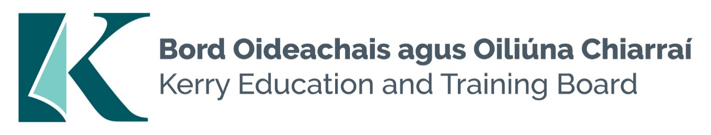

Second Permanent Deputy Principal Post
Causeway Comprehensive School Roll no. 70540E
Category XVI Deputy Principal Allowance

Kerry Education and Training Board invites applications for the post of a second Permanent Deputy Principal for Causeway Comprehensive School. This senior management post will afford the appointee an opportunity to lead teams to deliver and enhance quality education services in the Kerry area and to act as part of the senior management team in Kerry Education and Training Board.

To qualify for appointment candidates must have:
- A recognised post-primary teaching qualification.
- A minimum of 5 years’ satisfactory teaching experience or equivalent.
- Registration in accordance with Section 30 of the Teaching Council Act 2001.
- A proven track record in Curriculum Leadership and Change Management.
- Evidence of commitment to the core values of Kerry Education and Training Board: respect, quality, equality inclusion and excellence in learning

Colm Mc Evoy
Chief Executive Officer
-------------------------------------------------------------------------------------------------------------------------------------------

Conditions of Service, Terms of Appointment, Qualifications, Salary Scales and Allowances are in accordance with the regulations of the Department of Education & Skills.

Please complete an application form and return by email only to jobs@kerryetb.ie. No C.V.’s, only official application form will be accepted. Applications must be received not later than 4pm Monday 29th April 2024

Kerry Education & Training Board services Gaeltacht areas.
Cuirfear fáilte roimh chomhfhreagras i nGaeilge.
Garda Vetting of successful candidates will take place prior to offer of employment.
Canvassing will automatically disqualify.
Short-listing will take place on the basis of the information provided in the application form. Depending on the qualifications and experience of applicants, short-listing thresholds may be significantly higher than the minimum standards set out.

Kerry Education & Training Board is an equal opportunities employer.
“Creating a Learning Society in Kerry”

