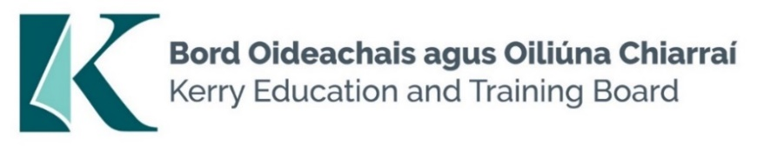

Evening Training / Part-Time Provision Instructor Pool

Kerry ETB provides Evening Training across a number of campus locations. Evening Training is of short duration (circa 10 – 12 weeks). Evening Training predominantly commences 3 times per year – January, April and September. All Evening Training is certified by appropriate organisation.

In addition to QQI there are a number of organisations that provide certification to Kerry ETB. These are City & Guilds/Accounting Technicians Ireland/METLAB/CIDESCO/CIBTAC/ITEC/CISCO/Irish Computer Society/CompTia/Digital Marketing Institute/National Governing Bodies of Sport. This list is not exhaustive - other certifying bodies may be included periodically.

Kerry Education and Training Board invite suitably qualified applicants, across a broad area of skills, for inclusion in a pool of Evening Training Instructors to provide instruction on part time programmes listed below.
The above is not an exhaustive list.
If you have suitable qualifications in other areas and would like to apply please complete the Evening Training Part Time Provision Instructor Application Form

Centre of first assignment:

- Kerry College, Monavalley Campus
- Kerry College, Clash Campus
- Kerry College, Denny St. Campus

- Kerry College, Killarney Campus
- Kerry College, Listowel Campus
- Kerry College, Killorglin Campus

Programmes:

- Business
- Childcare/SNA
- Health Related Courses- Nutrition/Strength & Conditioning
- Healthcare
- Diverse Outdoor Education/Training Programmes - Adapted Physical activity, Outdoor Activity modules (water and land based
- Engineering and Welding

- ICT/ICDL/CAD/Cybersecurity - from QQI L3 to L6
- Beauty and Complimentary Therapies
- Hairdressing and Barbering
- Construction
- Management and Leadership
- Tourism
- Office Administration
- Other – Please specify

An applicant’s inclusion in the pool is not an offer of employment. Hours will be assigned for posts that may arise.

Colm Mc Evoy
Chief Executive Officer
-------------------------------------------------------------------------------------------------------------------------------
Please complete application form which can be downloaded from our website www.kerryetb.ie/opportunities and return by email only to jobs@kerryetb.ie. No C.V.’s, only official application form will be accepted.

Kerry Education & Training Board services Gaeltacht areas.
Cuirfear fáilte roimh chomhfhreagras i nGaeilge.
Garda Vetting of successful candidates will take place prior to offer of employment.
Canvassing will automatically disqualify.
Short-listing will take place on the basis of the information provided in the application form. Depending on the qualifications and experience of applicants, short-listing thresholds may be higher than the minimum standards set out.

Kerry Education & Training Board is an equal opportunities employer.
“Creating a Learning Society in Kerry”

