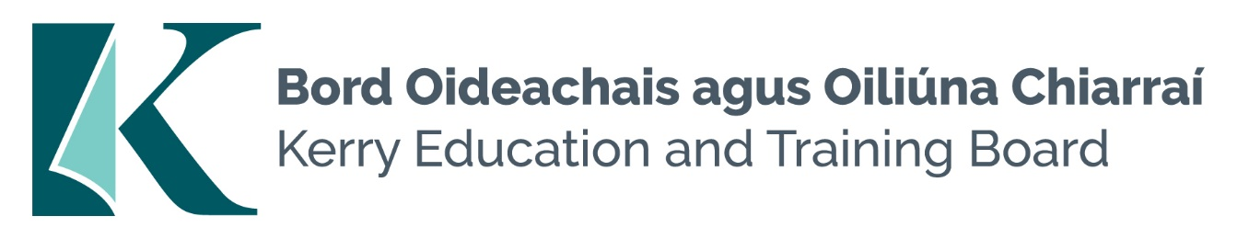

Kerry Education and Training Board (Kerry ETB) is a statutory education and training authority for County Kerry, established in accordance with the provisions of the Education and Training Boards Act 2013.
Kerry ETB is a provider of Primary, Post Primary and Further Education and Training services in Co. Kerry. The ETB has c. 1300, employees, an annual budget of c. €82 million, c.37 Centres of Education and Training with the organisations Head Office located in Tralee, Co. Kerry.
BUS ESCORT POOL
Kerry Education and Training Board
Essential Requirements:
- Punctual, reliable and trustworthy
- Good organisational and time management skills
- Flexible with the ability to deal with unexpected events and changing work activities
- Willingness to work outside normal hours as required
- Experience and understanding of Health and Safety

Desirable Requirements:
- Ability to work effectively and supportively as a member of the school team
- Good interpersonal and communication skills
- Ability to act on own initiative

Application form and full details for this pool may be obtained from www.kerryetb.ie/opportunities or contact the H.R. Department, Kerry ETB, Centrepoint, John Joe Sheehy Road, Tralee, Co. Kerry. Tel. 066-7121488

Please complete an application form and return by email only to jobs@kerryetb.ie. No Closing date applies to this pool.

Colm Mc Evoy
Chief Executive Officer

Kerry Education & Training Board services Gaeltacht areas.
Cuirfear fáilte roimh chomhfhreagras i nGaeilge.
Garda Vetting of successful candidates will take place prior to offer of employment.
Canvassing will automatically disqualify.
Short-listing will take place on the basis of the information provided in the application form. Depending on the qualifications and experience of applicants, short-listing thresholds may be higher than the minimum standards set out.
Kerry Education & Training Board is an equal opportunities employer.
“Creating a Learning Society in Kerry”

