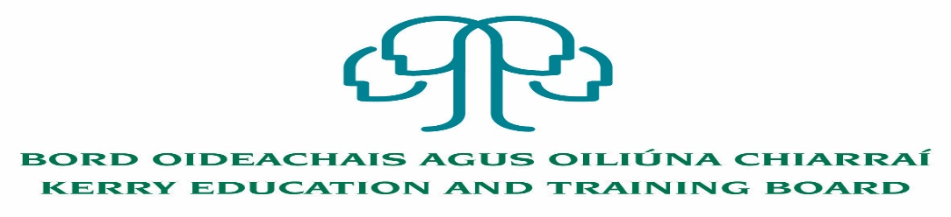

Job Description
Staff Officer (Grade V)
Finance Department

Nature of Post
Permanent Grade V Staff Officer – 35 hours per week

Reporting/Accountability Relationship
Grade V Staff Officer will report to the Grade VI FET Financial/Head of Finance/Director of OS&D.

Location
Appointment is to the Scheme – Kerry ETB reserves the right to assign a staff member to any other location, as the service exigencies require. Your centre of first assignment will be Kerry Education and Training Board Head Office, Centrepoint, John Joe Sheehy Road, Tralee, Co. Kerry.

Post Summary/Purpose:
The post holder will assist the Head of Finance/Grade VI with the administration of the Further Education and Training (FET) Finances including SOLAS Returns and other reports.

Key areas of responsibility
- Monthly Income and Expenditure Reports for Further Education and Training.
      - Review and prepare pay accruals on a monthly basis for FET.
      - Review Expenditure to ensure programme, location and general ledger codes are correct.
      - Preparation of monthly journals for FET Programmes.
      - Preparation of monthly transfer of allowance payments from SAP to SUN.
      - Preparation and distribution of monthly budget reports.
- Assisting the Grade VI in the preparation and monitoring of Monthly Budget Reports for FET.
- Assisting the Grade VI with the FAR 4 and Mid-Year and Q3 Review of FET Programme Budgets.
- Review and monitor FET devolved and apprenticeship capital.
- Processing of electronic funds transfer payments when required.
- Assist as required in the preparatory work for the Annual Financial Statements.
- ESF – Assist in the Preparatory work for the submission of the annual Financial Return to the Managing Authority on e-cohesion.
- Liaise with SOLAS/DoE in relation to Reports and Returns as required.
- Prepare files for any potential audits and checklist all files for audit.
- Attend relevant meetings and contribute ideas, and/or enhancement of approaches or practices.
- Involved in administration relevant to projects (e.g. report writing).
- Keep up to date with developments guidelines, circulars, regulations and legislation, from DoFHERIS/SOLAS/DoE/ESF etc., relating to the work assigned.
- Maintain an efficient and effective filing system for all key documents.
- Plan and prioritise work in terms of importance, timescales and other resource constraints, re-prioritising in light of changing circumstances for self and department.
- Support the maintenance and monitoring of effective quality control/internal control systems.
- Report any breaches/non-compliance issues relating to the work assigned to the Head of Finance.
- To carry out the lawful orders of the Chief Executive Officer, and to fulfill the rules and requirements of the Minister for Further and Higher Education Research Innovation and Science.
- Carry out any other duties appropriate to the grade and administrative functions which may be assigned from time to time.

The above list of accountabilities may be varied having regard to the changing needs of the Scheme and the terms of the post can include delivery of responses to unpredictable work demands as they arise.

Person Specification

As per Circular Letter 8/2017 and 46/2017 candidates must (by closing date for receipt of applications):

- Have the requisite knowledge, skills and competencies to carry out the role. Competencies will be informed by best practice Public Appointment Service competency frameworks for the Irish Public Service;
- be capable and competent of fulfilling the role to a high standard;
- have obtained at least Grade D3 in five subjects in the Leaving Certificate Examination (higher, ordinary, applied or vocational programmes) or equivalent or have passed an examination at the appropriate level within the QQI qualifications framework which can be assessed as being of a comparable to Leaving Certificate standard or equivalent or higher or have appropriate relevant experience which encompasses equivalent skills and expertise;

Desirable:
- Achieved or be at an advanced stage of working towards a Level 6 qualification or higher in a relevant area
- Excellent IT Skills
- Strong Communication Skills, both written and oral.
- Demonstrable initiative
- Strong attention to detail
- Commitment to on-going professional development

Competences required
Kerry ETB Core Values of Respect, Quality, Equality, Inclusion and Learning are the guiding principles of the organisation and underpin the competencies required to fulfil this role.

The person appointed to the above post will be required to show evidence of the following competences:

Specialist Knowledge, Expertise and Self Development
- Clearly understands the role, objectives and targets and how they fit into the work of the Organisation.
- Develops the expertise necessary to carry out the role to a high standard and has a thorough understanding of the Code of Practice for the Governance of Education and Training Boards
- Is proactive in keeping up to date on issues and key developments that may impact on the Department and/or wider ETB service
- Consistently reviews own performance and sets self-challenging goals and targets

Leadership Potential
- Is flexible and willing to adapt, positively contributing to the implementation of change
- Contributes to the development of policies in the Department/Organisation
- Seeks to understand the implications of taking a particular position on issues and how interdependencies need to be addressed in a logical and consistent way
- Maximises the contribution of the team, encouraging ownership, providing support and working effectively with others
- Formulates a perspective on issues considered important and actively contributes across a range of settings

Analysis & Decision Making
- Is skilled in policy analysis and development, challenging the established wisdom and adopting an open-minded approach
- Quickly gets up to speed in a complex situation, rapidly absorbing all relevant information/data (written and oral)
- Uses numerical data skilfully to understand and evaluate service issues and adjudicating tenders.
- Identifies key themes and patterns in and across different sources of information, drawing sound and balanced conclusions
- Sees the logical implications of taking a particular position on an issue

Delivery of Results
- Assumes personal responsibility for and delivers on agreed objectives/goals
- Manages and progresses multiple projects and work activities successfully
- Accurately estimates time parameters for projects and manages own time efficiently, anticipating obstacles and making contingencies for overcoming these
- Maintains a strong focus on meeting the needs of customers at all times
- Ensures all outputs are delivered to a high standard and in an efficient manner
- Use resources effectively, at all times challenging processes to improve efficiencies

Interpersonal & Communication Skills
- Communicates in a fluent, logical, clear and convincing manner verbally and in writing
- Is able to listen effectively and develop a two-way dialogue quickly
- Maintains a strong focus on meeting the needs of internal and external customers
- Effectively influences others to take action
- Works to establish mutual understanding to allow for collaborative working

Drive & Commitment to Public Service Values
- Consistently strives to perform at a high level
- Maintains consistent effort under pressure and is resilient to criticism or setbacks at work
- Demonstrates high levels of initiative, taking ownership for projects and demonstrating self sufficiency
- Is personally trustworthy and can be relied upon
- Places the citizen at the heart of all process and systems

