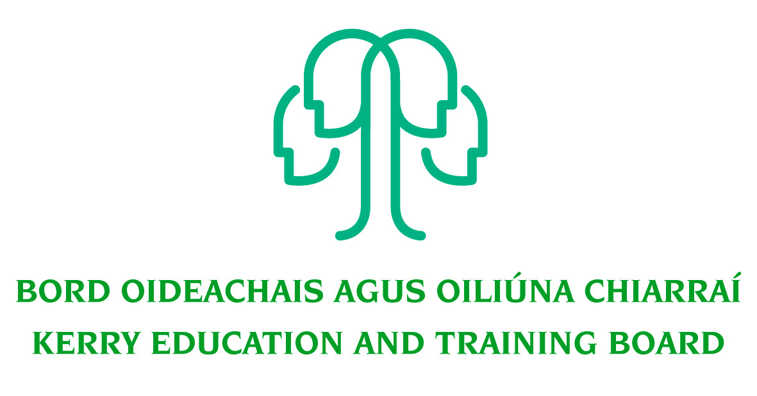

Job Description
Confined competition
(as per C. L. 0008/2017)

Grade VII Post - Two Year Fixed Term
Initial responsibility: National Apprenticeships Programme Coordinator working in collaboration with the Kerry College Business Support Unit.

Centre of first assignment: Kerry College, Monavalley Campus

Nature of Post
2 Year Fixed Term 35 hours per week.

Salary Scale:
Salary will be paid in accordance with such rates as may be authorised by the Minister for Education and Skills from time to time for ETB Grade 7

Location
Appointment is to the Scheme – Kerry ETB reserves the right to assign a staff member to any other location, as the service exigencies require. Your centre of first assignment will be Kerry College, Monavalley Campus (The post will require travel within the Kerry ETB area and beyond)

Reporting/Accountability Relationship
The Grade VII reports to the Campus Manager, Kerry College, Monavalley Campus

Post Summary/Purpose:
The post-holder will oversee aspects of the day to day management and administration of Apprenticeship Programmes for Kerry ETB, and also play a role in contributing to the development of new Programmes. (availability outside the normal office hours may be required from time to time)

Key areas of responsibility
- Day to day management and administration of the Apprenticeship; and other new apprenticeships on behalf of Kerry ETB.
- Management of the Kerry ETB’s approval application process for New Apprenticeship Programmes.
- Management of the Kerry ETB’s re-approval process.
- Set-up and management of a collaborating provider database.
- Coordination of Collaborating Provider approval process
- Organisation and Management of all communications with employers, apprentices, the National Programme Board, the Community of Practice, The National Examination Board, Kerry ETB Quality Council and the Consortium Steering Group
- Communications with and monitoring of approved providers of the Wind turbine Apprenticeship nationally; and other apprenticeships as developed.
- Convening meetings of the Consortium Steering Group and the National Programme Board, the National Examination Board and the Community of Practice.
- Coordinating External Authentication for approved providers.
- Chairing meetings of the National Examination Board.
- Providing the secretariat for the Consortium Steering Group and the National Programme Board.
- Gathering, Analyzing and Providing Programme Statistical Data to the Kerry ETB Quality Council, the National Programme Board, the National Examination Board and the Consortium Steering Group.
- Providing assistance and guidance to Instructors, Programme Managers and Quality Assurance personnel from approved providers.
- Organisation and coordination of mentor training for Workplace Mentors.
- Managing continuous professional development for Kerry ETB Instructors.
- Maintenance of a database of employers and mentors from all providers.
- Representation of new Apprenticeships and Kerry ETB at events Nationwide as requested.
- Dealing with day to day issues with Employers and Apprentices Nationally.
- Work closely with Kerry College Business Support Unit to promote and organize Skills To Advance training on a county wide level.
- Contribute to the setting of organisational tone through policies and the development and promotion of good internal controls in relevant areas of responsibility.
- To carry out the lawful orders of the Chief Executive Officer, and to fulfill the rules and requirements of the Minister for Further and Higher Education Research Innovation and Science.
- The above list of accountabilities may be varied having regard to the changing needs of the Scheme and the terms of the post can include delivery of responses to unpredictable work demands as they arise
- Any other duties that may be assigned by management as required.

The above list of accountabilities may be varied having regard to the changing needs of the Scheme and the terms of the post can include delivery of responses to unpredictable work demands as they arise.

Person Specification

As per CL 0008/2017, candidates for a Grade VII post must:
- Have the requisite knowledge, skills and competencies to carry out the role. Competencies will be informed by best practice Public Appointment Service competency frameworks for the Irish Public Service;
- Be capable and competent of fulfilling the role to a high standard;
- Have obtained at least Grade D3 in five subjects in the Leaving Certificate Examination (higher, ordinary, applied or vocational programmes) or equivalent or have passed an examination at the appropriate level within the QQI qualifications framework which can be assessed as being comparable to Leaving Certificate standard or equivalent or higher or have appropriate relevant experience which encompasses equivalent skills and expertise;
- have at least two years in a Grade III post, or equivalent, or higher, in the Education and Training Sector. ETB Caretaker Grade will also be considered valid.
- have successfully completed their probation period, or have successfully completed a probation period at a lower eligible grade.

Desirable Criteria
- A third level qualification in the relevant area
- Comprehensive Information or delivery of training programmes or other relevant experience
- Knowledge of labour market training needs, performance indicators and quality assurance
- A work history which demonstrates initiative
- Innovation and ability to accept changes and new challenge’s
- Demonstrate an understanding of the linkages between strategy and business plans with operational goals and targets
- Comprehensive Information Technology Skills and Working Knowledge of Training centre IT Systems – PLSS, SAP, Apprenticeship Client Services
- Good General knowledge of planning, organising and managing training programs
- Have knowledge of the national development relating to apprenticeship, learning and qualifications
- Demonstratable of Skills to Advance training initiative and the work of the Kerry College Business Support Unit.
- Ability to work in a multidisciplinary team.

Competencies Required
Kerry ETB Core Values of Respect, Quality, Equality, Inclusion and Learning are the guiding principles of the organisation and underpin the competencies required to fulfil this role.
The appointee to the Grade VII post will be required to show evidence of the following competencies:

Specialist Knowledge, Expertise and Self Development
- Has a clear understanding of the roles objectives and targets of self and the team and how they fit into the work of the ETB and effectively communicates this to others.
- Displays high level of skills/expertise in the area and provides guidance to colleagues.
- Has a high level of expertise and broad Kerry ETB sector knowledge and has a thorough understanding of the Code of Practice for the Governance of Education and Training Boards
- Is focused on self-development and strives to improve performance.
- Has the required level of knowledge and expertise to undertake the technical aspects of the role.

Analysis & Decision Making
- Gathers and analyses information from relevant sources, whether financial, numerical or otherwise weighing up a range of critical factors.
- Draws accurate conclusions and makes balanced and fair recommendations backed up with well-reasoned rationale and stands by these.
- Has capacity to work on own initiative to support other staff and to deal with unexpected problems that can arise.
- Understands the practical implications of information in relation to the broader context in which s/he works – procedures, service objectives, etc.

Management & Delivery of Results
- Takes ownership of tasks and sees them through to a satisfactory conclusion.
- Is logical and pragmatic in approach, setting objectives and delivering the best possible results with the resources available through effective prioritisation.
- Delegates work effectively, providing clear information and evidence as to what is required.
- Minimises errors, reviewing learning and ensuring, remedies are in place.
- Proactively identifies areas for improvement and develops practical suggestions for their implementation.
- Demonstrates enthusiasm for new developments/changing work practices and strives to implement these changes effectively.
- Applies appropriate systems/processes to enable quality checking of all activities and outputs.
- Practices and promotes a strong focus on delivering high quality customer service, for internal and external customers.

Team Leadership
- Works with the team to facilitate high performance, developing clear and realistic objectives and addressing any performance issues if they arise.
- Provides clear information and advice as to what is required of the team.
- Strives to develop and implement new ways of working effectively to meet objectives.
- Leads the team by example, coaching and supporting individuals as required.
- Places high importance on staff development, training and maximising skills & capacity of team.
- Is flexible and willing to adapt, positively contributing to the implementation of change.
- Deals with any tensions within the team in a pro-active manner.
- Encourages, listens to and acts on feedback from the team to make improvements.
- Actively shares information, knowledge and expertise to help the team to meet agreed objectives.

Interpersonal & Communication Skills
- Builds and maintains contact with colleagues and other stakeholders to assist in performing role.
- Acts as an effective link between staff and senior management.
- Encourages open and constructive discussions around work issues.
- Projects conviction, gaining buy-in by outlining relevant information and selling the benefits.
- Treats others with diplomacy, tact, courtesy and respect, even in challenging circumstances.
- Presents information clearly, concisely and confidently when speaking and in writing.

Drive & Commitment to Public Service Values
- Strives to perform at a high level, investing significant energy to achieve agreed objectives.
- Is flexible and open to change.
- Is resilient and perseveres to achieve objectives despite obstacles or setbacks.
- Is personally trustworthy and can be relied upon.
- Behaves with integrity and encourages this in others.

