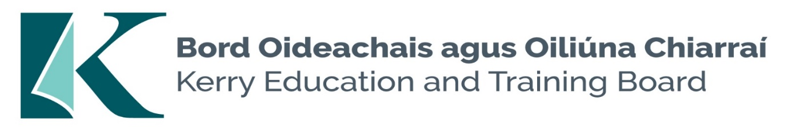
Supervisor Pool for Kerry ETB Schools

Applications are invited for the above pool, under the aegis of Kerry Education & Training Board for posts which may arise in the school year 2023/2024 (all appointments are to Kerry ETB).

The role will include but is not limited to the supervision of post primary students before and after school and during breaks. The Successful candidates must be available for work at short notice

Essential Criteria
- Satisfactory Garda Vetting
- Successful completion of TUSLA Children First E-Learning Programme
Desirable Criteria;
- Experience of working with young people in a community context e.g. sports coaching, youth club work etc.
---------------------------------------------------------------------------------------------------------------------------------------
Application forms for this pool can be downloaded from www.kerryetb.ie/opportunities or contact the H.R. Department, Kerry ETB, Centrepoint, John Joe Sheehy Road, Tralee, Co. Kerry. Tel. 066-7121488.

Please complete an application form and return by email only to jobs@kerryetb.ie. No C.V.’s, only official application form will be accepted.

Kerry Education & Training Board services Gaeltacht areas.
Cuirfear fáilte roimh chomhfhreagras í nGaeilge.
Garda Vetting of successful candidates will take place prior to offer of employment.
Canvassing will automatically disqualify.
Short-listing will take place on the basis of the information provided in the application form. Depending on the qualifications and experience of applicants, short-listing thresholds may be higher than the minimum standards set out.
Kerry Education & Training Board is an equal opportunities employer.
“Creating a Learning Society in Kerry”

