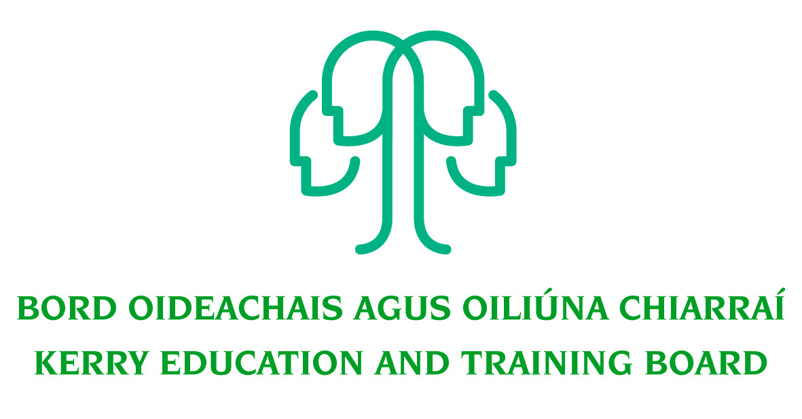

Job Description and Person Specification

Permanent Assistant Staff Officer (Grade IV) Post

Centre of first assignment: Coláiste Na Sceilge, Caherciveen, Co Kerry

Nature of Post
Permanent Full Time – 35 hours per week

Salary Scale:
Salary will be paid in accordance with such rates as may be authorised by the Minister for Education from time to time for ETB Grade IV

Location
Appointment is to the Scheme – Kerry ETB reserves the right to assign a staff member to any other location, as the service exigencies require. Centre of first assignment will be Coláiste na Sceilge, Caherciveen, Co. Kerry

Reporting/Accountability Relationship
The Assistant Staff Officer reports to the Principal

Post Summary/Purpose
The Assistant Staff Officer is a support/supervisory position within Kerry ETB and is assigned responsibility for the day to day operation of a work area, section or team.

The Assistant Staff Officer works as part of a team, supporting managers and colleagues to meet work goals and objectives and to deliver quality services to internal and external customers. The post holder will be responsible for the implementation of work programmes to achieve goals and targets.

The post holder will be required to be flexible, and undertake duties to support the work of the department/section as a whole.

The post holder will promote and maintain best practices throughout the department/school to ensure a quality service is delivered at all times

Key Responsibilities:

- To provide clerical and administrative support to the Principal, and to support the Deputy Principal and teaching staff as policy directs.
- To ensure that the school and office operates in a consistently organised manner.
- To maintain records with a high degree of accuracy.
- To plan and prioritise work in terms of importance, timescales and other resource constraints, re-prioritising in light of changing circumstances for self and relevant staff teams.
- To act as liaison between the community, the school and other internal and external stakeholders.
- To act as first point-of-contact to callers, relay messages, and transfer calls as appropriate.
- To co-ordinate appropriate documents for communication between schools and stakeholders, internal and external.
- To adhere to rigorous student and staff confidentiality protocols in all circumstances.
- To complete forms in accordance with school and DES procedures, following education legislation.
- Ensure the filing system in the schools is up to date.
- Co-operation with existing and new ICT systems.
- Maintain a strong focus on self-development, seeking feedback and opportunities for growth.
- Research issues thoroughly, consult appropriately to gather all information needed on an issue.
- Contribute to the setting of organisational tone through policies and the development and promotion of good internal controls in relevant areas of responsibility.
- Carry out lawful orders of the Chief Executive.
- Carry out any other duties appropriate to the grade which may be assigned from time to time.
- The above list of accountabilities may be varied having regard to the changing needs of the Scheme and the terms of the post can include delivery of responses to unpredictable work demands as they arise.

Person Specification

The following are the essential requirements for appointment to this post:

Essential requirements:

As per CL 0008/2017 and CL 46/2017, candidates for a Grade IV post must:
- Have the requisite knowledge, skills and competencies to carry out the role. Competencies will be informed by best practice Public Appointment Service competency frameworks for the Irish Public Service;
- Be capable and competent of fulfilling the role to a high standard;
- Have obtained at least Grade D3 in five subjects in the Leaving Certificate Examination (higher, ordinary, applied or vocational programmes) or equivalent or have passed an examination at the appropriate level within the QQI qualifications framework which can be assessed as being comparable to Leaving Certificate standard or equivalent or higher or have appropriate relevant experience which encompasses equivalent skills and expertise;

Desirable Criteria
- Achieved or be at an advanced stage of working towards a Level 6 qualification or higher on the National Framework of Qualifications
- Ability to analyse complex issues
- Excellent administrative and IT Skills
- Strong Communication Skills, both written and oral
- Demonstrable initiative
- Strong attention to detail

Competences required
Kerry ETB Core Values of Respect, Quality, Equality, Inclusion and Learning are the guiding principles of the organisation and underpin the competencies required to fulfil this role.

The person appointed to the above post will be required to show evidence of the following competences:

People Management
- Consults and encourages the full engagement of the team, encouraging open and constructive discussions around work issues
- Gets the best out of individuals and the team, encouraging good performance and addressing any performance issues that may arise
- Values and supports the development of others and the team
- Encourages and supports new and more effective ways of working
- Deals with tensions within the team in a constructive fashion
- Encourages, listens to and acts on feedback from the team to make improvements
- Actively shares information, knowledge and expertise to help the team to meet it’s objectives
- Acts as an effective link between staff and other managers

Information Management and Decision Making
- Follow procedures and ensures they are implemented in own area, understanding the rationale behind them
- Reviews completed work regularly and acts on learning points
- Evaluates current work practices to identify changes that could be made to improve efficiencies
- Can work effectively on a number of tasks at the same time
- Is comfortable working with and manipulating a range of data, e.g. numerical, written etc.
- Makes sound appropriate decisions in a confident manner and can justify and stand by them

Delivery of Results
- Assumes personal responsibility for and delivers on agreed objectives/goals
- Manages and progresses multiple projects and work activities successfully
- Accurately estimates time parameters for projects and manages own time efficiently, anticipating obstacles and making contingencies for overcoming these
- Maintains a strong focus on meeting the needs of customers at all times
- Ensures all outputs are delivered to a high standard and in an efficient manner
- Use resources effectively, at all times challenging processes to improve efficiencies

Interpersonal & Communication Skills
- Shows respect, tact and maintains composure when dealing with customers or staff members
- Demonstrates the ability to be assertive and negotiate when necessary, communicating in a fluent, logical, clear and convincing manner whilst remaining approachable and polite
- Is able to listen effectively and develop a two-way dialogue quickly
- Maintains a strong focus on meeting the needs of internal and external customers
- Influences others by actively listening and clearly expressing their position
- Produces written letters/reports in a clear and concise manner

Specialist Knowledge, Expertise and Self Development
- Displays high level of skills/expertise in own area and provides guidance to colleagues
- Has a clear understanding of the role, objectives and targets and how they support the service delivered by the Department/ETB and can communicate this to the team.
- Leads by example, demonstrating the importance of development by setting time aside for development initiatives for self and the team.
- Is proactive in keeping up to date on issues and key developments that may impact on own area, the Department and/or wider ETB service

Drive & Commitment to Public Service Values
- Consistently strives to perform at a high level, demonstrating flexibility and finding solutions to overcome obstacles or setbacks
- Serves the Government and people of Ireland
- Can work independently without excessive guidance or support
- Demonstrates resilience in the face of significant demands and challenges
- Ensures that customer service is at the heart of own/team work
- Is personally honest and trustworthy
- Acts with integrity and encourages this in others

.

Respect, Quality, Equality, Inclusion and Learning

