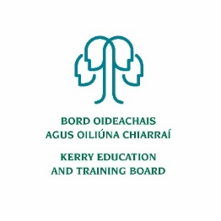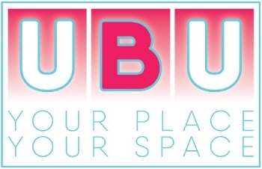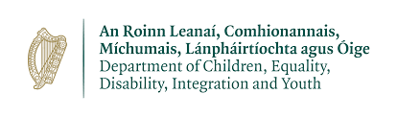

Kerry ETB UBU Your Place Your Space – Call for Service
Introduction:
Kerry ETB is seeking an organisation with experience of providing services to young people, to deliver a youth service to young people in the West Iveragh region of Co. Kerry. This new project is being established in line with the UBU Your Place Your Space scheme funded by the Department of Children, Equality, Disability, Integration and Youth (DCEDIY).

The mission of the UBU Your Place Your Space Funding Scheme is:
“To provide out-of-school supports to young people in their local communities to enable them to overcome adverse circumstances and achieve their full potential by improving their personal and social development outcomes.”

The organisation Kerry ETB is seeking should:
- Exemplify good practice in relation to vision, methodologies, governance, compliance, programme design, delivery and evaluation
- Be experienced in working with targeted young people aged 10-24 years with complexity of needs, using a non-formal educational methodology
- Operate in an out-of-school setting, including evenings, weekends and school holidays
- Understand the nature and needs of young people living in disadvantaged communities and offer appropriate responses
- Able to devise and measure effective responses to the needs of the target group
- Be committed to on-going sharing of learning and collaboration

Background:
Education and Training Boards (ETB)
Education and Training Boards (ETBs) have a role in the development, implementation and strengthening of policy and service provision for children and young people, including youth work provision, which will achieve better outcomes for children and young people. This is in line with the statutory responsibility of the ETBs in matters of youth work policy implementation and additionally covers the ETB role in the broader policy objectives of DCEDIY as it relates to youth policy.

The Education and Training Boards Act, 2013 states that the functions of ETBs with regard to youth work are to:

- Support the provision, coordination, administration and assessment of youth work services in its functional area and provide such information as may be requested by the Minister for Children and Youth Affairs in relation to such support; and assess whether the manner in which it performs its functions is economical, efficient and effective.

The Education and Training Boards Act goes on to state (Section 10(6)) that “youth work” has the same meaning as it has in the Youth Work Act 2001.

Department of Children, Equality, Disability, Integration and Youth (DCEDIY)
The DCEDIY is the principal Department to whom ETBs report in relation to their youth work functions. It has a mandate in relation to policy and service provision for children and young people. The Department comprises a number of interrelated strands, including the direct provision of universal and targeted services, and working to achieve the harmonisation of relevant policy and provision across Government so as to improve outcomes for children, young people and families.
The DCEDIY strategic and operational objectives are informed by the following:
• Better Outcomes, Brighter Futures – The national policy framework for children and young people, 2014-2020,
• National Youth Strategy, 2015-2020,
• Recommendations of the Value for Money and Policy Review of Youth Programmes, 2014 (VFMPR) – see below,
• UBU Your Place Your Space funding Scheme 2020,
• National Quality Standards Initiatives (National Quality Standards Framework for the Youth Work Sector/National Quality Standards for Volunteer-led Youth groups),
• LGBTI+ National Youth Strategy 2018-2020,
• Directives and circulars pertaining to the management of public funds, accountability and by needs identified by ETBs locally.

UBU Scheme:
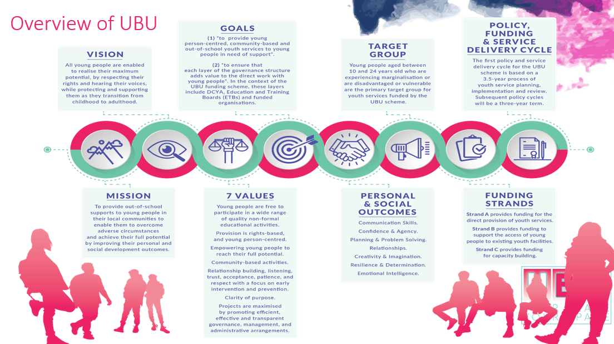

Area Profile Needs Assessment and Service Requirements (APNASR)
This tool supports an ETB in identifying and prioritising the needs of young people who fall within the defined target group for UBU Your Place Your Space scheme. The APNASR requires an ETB to understand, integrate and analyse different sources of quantitative and qualitative information. The data sources have been selected because they are nationally available and free to access, helping to establish a consistency of focus across UBU Your Place Your Space. The successful organisation must work with the target groups identified through this process.

Service Brief:
The approach offered by the successful organisation must have at its core the following elements:
- Develop new and innovative programmes and interventions to meet the needs and interests of the young people identified in the catchment area.
- Operate primarily on late evenings, on weekends and during school holidays.
- Focus on developing culturally appropriate interventions in response to the needs of the young people targeted by the Project. This requires dynamic and creative approaches to working with such diverse groups of young people.
- Engage the young people in the co-design of the Project and the programmes on offer.
- Ensure a minimum of 80% of the young people (aged 10 to 24 years) accessing the Project are within the target group requiring support or at significant risk. Additionally, there will be scope and an expectation on the Provider to develop and respond to any new and emerging needs as may be identified by ETB.
- Ensure a minimum of 70% of the service effort will be on direct service delivery with young people.
- Engage qualified, skilled staff utilising evidenced based interventions and adopting the Logic Model for programme planning.
- Give priority to developing and enhancing interagency collaborations with other providers of services for young people operating in the identified area.
- Regularly evaluate the impact of the youth work interventions and evidence the improved outcomes for young people.
Funding:
A budget of €120,000 per annum has been made available under the UBU Your Place Your Space funding scheme for this new youth service. The budget will support direct and indirect costs associated with delivering the youth service in line with the UBU Your Place Your Space Policy & Operating Rules, Financial Requirements outlined in Chapter 7.
Location:
Kerry ETB has identified West Iveragh as the location for the new youth service. This includes the following EDs: Na Beathacha; Baile an Sceilg; An Baile Breac; Caher; Cathair Dónall; Ceannúigh / Máistir Gaoithe; Castlequin; Doire Fhíonáin; Doire Ianna / Cloon; An tImleach; Killinane; Loch Luíoch; Portmagee; Toghroinn Fhíonáin; Teeranearagh; Valencia; and Castlecove. The map below illustrates the catchment area for the new youth service. This was based on evidence gathered through the APNASR process 2019 and on consultations/research undertaken in 2021.
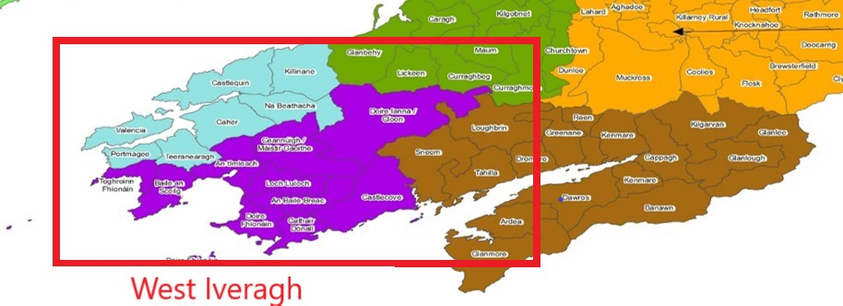

Social Profile:
The area has a total population of 7,317, of whom 1,108 (15%) are aged 10 to 24. This extensive rural space has a surface area of 690km2, which corresponds to 15% of County Kerry.
Strengths: Iveragh has a strong tradition in community-led local development, and once a UBU is operational, it will be able to tap into the expertise, supportive networks and linkages offered by local civil society organisations. Community-based organisations and projects are open to working with young people and to including them more extensively in civic life and in inter-generational projects. While many of those aged 18 to 24 leave the area in search of employment / further education, they return most summers – to work in the hospitality sector and to participate in the many sporting activities and festivals that punctuate the Iveragh calendar. While rural areas, such as Iveragh, can be homogenous and conservative, they tend to be caring and close-knit, and local people rally around one another to provide support and friendship, and local social capital (bonding) can assist and sustain young people and families in times of pressure and crisis. Iveragh has some accessible premises that will lend themselves to youth development endeavours, particularly in the creative arts.

Challenges- Rurality, isolation, peripherality and distance from services are among the significant factors that delimit young people’s progression. Of the 17 EDs in the priority area, 12 have negative scores on the HP Index. These are home to 82% of the population. There are several small areas (SAs) with Pobal HP Index scores below -10. These have a combined population of 992, and they are in both urban /village settings and in rural communities. In both contexts, deprivation is inter-generational, and is characterised by low levels of educational attainment, unemployment / underemployment and limited engagement in civic life. These factors combine to delimit young peoples’ progression – educationally, socially and economically, and they are associated with high levels of under-age drinking, the consumption of illicit drugs and increasingly acute mental health problems. The latter are most manifest in rural parts of Iveragh and are compounded by distance, lack of knowledge, low expectations and non-engagement with supports / services. The COVID-19 pandemic has exacerbated loneliness, isolation and mental health problems; low-income families have not been able to avail of ICT enabled connectivity, and those living in peripheral rural areas have also lacked broadband connectivity.

Response:
The UBU service required will respond to the needs of:
- Young people (10-18 Yr Olds) who are at risk of not flourishing due to rural isolation throughout West Iveragh. These young people are at risk of developing associated difficulties in the areas of: mental health, substance misuse, anti-social behaviour and poor perceptions of place and of self.
- 13/14 Yr Olds experiencing social anxiety due to disrupted transition from primary to post-primary school (young people beginning 2nd year in academic year 2021/22).
- Young people (10-24 Yr Olds) experiencing economic, social and cultural disadvantages living in areas of high deprivation presenting with multiple problems in the area.
- Young people (10-24 Yr Olds) experiencing marginalisation whose specific circumstances limit their opportunities (in particular LGBTI+ and Physical/Intellectual Disability).

General considerations:
Those with most intense levels of need within each target group should be prioritised. Stakeholders emphasise that due to its rurality, and the nature thereof, Iveragh has to have a bespoke UBU – in line with local needs, culture and potential. Actions should endeavour to increase young peoples’ ‘rootedness’ and sense of belonging.
- The goal is to provide young people opportunities to participate in out of school, community based youth activities that are fun, recreational, educational and youth centred. Youth Work approaches will need to encourage a sense of belonging and connectedness promoting social skills and the development of positive relationships
- Work will combine one-to-one and group work where appropriate with a focus on early intervention and prevention. There will be clarity of purpose, and practitioners /youth workers should be critical and reflective in ensuring that their work is evidence informed.
- Creative outreach dimension required to engage rurally isolated youth. Promotion of service will be critical to projects success. This may involve engaging larger groups of young people with a view to identifying those with additional needs. Primary and post-primary schools will need to be engaged with. Transport and safety will also need to be considered with this younger cohort. Collaborative approach utilising community resources optimal.
The general view of local-level informants is that UBU should endeavour to:
- Pursue a preventive approach to youth development – intervene as early as possible in the lives of young people to prevent problems arising and to equip young people with the skills and capacity to cope with challenges that may emerge.
- Address mental health issues – immediate and structural
- Involve and nurture families, as appropriate – so that parents support their children and affirm the work of UBU
- Work with local civil society to tackle isolation and loneliness;
- Operate on an outreach basis – so as to mitigate the effects of rurality and the associated isolation
- Provide (directly and through collaborations) multiple pathways through which young people can express themselves, including creatively; and
- Complement, cooperate with and feed into other local services, supports and structures including schools, sporting organisations and the Community Drugs Project and Youth Justice Project.
Selection Process for the New Project Preferred Provider
A preferred provider will be identified through the following selection process:
• Stage 1 – Kerry ETB publicly advertise the Scheme in July 2021 asking interested parties to apply according to the steps outlined in the Information Pack. The closing date for receipt of fully completed Submission Application Form is Monday 16th August 2021.
NOTE: Only organisations who have fully completed the Submission Application Form and answered YES to all 12 UBU Eligibility Criteria will be considered.
• Stage 2 – Analysis of Submissions received and shortlisting for interview process by Kerry ETB.
• Stage 3 – Interviews, consisting of a formal presentation by the applicant organisation will be scheduled for early September 2021.
• Stage 4 – Decision is reached by Kerry ETB interview panel, further discussions may be held with selected preferred provider regarding their service offer and Kerry ETB’s requirements. Kerry ETB will inform DCEDIY that the process is complete and that the identified organisation is being recommended as the preferred provider.
• Stage 5 – Once confirmed by the DCEDIY the successful preferred provider will be asked to make a formal UBU application for funding to Kerry ETB. If in order, Kerry ETB will make a recommendation to DCEDIY as per UBU Policy and Operating Rules. Following DCEDIY approval, a letter of allocation will issue to the funded organisation.
• Stage 6 – A Service Level Agreement will be issued and signed by the successful funded organisation and Kerry ETB. The Funded Organisation undertakes phase one of the New Youth Service, hiring staff, providing orientation training, securing premises etc.
• Stage 7 – New Youth Service launch & the UBU Your Place Your Space Performance Oversight & Engagement Framework will commence.
In compliance with the Data Protection Act 2018, the General Data Protection Regulation, and guidance from the Data Protection Commission, any personal data you give Kerry ETB in connection with this application will be kept securely and only used for the purposes of assessment (including shortlisting and interviewing), general administration, reporting and to fulfil our other legal obligations. When Kerry ETB no longer have any lawful basis for retaining it, it will be destroyed/deleted. Under the Freedom of Information (FOI) Act 2014, any information we receive in our dealings with you can potentially be released to the general public on request. Under S8 of the FOI Act, a list of all grants over €10,000 will be published on our website on an annual basis.
Details Stage 1: Return of Submission Application Form
Closing date for applications is Monday 16th August 2021 and should be submitted electronically to Kerry ETB Youth Development Office at youthwork@kerryetb.ie
Or
Hard Copies can be addressed to Kerry ETB Youth Development Office and sent to:
Kerry Education and Training Board, Centrepoint, John Joe Sheehy Road, Tralee, Co. Kerry, V92 P2FE.

It is the responsibility of each respondent to ensure that the Submission Application Form reaches Kerry ETB before the deadline. Submission Application Forms sent to any other address (other than the one indicated above) or received after the deadline will be deemed invalid.

Details Stage 2: Analysis of Submissions received and shortlisting for interview process by Kerry ETB
UBU Your Place Your Space Eligibility Criteria
The following 12 questions will be used to assess the organisations eligibility to access funding under the UBU Your Place Your Space scheme. All respondents must be in a position to answer Yes to all of the Eligibility Criteria questions to be shortlisted. The ETB reserves the right to ask for evidence relating to each question. (UBU Policy & Operating Rules)
No | Eligibility Criteria | Yes | No
1 | Do you have a Memorandum and Articles of Association or a Constitution, which outlines the projects governance structure, and a list of the Board of Directors?
2 | Are you willing to provide the financial records and related materials in respect of the Grant provided for auditing and inspection purposes by DCEDIY, ETB and/or its designated bodies, or the Comptroller and Auditor General?
3 | Are you willing to fulfil the UBU Your Place Your Space scheme rules?
4 | Are you willing to comply with the DPER circular 13/2014 and have you the appropriate systems in place to ensure compliance?
5 | Are you compliant with the Children First Act 2015?
6 | Do you have appropriate levels of insurance in place on all the project’s assets, public liability and employer’s liability? (The levels of insurance required cover: €12.7 million for employer’s liability insurance; and €6.5 million for public liability insurance.)  AND  Will your organisation specifically indemnify DCEDIY and ETB.
7 | Have you a recruitment and selection process in place that is compliant with the relevant legislation inclusive of Garda Vetting of adults working with young people in a paid and voluntary capacity in line with the National Vetting Bureau (Children and Vulnerable Persons) Acts 2012-2016.
8 | Have you an Organisational Health and Safety Statement and Policy in place and have you a listed person as Health & Safety Officer?
9 | Have you accounts that are audited on a calendar year by external auditors and have available the 2020 signed audited accounts?
10 | Is your organisation fully compliant with all its relevant governance code/s? (e.g. companies ltd by guarantee with no share capital, public bodies, charitable bodies, cooperatives).
11 | Is your organisation willing to participate in the trialling of sample services and tools as directed by ETBs and DCEDIY to support development of best practice and evaluation initiatives?
12 | Is your organisation willing to report directly to the ETB on work with young people, targets achieved and financial matters?

Shortlisting:
Once the ETB has assessed that the respondent is in a position to answer YES to all 12 eligibility criteria the following categories are scored. Please Note: respondents must meet a minimum score under each category in order to be shortlisted.
Category |  | Weighting | Maximum Score | Minimum Score Required
1 | Response to identification of need/Impact | 20% | 200 | 120
The degree to which the submission demonstrates:
- A plan which addresses the needs identified by the ETB
- The suitability of the methods the respondent intends to deploy to engage the target groups of young people identified by the ETB
- The projected numbers of young people to be engaged
- Ability to facilitate young people’s involvement in the co-design of the programmes/project
2 | Demonstrated knowledge and track record: Practice & Delivery | 30% | 300 | 180
The degree to which the submission has demonstrated:
- Knowledge and track record of working through a non-formal educational approach with the target groups outlined in the Call for Service.
- Knowledge of the local area or working in similar areas with similar target groups,
- Demonstrable knowledge and track record in addressing the needs of the target groups
- Demonstrable capacity and capability to implement youth work approaches
- Demonstrable commitment to mission, goals and values of UBU Your Place Your Space.

3 | Demonstrated knowledge and track record: Governance & Oversight | 30% | 300 | 180
The degree to which the submission has demonstrated a capacity and ability to deliver the proposed on the operational and governance requirements:
- Evidence of an ability to deliver on the governance requirements through appropriate structures, systems and policies including but not limited to, Health and Safety Policy,
- A written child protection, welfare and safeguarding policy and related procedures, Garda Vetting Policy, Volunteer Policy and Procedures., Drug and Alcohol Policy and Procedures.
- Financial Management Procedures, Human Resources (HR) policy and procedures, Data Protection policy, Risk Management policy and procedures.
- Evidence should demonstrate the organisations ability to implement all relevant sections of the Companies Act 2014, FRS 102 (mandatory) and to prepare where possible for Statement of Recommended Practice (SORP) compliant accounts.
- Quality of the risk assessment and appropriateness of the actions to address the risks identified,
- Experience of monitoring and evaluation systems in human services.
4. | Value For Money/Additionality | 10% | 100 | 60
The degree to which the submission has demonstrated:
- Clear, realistic budget with supporting rationale,
- The degree to which the applicant can demonstrate that they can bring additional resources to this application (including, but not limited to):
• Relationships with key agencies operating in the geographic/issue area,
• Additionality offered from existing services offered by the applicant organisation,
• Access to premises, equipment, volunteers and other resources,
• Access to administration and management support.
5 | Implementation | 10% | 100 | 60
The degree to which the submission has demonstrated:
- A clear plan for each element of the project establishment and implementation
- A clear timeframe for each stage of project establishment and implementation
- A clear plan for managing the delivery, reporting and financial management requirements

Details Stage 3: Interview
Interviews consisting of a formal presentation by respondents are scheduled to take place early September 2021. The Kerry ETB recommendation of a preferred provider will be based upon assessment of both the Submission Application Form AND the interview process. Both the Submission Application Form and the interview will be marked under the 5 categories outlined below:
- Response to identification of need/impact
- Demonstrated knowledge and track record: Practice & Delivery
- Demonstrated knowledge and track record: Governance & Oversight
- Value for Money/Additionality
- Implementation
Please Note: In order to be considered for recommendation by Kerry ETB as the preferred provider respondents must attain the minimum score in each category.
The formal presentation which is part of the interview process must address the 5 categories indicated in the scoring system.
Appeals Process
Final decision with regard to the selected provider rests with DCEDIY. As such respondents to the Call for Service can only appeal the outcome with the ETB based on procedural issues relating to the application and appraisal process. All appeals must be submitted within one week of the date on the notification of the outcome correspondence.
Appeals should be submitted to youthwork@kerryetb.ie placing “UBU Call For Service Appeal” in the subject line. It is the responsibility of the appellant organisation to ensure the appeal is received.
Please Note:
- As indicated above appeals can only be based on procedural issues related to the process as outlined in the Kerry ETB Call for Service
- Appeals will only be accepted from the lead applicant.
- Appeals submitted to Kerry ETB after the appeal date will not be considered.
- The appeals panel will not include any member of the original assessment group.
- The appeal process will be conducted within a two-week period from the date of receipt of the appeal.
- The appeals panel will review the appeal and make a recommendation to the Chief Executive of Kerry ETB. This recommendation will form the basis for any decisions made with regard to the recommendation of preferred providers to DCEDIY.
- Kerry ETB will inform the appellant organisation of the outcome.

