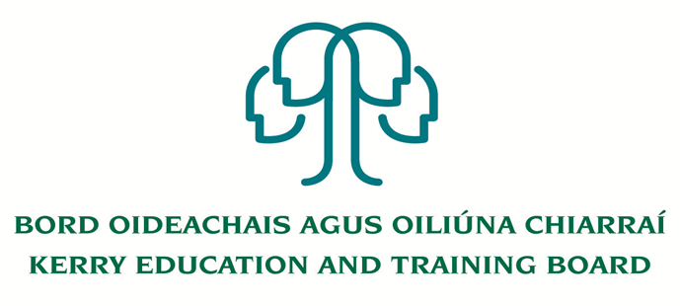

Job Description

Title: Instructor – Learner Support

Grade: Career Grade

Reporting To: Campus Manager

Location: Kerry College Monavalley Campus

Function of Job: Planning, overseeing, managing & implementing effective learner support strategies for learners & apprentices - on a one to one basis and in group settings. Developing creative and innovative approaches to enable learners and apprentices to progress through their chosen field of study/professional development

Duties and Responsibilities

- Planning and implementing effective delivery strategies, liaising with learners and apprentices, on a one to one basis and in group settings
- Completion of required administrative duties using appropriate procedures and IT systems
- Development of study skills programme and learning support programmes to ensure optimum efficiency in delivery of service
- Prepare lesson plans, course notes, presentational material and handouts as appropriate
- Use new technology as appropriate to assist in delivering and administering support to learners
- Prepare and issue progress reports as requested
- Conducting numeracy & literacy assessments with learners and apprentices so as to establish an individual learning approach plan for learners and apprentices.
- Liaise with internal departments to Kerry ETB and external agencies to promote learner support service provision
- Working as a team-member within the wider campus and liaising with other relevant individuals such as instructors and employers.
- Participate in and contribute to educational and programme planning and development within the Campus
- Demonstrate commitment to continuous professional development to extend knowledge and skill, keeping up to date with current educational thinking and practice.
- Uphold and implement the centre/service code of conduct for learners
- Assisting with special events, including PR/Promotion, Open days etc.

- Undertake such other duties as may be assigned from time to time

PERSON SPECIFICIATION

Job Title: Instructor – APPRENTICESHIP

 | ESSENTIAL | DESIRABLE
MOTIVATION:  Knowledge of Post / Organisation  Personal Motivation  Work-related Achievements. | Have knowledge of the national developments relating to apprenticeship, learning and qualifications  Have sufficient confidence in his/her ability to transfer the skills of the occupation as specified in the relevant curriculum/programme specification  Proven record of achievement | Have knowledge of modern training methods.  Ability to work as part of a team.  Previous training experience.
WORK EXPERIENCE  Specify particular experience/ skills required. | Experience in delivery of learner support and learner assessment | Knowledge of apprenticeship and non apprenticeship curriculum
COMMUNICATIONS INTERPERSONAL SKILLS:  Verbal/presentation skills  Administrative, record maintenance and assessment skills  Special requirements  Disposition | Articulate, with the ability to communicate relevant learner support strategies in a manner designed to motivate the learner.  Experienced in work related administrative skills (e.g. learner support, assessment, instructor)  Having the necessary coping skills to deal with conflict, motivational & disciplinary problems associated with training.  The candidate will understand the totality of the job and be prepared for any unforeseen situations that may arise. | To display experience in using these skills  Some experience in administrative skills  Have worked with multidisciplinary groups
EDUCATION:  Minimum L6 qualification | Qualifications in the areas of Further or Adult Education.  Experience in delivering learner supports | Membership of professional bodies in the field of learner support  Knowledge of Apprenticeship and FET provision and assessments

