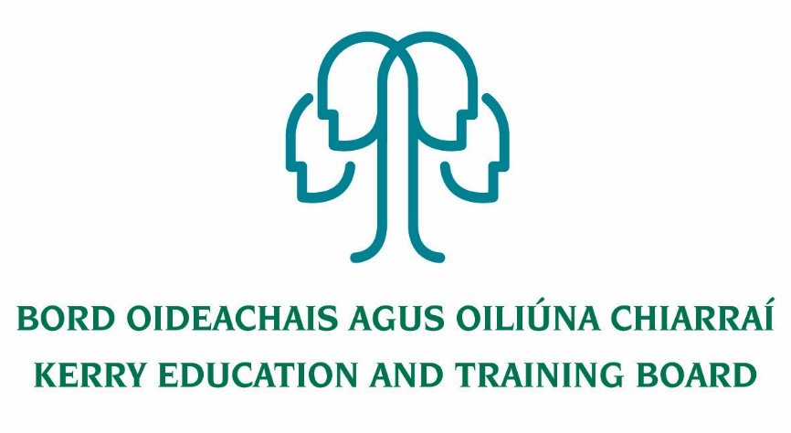

Kerry Education & Training Board wishes to recruit committed, enthusiastic and talented educators to its team of tutors and educational leaders. We provide a quality comprehensive education service through a wide range of community-based adult and further education and training programmes.

**Resource Worker Post**

**Maternity Leave Cover commencing January 2020**

Applications are invited for the following Resource Worker post under the aegis of Kerry Education & Training Board, which may arise. All appointments are to Kerry ETB – centre of first assignment is indicated here for the assistance of applicants. A panel may be formed from this competition from which appointments may be made in 2019/2020.

**Tralee LCA Youthreach  *Hours***

Resource Worker (combination of tuition & administration) **37**

**Essential Criteria**

* 3rd Level Degree (Level 8 or equivalent) in Education or a related field
* Ability and experience in the delivery of LCA Curriculum in ICT, Leisure & Recreation
* Experience in working with vulnerable young people in an informal education setting
* Experience of assessing literacy needs, devising, delivering and evaluating individual learning plans.
* Fluency in English, both written and verbal

**Desirable Criteria**

* Good planning and organisational skills
* High level of interpersonal and communication skills
* Good time management skills and ability to work on own initiative
* Commitment to Kerry ETB core values: Respect, Quality, Equality, Inclusion and Learning.

Rate of pay: Resource Worker Salary Scale

***Colm Mc Evoy***

***Chief Executive Officer***

-------------------------------------------------------------------------------------------------------------------------------------------

Please complete application form which can be downloaded from this website www.kerryetb.ie/opportunities and return **by email only** to [jobs@kerryetb.ie](mailto:jobs@kerryetb.ie). No C.V.’s only official application form will be accepted.

Applications by email only must be received not later than 12 noon Monday 16th December 2019.

**Kerry Education & Training Board services Gaeltacht areas.**

**Cuirfear fáilte roimh chomhfhreagras i nGaeilge.**

**Garda Vetting of successful candidates will take place prior to offer of employment.**

**Canvassing will automatically disqualify.**

**Short-listing will take place on the basis of the information provided in the application form. Depending on the qualifications and experience of applicants, short-listing thresholds may be higher than the minimum standards set out.**

###### Kerry Education & Training Board is an equal opportunities employer.

*“Creating a Learning Society in Kerry”*

