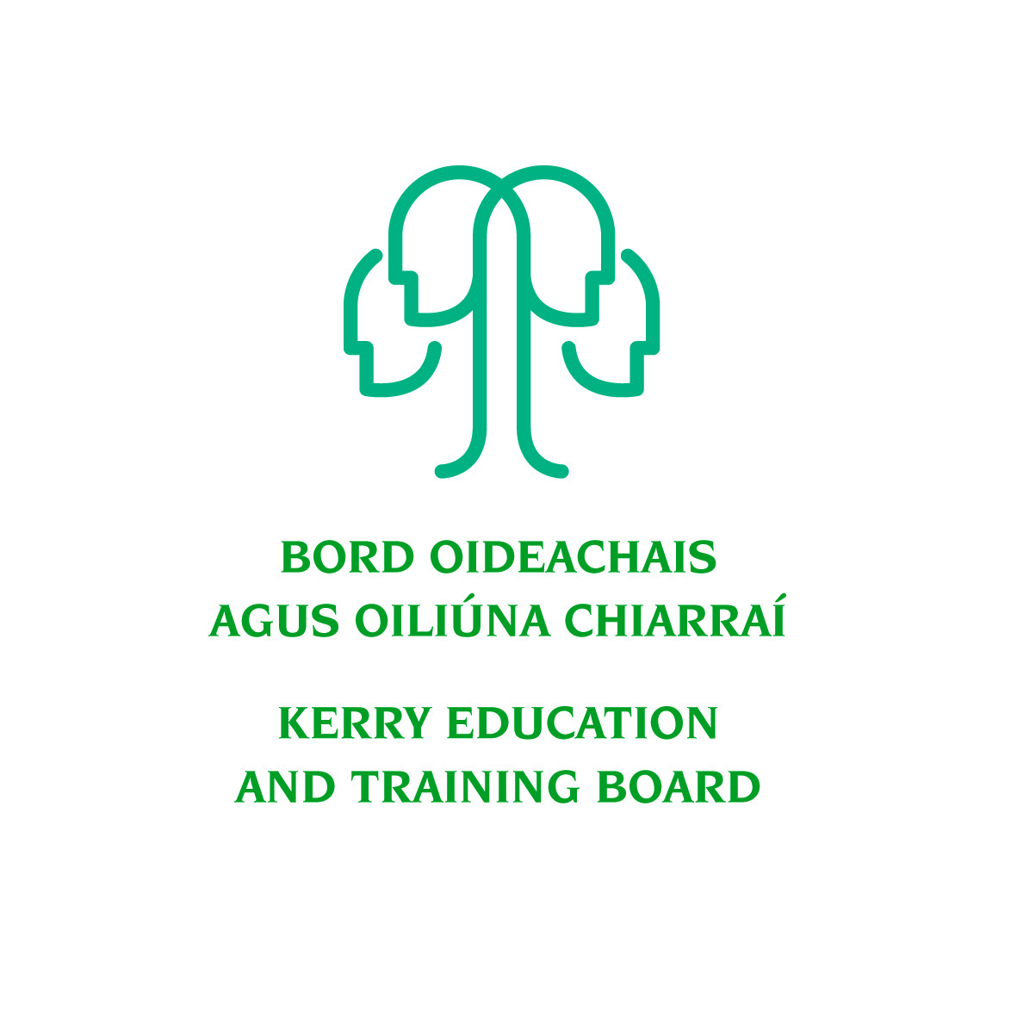
Kerry Adult Guidance and Information Service
Kerry ETB, Centrepoint, John Joe Sheehy Road, Tralee, Co. Kerry
Tel: 066 7121300; e-mail: guidance@kerryetb.ie
Web: www.kerryetb.ie/guidance

The Information Interview - What is it?

Purpose: The Purpose of the Information Interview is to get information. It is also the process of “Trying on Jobs to see if they fit you” –Richard Bolles, Author of What Color is Your Parachute

Informational Interviewing is designed to:
Produce information about a career/job field
- Opportunity to make personal contacts and get other contacts
- Learn how to break in and find out if you have what an employer is looking for to succeed
- Become aware of the employer needs
- Gain insight into the “hidden job market”
- Gain confidence in talking with people
- Find out what you need
- Get feedback on you CV
- Get feedback on what you still may need (training, education, experience)
- Get referrals to other contacts

Remember:
- You are in control of the interview.
- Never ask for a job, or if jobs are out there.
- Instead ask where the jobs opportunities are, and what is needed to be competitive.
- There is a good chance of getting offered work experience and/or a job from doing Information Interviews well.

The “Hidden” Job Market
What percentage of Jobs are “advertised” in papers, internet, etc.
- 30% maximum…but usually only around 10%

What percentage of job adverts are not real jobs? And why is this done?

Bottom line…about 10% of jobs are actually advertised

Five Worst Ways of Looking for a Job
(US Statistics)
- Looking for Employers’ Job Postings on the Internet (4-10% Success Rate; however note that Computer-related jobs are at 10% Success Rate, and the other c.20,000 job titles are at 4% Success Rate)
- Sending out CVs to Employers at Random (1-7% Success Rate)
- Answering Local Newspaper Ads (5-24% Success Rate)
- Answering Ads in Professional or Trade Journals (7% Success Rate)
- Going to Employment Agencies (5-28% Success Rate)

What is the “success rate” of Information interviews?
- Some studies show 12 Information Interviews = 1 Job Offer.

Remember:
- You are in control of the interview
- Never ask for a job or if jobs are out there.
- Instead ask where are the jobs opportunities and what is needed
Ways Typical Employer Prefers to Fill a Vacancy
Ways Typical Job Hunter Prefers to Fill a Vacancy
From Within the Business
Using Proof : (Job hunter that brings proof of abilities)
Using a best friend or Work or Business Colleague
Using an Agency
Using an Ad
Using a CV
Can You Spot the Difference?

Suggested Steps to an Information Interview

1. Identify an Occupation area of work
- Research and read ahead about an Occupation or career area for an information interview
- Decide what you want to ask and what information you want to get.
- Prepare a list of questions to have answered.

2. Identify People to Interview
Start with lists of people you already know
- Friends
- Present of former co-workers/supervisors/neighbours
- Use Professional organisations/trade unions etc.

3. Remember: Never ask for a job!
- Do not confuse information interviews with job seeking
- Sometimes interviewee will offer you work experience or job
- Let any job/work experience offer come from the employer

4. Research
- Research the Business/ Company or Organisation
- Company Website
- Business Literature

5. Prepare Ahead of Time for the Interview
- Ask questions that are appropriate and important to you
- Acknowledge the interviewee’s time and care in meeting with you.
- Keep number of questions to the time
- Ask for feedback or comments on your CV…you may want to send it in advance

6. Schedule the Information Interview (20 – 30 minutes max)
- Best to use a person’s name that knows the interviewee and referred you (also have the person who referred you inform the interviewee in advance)
- Contact by telephone or letter, or email
- Can make “cold contact” as well if needed

7. Present Yourself Well
- Dress Appropriately: Dress as if a regular job interview
- Be Prepared to Take Notes,
- Good Eye Contact and Posture
- Be positive and show your interest and enthusiasm
- Bring your CV with you…you may ask for feedback/identify needed training education for the position or area of work.
- Share something about yourself focused on your why you are interested in this area of work

8. Ask for Advice or Suggestions
- Ask for referral to other employers
- Ask permission to use their name in the referral

9. Send a Note of Thanks

10. Review and Follow-up
- What did I learn from this interview?
- How does what I learned fit with my own interests and abilities?
- Can I see myself working in this area?
- What do I still need to know?
- What next steps do I need take?

Side Note: Many who have used Information Interviews will say they have regained their self Confidence and sense of control.
How about you?

Remember:

“Success is 20% skill and 80% strategy”

Success lies in the opposite direction of the normal pull”

Tips in Arranging the Information Interview:

- Once you have the name of someone to contact, call and ask to speak with them. Arrange an information interview to answer your questions about that person’s area of work/career field.

- Be prepared for two problems:
- You might be a little nervous
- You will often be mistaken as a jobseeker on the telephone.

Nervous?
Be well organized
Make a list of the questions, and arrange in order.
Bring the list of questions with you, and use them to make short notes.
Practice with someone you know.

Mistaken as Job Seeker on the telephone?
Receptionist may want to know the purpose of your call.
Explain as clearly as you can that you are looking for information about an area of work. State that you are not looking for a job, just information to base a decision for yourself.

- Other Approach?
Send a letter and then follow up with a phone call.
In the letter, introduce yourself and what you would like to do.

Important: do not ask the interviewee to phone you…give them a timeframe to follow up with a phone call and arrange to meet…STAY IN CONTROL of the situation as much as possible!

Suggested Questions for the Information Interview

- What is your job like? What motivates you in this work?
- What do you do in a typical day?
- What is the most enjoyable part of the work?
- What is the most challenging part of the work?
- What interested you in this work?
- How did you get started in this work?
- How did you get this job?
- What jobs and experiences did you have to help get this job?
- What other jobs are there in this area of work?
- What kinds of changes are happening in this kind of work?
- What are the future challenges for this work?
- What are the most important skills or talents in this work?
- What are the perks of the job?
- What is the next step in your career?
- With the information you have about my education, skills and experience, what other fields or jobs would you suggest I explore?
- How is the economy affecting this area of work?
- Would you mind taking a look at my CV?

Sample Information Interview Questions – To keep it Brief, or if Nothing Else Comes to Mind!

- How did you get interested in this work and how did you get hired?

- What do you like most about this kind of work?

- What do you like least about this kind of work?

- What are the typical challenges or problems you have to deal with in this work?

- What are the key skills you need in this work?

Sample Letter Requesting an Information Interview

12 January 2018

Jennifer Hayes
Sales and Marketing
Anybusiness
Anywhere

Dear Ms Hayes,

I was referred to you by Mr. George Walshe, of XXXXXXX.

I am finishing a course in XXXX and am very interested in your area of work as a future career. I would be very appreciative if you could meet with me for a short 20-30 minute information interview. I believe your help in answering some questions about your career area would be really useful for me in planning my next steps.

I will contact your office during the week of January 18th to see if you would be able to meet me, and to set a mutually convenient time.

Sincerely,

Mary Doe
Useful References for Information Interviews
What Colour is Your Parachute? 2010 Edition – Richard Bolles

Quintessential Careers www.quintcareers.com

Careers Center, Florida State University www.career.fsu.edu/experience/information-interviews-guide.html

Other Useful Websites for Research, Self-Assessment, Course Searches, etc
www.careersportal.ie
Career exploration website which helps you to plan your career. Includes toolkit on: Self-Assessment; Employment Sectors; Occupational
Listing A-Z; Employer Profiles; Jobholder Interviews; and CAO Course Finder.

www.educationireland.ie
Information about studying in Ireland at any level. It gives details of the Irish education system, all the third-level institutes in the country and all the English language schools. It details the entry requirements for those coming from abroad and the application system. The website is available in a number of different languages.

www.fetchcourses.ie
Further Education and Training or FET, offers a wide variety of life-long education options to anyone over 18. FET includes apprenticeships, traineeships, Post Leaving Cert (PLC) courses, community and adult education as well as basic literacy and numeracy services.

www.kerryetb.ie
Lists all Kerry Education and Training Board Adult Education courses offered throughout the County, both full time and part-time. Also information on Grants and Bursaries.

www.qualifax.ie
Lists Adult Education and Third Level Education throughout Ireland. Search by key word, or by occupational interest, also includes CAO Points Calculator, Grant and Bursary information, Career Interest Inventory Assessment.

