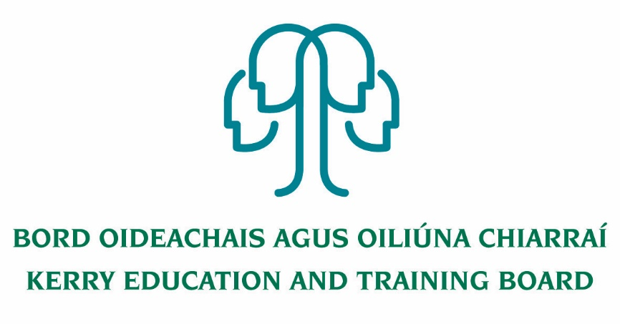

Job Description
Community Education Tutor Pool – Kerry ETB

Nature of Post
For the establishment of a Community Education Tutor pool to provide tutoring in the areas of community education outlined on the main job advert.

An applicant’s inclusion on the pool is not an offer of employment.

Salary Scale:
Salary will be paid in accordance with such rates for Tutors as may be authorised by the Department of Education and the Department of Further and Higher Education, Research, Innovation and Science

Location
An appointment is to the Scheme – Kerry ETB reserves the right to assign a staff member to any other location, as the service exigencies require.

Tutor’s principal place of work will be dependent on the programme to which they are assigned which may be in any centre in which any one of the Further Education and Training part-time programmes operate. Tutors may also be placed in other settings identified to provide the necessary support to students.

Hours of Work
The hours of work and the normal place of work will be agreed upon with the relevant Adult Education Officer/Director of Further Education and Training. As a tutor is employed in the Kerry ETB scheme as a whole, this does not preclude the delivery of hours in other areas.

The tutor will work to a timetable for the delivery of the assigned programme(s) and record their attendance by whatever system is prescribed. The tutor is expected to arrive at a reasonable time before the commencement of each class so that it can start on time. Attendance at continuous professional development opportunities provided by Kerry ETB may be required from time to time.

Reporting/Accountability Relationship
Tutors are accountable and subject to the direction and management on a day to day basis of the relevant Adult Education Officer/Director of Further Education and Training in which they are timetabled for their duties as far as they relate to the role as a Tutor.

The Tutor is an employee of the Kerry ETB and the general terms and conditions of employment will apply. Tutors must comply with all of the requirements of the relevant Department as well as Kerry ETB requirements.

The Role of the Tutor for this post and key areas of responsibility will include the following:

- To develop a course plan.
- To endeavour to ensure that participation in the course is a positive learning experience for all.
- The tutors facilitate a needs-based programme that is creative, challenging and respectful
- To review modes of delivery to ensure a ‘good fit’ between teaching methodologies and identified learner needs.
- To report any attendance issues to the programme coordinator.
- To carry out an evaluation at the end of the course.
- To keep records for Kerry ETB registration forms are maintained detailing attendance and where relevant certification and progression. This documentation is to be kept safely and confidentially
- To update the attendance register each week.
- To be responsible for the safekeeping of documents including Registration Forms, Attendance Sheets and Evaluation forms.
- To ensure that the Guidelines for best practice are adhered to.
- Contribute to the setting of organisational tone through policies and the development and promotion of good internal controls in relevant areas of responsibility.
- To carry out the lawful orders of the Chief Executive Officer, and to fulfill the rules and requirements of the Minister for Further and Higher Education Research Innovation and Science.
- Carry out any other duties appropriate to the grade which may be assigned from time to time.
- The above list of accountabilities may be varied having regard to the changing needs of the Scheme and the terms of the post can include delivery of responses to unpredictable work demands as they arise

Person specification for Community Education Tutor

Essential
Knowledge of Community Education and its role in Adult and Further Education
An understanding of informal learning and its role in society
Experience in Teaching adults, an understanding and appreciation of the challenges of adults returning to learning
Experience in working with and teaching disadvantaged groups
An ability to facilitate the learning group to identify further learning needs
Experience in working in community settings and availability to tutor in the evenings.

Desirable
An Understanding of the ETB and recent changes
An appreciation of QQI, progression, accreditation etc.
Literacy awareness,
Irish language
Curriculum development experience or proof of the same

Qualifications
Accreditation as recognised by QQI in area/subject of expertise,
Qualification in teaching adults
Other relevant courses, training

