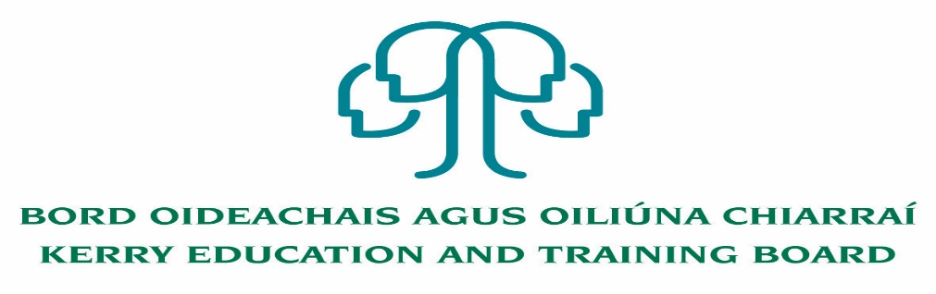

Kerry Education & Training Board wishes to recruit committed, enthusiastic and talented educators to its team of teachers and educational leaders. We provide a quality comprehensive education & training service in eight second level schools, two Further Education colleges, Kerry ETB Training Centre, five adult education and training centres and through a wide range of community-based adult and further education and training programmes.

**Teaching Posts**

Applications are invited for the following Fixed Term/Specific Purpose teaching post (s), under the aegis of Kerry Education & Training Board which may arise in the school year 2020/2021 (all appointments are to Kerry ETB – centre of first assignment is indicated here for the assistance of applicants). All vacancies are subject to the Directors of Redeployment agreeing to the posts being filled, following completion of the 2020 Scheme. A panel may be formed from these competitions from which appointments may be made in 2020/2021

**Hours**

**Killorglin Community College**

KOS 20.21.43 Learning Support 22

KOS 20.21.44 Religion (experience of teaching SEN is an advantage) 11

**Castleisland Community College**

CIS 20.21.45 Irish (Experience of teaching Geography is an advantage) (Maternity leave Cover) 22

**A Teacher Education qualification is a requirement.**

---------------------------------------------------------------------------------------------------------------------------------------Candidates proposed for appointment with Kerry Education & Training Board must be registered in accordance with Section 31 of the Teaching Council Act, 2001.

***Applicants are requested to submit Confirmation of Teaching Council Registration outlining subjects qualified to teach and proof of current registration with their application form.***

---------------------------------------------------------------------------------------------------------------------------------

*Please complete application form which can be downloaded from our website www.kerryetb.ie/opportunities and return by email only to* [*jobs@kerryetb.ie*](mailto:jobs@kerryetb.ie)*. No C.V.’s, only official application form will be accepted.*

*Applications by* ***email only*** *must be received not later than 12 noon Wednesday 2nd September 2020*

*Please complete application form, including reference form, for the post(s) you are applying for*

***Colm Mc Evoy***

***Chief Executive Officer***

**Kerry Education & Training Board services Gaeltacht areas.**

**Cuirfear fáilte roimh chomhfhreagras i nGaeilge.**

**Garda Vetting of successful candidates will take place prior to offer of employment.**

**Canvassing will automatically disqualify.**

**Short-listing will take place on the basis of the information provided in the application form. Depending on the qualifications and experience of applicants, short-listing thresholds may be higher than the minimum standards set out.**

###### Kerry Education & Training Board is an equal opportunities employer.

*“Creating a Learning Society in Kerry”*

