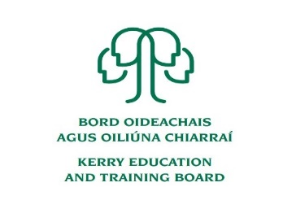

Kerry Education and Training Board (Kerry ETB) is a statutory education and training authority for County Kerry, established in accordance with the provisions of the Education and Training Boards Act 2013. Kerry ETB is a provider of Primary, Post Primary and Further Education and Training services in Co. Kerry. The ETB has over 1,100 employees, an annual budget of circa €52 million, 36 Centres of Education and Training, with the organisation’s Head Office located in Tralee, Co. Kerry.

**Supervisor Pool for Kerry ETB Schools**

**Kerry Education & Training Board**

Kerry Education and Training Board invites applications for inclusion on the above which may arise (all appointments are to Kerry ETB)

**Essential Criteria**

* Satisfactory Garda Vetting
* Successful completion of TUSLA Children First E-Learning Programme

**Desirable Criteria;**

* Experience of working with young people in a community context e.g. sports coaching, youth club work etc.

---------------------------------------------------------------------------------------------------------------------------------------

Application forms for this pool can be downloaded from [www.kerryetb.ie/opportunities or contact the H.R](http://www.kerryetb.ie/opportunities%20or%20contact%20the%20H.R). Department, Kerry ETB, Centrepoint, John Joe Sheehy Road, Tralee, Co. Kerry. Tel. 066-7121488.

Please complete an application form and return by email only to jobs@kerryetb.ie. No C.V.’s, only official application form will be accepted. Applications must be received not later than 12 noon Friday 11th September 2020.

***Colm Mc Evoy***

***Chief Executive Officer***

Kerry Education & Training Board services Gaeltacht areas.  
Cuirfear fáilte roimh chomhfhreagras í nGaeilge.  
Garda Vetting of successful candidates will take place prior to offer of employment.  
Canvassing will automatically disqualify.   
Short-listing will take place on the basis of the information provided in the application form. Depending on the qualifications and experience of applicants, short-listing thresholds may be higher than the minimum standards set out.

Kerry Education & Training Board is an equal opportunities employer.

*“Creating a Learning Society in Kerry”*

