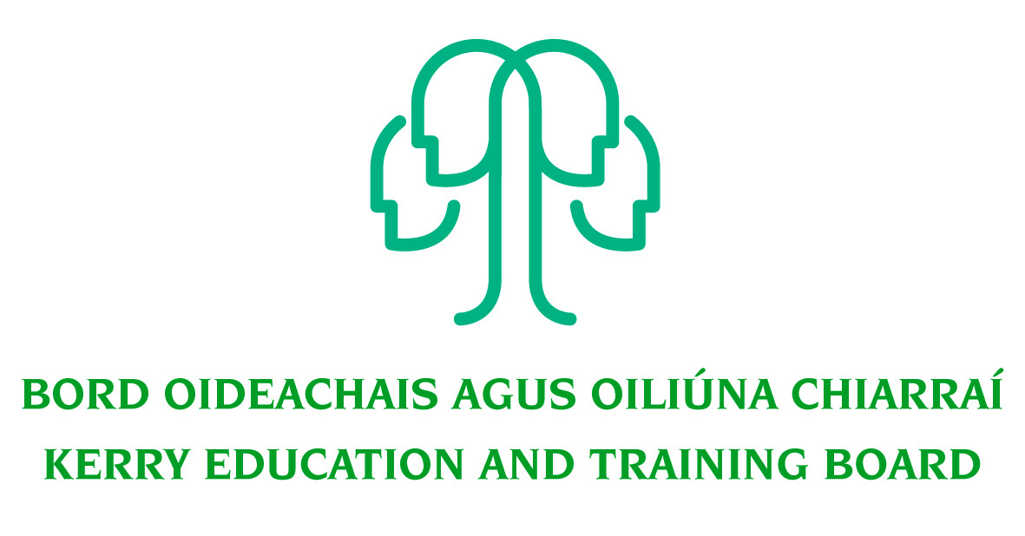

Kerry Education & Training Board wishes to recruit committed, enthusiastic and talented educators to its team of teachers and educational leaders. We provide a quality comprehensive education & training service in eight second level schools, two Further Education colleges, Kerry ETB Training Centre, five adult education and training centres and through a wide range of community-based adult and further education and training programmes.

Substitute Teachers Pool – North and South Kerry Panels

Kerry Education & Training Board invites applications for the above panels for our eight Second Level Schools and Further Education Programmes. This panel will be used for the filling of casual part-time teaching posts which may arise at short notice during 2020/2021.
------------------------------------------------------------------------------------------------------------------------
Candidates proposed for appointment with Kerry Education & Training Board must be registered in accordance with Section 31 of the Teaching Council Act, 2001.
Applicants are requested to submit confirmation of Teaching Council registration status and subjects qualified to teach with their application form. Garda Vetting of substitute teachers will take place prior to inclusion on the sub pool.

For further details please contact the HR Department, Kerry Education & Training Board, Centrepoint, John Joe Sheehy Road, Tralee, Co. Kerry. Tel. 066-7121488, Fax 066-7117572,
Email jobs@kerryetb.ie.

Kerry Education & Training Board services Gaeltacht areas.
Cuirfear fáilte roimh chomhfhreagras i nGaeilge.
Garda Vetting of successful candidates will take place prior to offer of employment.
Canvassing will automatically disqualify.
Short-listing will take place on the basis of the information provided in the application form. Depending on the qualifications and experience of applicants, short-listing thresholds may be significantly higher than the minimum standards set out.

Kerry Education & Training Board is an equal opportunities employer.
“Creating a Learning Society in Kerry”

