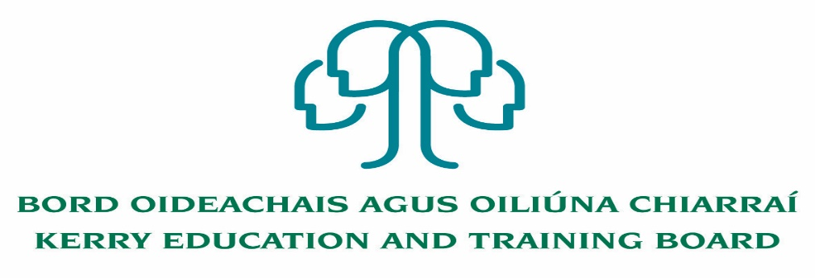

Kerry Education & Training Board wishes to recruit committed, enthusiastic and talented educators to its team of teachers and educational leaders. We provide a quality comprehensive education & training service in eight second level schools, two Further Education colleges, Kerry ETB Training Centre, five adult education and training centres and through a wide range of community-based adult and further education and training programmes.

**Substitute Teachers Pool – North and South Kerry Panels**

Kerry Education & Training Board invites applications for the above panels for our eight Second Level Schools and Further Education Programmes. This panel will be used for the filling of casual part-time teaching posts which may arise at short notice.

------------------------------------------------------------------------------------------------------------------------

Candidates proposed for appointment with Kerry Education & Training Board must be registered in accordance with Section 31 of the Teaching Council Act, 2001.

*Applicants are requested to submit confirmation of Teaching Council registration status and subjects qualified to teach with their application form.* Garda Vetting of substitute teachers will take place prior to inclusion on the sub pool.

**Kerry Education & Training Board services Gaeltacht areas.**

**Cuirfear fáilte roimh chomhfhreagras i nGaeilge.**

**Garda Vetting of successful candidates will take place prior to offer of employment.**

**Canvassing will automatically disqualify.**

**Short-listing will take place on the basis of the information provided in the application form. Depending on the qualifications and experience of applicants, short-listing thresholds may be significantly higher than the minimum standards set out.**

###### Kerry Education & Training Board is an equal opportunities employer.

*“Creating a Learning Society in Kerry”*

