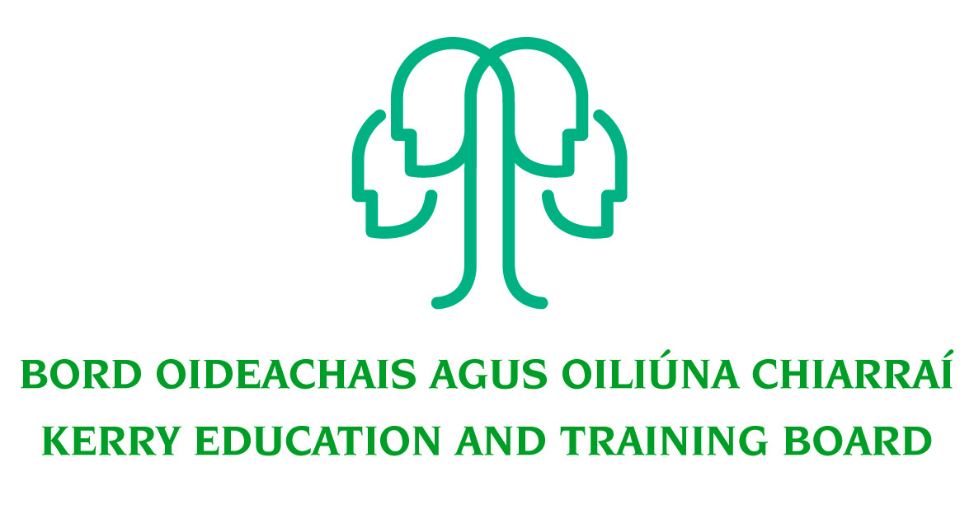

Special Needs Assistant Pool
Various Kerry ETB Schools

Applications are invited for a Special Needs Assistant Pool, under the aegis of Kerry Education & Training Board for substitution posts which may arise in the school year 2021/2022 (all appointments are to Kerry ETB).

To qualify for appointment, candidates must have:
- Practical work experience in Second level system/Further Education/Primary School

Candidates should possess:
- Organisational, good communication and interpersonal skills
- Familiarity with Second level curriculum.
- Ability to support and enhance educational experience for children with Special Educational Needs (SEN) who present in Kerry Education and Training Board Schools.
- A commitment to creating a safe supported environment for students with SEN needs
- A good understanding of recent developments in SEN in Ireland particularly the legislation as it pertains to the Education for persons with SEN Act 2004.
- Competency in the Irish Language will be a requirement in relevant schools.
- TUSLA Child First Training – Certificate of completion
- Current First Aid Responder Certification
- Current Manual Handling Certification
Desirable
- Completed QQI Level 5 Full Award or equivalent in childcare or equivalent Special Needs qualification
- Medical/Healthcare experience
- Excellent ICT Skills
- Competency in the use and understanding of Sign Language

Application forms for this pool can be downloaded from www.kerryetb.ie/opportunities or contact the H.R. Department, Kerry ETB, Centrepoint, John Joe Sheehy Road, Tralee, Co. Kerry. Tel. 066-7121488.

Please complete an application form and return by email only to jobs@kerryetb.ie. No C.V.’s, only official application form will be accepted.

Kerry Education & Training Board services Gaeltacht areas.
Cuirfear fáilte roimh chomhfhreagras i nGaeilge.
Garda Vetting of successful candidates will take place prior to offer of employment.
Canvassing will automatically disqualify.
Short-listing will take place on the basis of the information provided in the application form. Depending on the qualifications and experience of applicants, short-listing thresholds may be significantly higher than the minimum standards set out.

Kerry Education & Training Board is an equal opportunities employer.
“Creating a Learning Society in Kerry”

