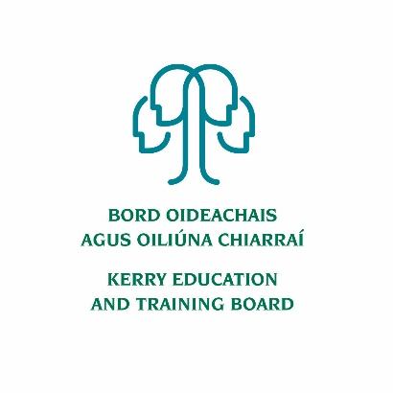
Kerry ETB Board Members

The term of office for the new Board of Kerry ETB came into effect on 26th July 2019.

In accordance with the Education and Training Boards Act 2013, membership of the Board of Kerry ETB is as follows:

- 12 members elected by the local authority
- 2 staff representatives
- 2 parent representatives
- 5 members with interest or knowledge in education and training

The following representatives have been appointed as members of the Board of Kerry ETB

Name | Nominating Body
Cllr. Jim Finucane | Kerry County Council
Cllr. Terry O’Brien | Kerry County Council
Cllr. Deirdre Ferris | Kerry County Council
Cllr. Cathal Foley | Kerry County Council
Cllr. Michael Cahill | Kerry County Council
Cllr. Fionnán Fitzgerald | Kerry County Council
Cllr. Johnnie Wall | Kerry County Council
Cllr. Norma Moriarty | Kerry County Council
Cllr. Marie Moloney | Kerry County Council
Cllr. Maura Healy-Rae | Kerry County Council
Cllr. Niall O’Callaghan | Kerry County Council
Cllr. Aoife Thornton | Kerry County Council
Mr. Joseph Brennan | Staff Representative
Ms. Celia O’Shea | Staff Representative
Ms. Tara Donoghue | Parent Representative
Mr. Niall Lucey | Parent Representative
Mr. Tim Daly | Representative of Bodies with Special Interest in, knowledge of education and training
Mr. Zaid Kassoob | Representative of Bodies with Special Interest in, knowledge of education and training
Ms. Joan McCrohan | Representative of Bodies with Special Interest in, knowledge of education and training
Mr. John O’Roarke | Representative of Bodies with Special Interest in, knowledge of education and training
Ms. Maria O’Gorman | Representative of Bodies with Special Interest in, knowledge of education and training

