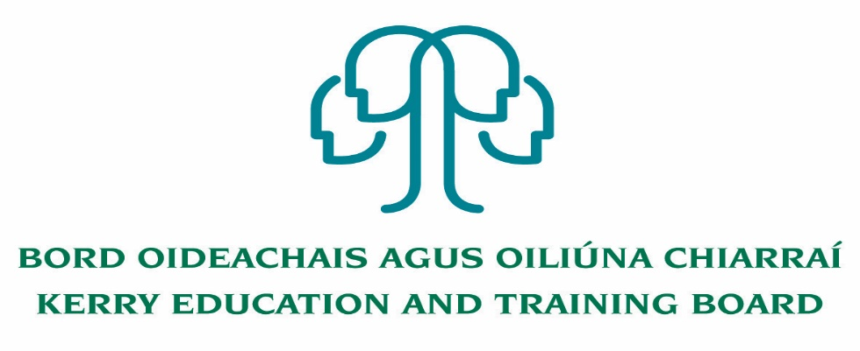
Job Description

Job Title: Resource Person – Initial Assignment to Adult Literacy and Basic Education Programme
(Tuition will form part of the post proposed 7 hours)

Hours of Attendance:
The post is a full time 5 days per week (35 Hours). Attendance shall be at such times as necessary for the delivery of the service including attendance outside of normal office hours as required. This post will include a combination of both tuition & administration duties.

Location:
Appointment is to the Scheme – Kerry ETB reserves the right to assign a staff member to any other location, as the service exigencies require. Centres of first assignment will be
Kerry Education and Training Board, Adult Literacy and Basic Education Centre, Liber House, Monavalley Industrial Estate, Tralee, Co Kerry

Duration:
This post is specific purpose to cover a staff member on leave.

Reporting/Accountability Relationships:
The post holder will report to the Adult Literacy Organiser/Adult Education Officer/Director of Further Education and Training.

This post requires flexibility as the Resource Worker will perform varied tasks at different locations.

Combination of daytime and evening hours: Post Holder must be prepared to work some evenings and occasional weekends as the work will require visits to various locations including various outreach locations where adult literacy and basic education is delivered. Post Holder must have own transport and a full driving license. He or she is not only involved in delivering tuition hours duties but also expected to operate as part of a team and contribute to the overall growth of the Kerry ETB Adult & Further Education & Training Sector.

General Responsibilities:

- Supporting the ALO with the preparation of the annual reports for the delivery of the ABE Programme in Kerry for approval and implementation. Initial responsibility will be for the ESOL programme.
- Supporting Programme Planning, Administration and on-going Evaluation of the programmes in accordance with the Kerry ETB, FET Strategy Plan. All new course initiatives must be referred to the ALO for recommendation to the AEO for approval in accordance with agreed protocol.
- Assisting the ALO with sourcing suitable accommodation and ensuring organisational arrangements are in place for the delivery of quality teaching
and learning. Decisions in respect of utilising new venues for the Programme must be approved by the AEO/Director of Further Education.
- To ensure Kerry ETB Quality Assurance Procedures are implemented for all programmes.
- To schedule courses on PLSS and assist the ALO in the management of learners on PLSS.
- Assist the ALO in checking Class Registers and managing tutor payments on DCS
- Assisting the ALO to maintain files on programme content.
- To support the ALO with curriculum development, useful resources for tutors including contributions to the Kerry ETB annual newsletter.
- To assist the ALO in the organisation of CPD for tutors and volunteer tutors
- To support the ALO in the marketing of ABE programmes.
- Liaise with the relevant voluntary and statutory bodies, including the literacy referral networks.

Administration Matters:
- Assist the ALO in day to day administration, planning, delivery and evaluation of the Programme.
- Carry out initial assessment of learners.
- To collaborate with the ALO on all administration matters relating to the Programme.
- In the absence of the ALO, deal with queries from the public, tutors and learners where appropriate.
- To assist the ALO in ensuring that learners registered on all courses meet the criteria as per the Department of Education and SOLAS Guidelines. To assist the ALO, when required with the enrolment of learners for day/evening classes.
- To assist the ALO in ensuring that learner data is recorded on the PLSS on-line Learner Record.
- Assist the ALO with the preparation of reports.
- To support the ALO on all dealings with QQI Requirements specific to the Kerry ETB Programme.
- Assist the ALO to ensure that the documentation and procedures in relation to QQI/certification are properly administered in compliance with Kerry ETB Quality Assurance Procedures.
- Support the ALO with the preparation of Implementation Reports for SOLAS.
- Assist the ALO with the preparation of internal bi-annual Course Activity Reports in preparation for the submitting of the Annual Course Activity Report.
- Assisting the ALO with organisation of Special Events including Presentation of Certificates/Information days, staff in-service and CPD.
- To ensure all learner assessment documentation is submitted by tutors, recorded and checked in compliance with Kerry ETB Quality Assurance Procedures.
- Assist the ALO with the Internal Verification Process.
- Assist the ALO with the External Authentication process.
- Attend appropriate in-service training as directed by the ALO/AEO.
- Carry out any other duties appropriate to the grade which may be assigned from time to time.

The above list of accountabilities may be varied having regard to the changing needs of the Scheme and the terms of the post can include delivery of responses to unpredictable work demands as they arise.

Person Specification

Selection Criteria
Selection criteria outline the qualifications, skills, knowledge and/or experience that the successful candidate must demonstrate for successful discharge of the responsibilities of the post. Applications will be assessed on the basis of how well candidates satisfy these criteria.

Essential Criteria
- Recognised primary degree
- Minimum of 2 years tutoring experience
- Experience of QQI assessment protocols and procedures
- Excellent ICT skills/experience (including database, data analysis and spreadsheets, other MIS systems)
- Full clean driving Licence

Desirable Criteria
- NALA/WIT National Certificate in Training & Development or equivalent Adult Education Qualification as approved by the Department.
- Good planning and organisational skills
- High level of interpersonal and communication skills
- Good time management skills and ability to work on own initiative
- Commitment to Kerry ETB core values: Respect, Quality, Equality, Inclusion and Learning.

Competencies Required
Kerry ETB Core Values of Respect, Quality, Equality, Inclusion and Learning are the guiding principles of the organisation and underpin the competencies required to fulfil this role.

Specialist Knowledge, Expertise & Self Development
- Clearly understands the role, objectives and targets and how they fit into the work of the organisation.
- Understands the boundaries of professional practice
- Develops the expertise necessary to carry out the role to a high standard and shares this with others
- Demonstrates knowledge of child protection policy and practice
- Understands and shows commitment to the purpose of Kerry Education and Training Board and to work within the values, policies and procedures of the organisation and in the context of current legislation and regulations
- Has expertise in his/her field that is recognised and utilised by colleagues

Administrative & Technical Skills
- Experience in Microsoft Office (Word, Excel, Access & PowerPoint etc.)
- Experience of communication via information technology
- Experience of maintaining accurate paper and electronic record systems
- Experience of working to multiple deadlines.

Delivery of Results
- Plans and prioritises work in terms of importance, timescales and other resource constraints, re-prioritising in light of challenging circumstances
- Assumes responsibility for and delivers on agreed objectives / goals
- Effectively manages multiple projects
- Ensures all outputs are delivered to a high standard and in an efficient manner
- Uses resources effectively, challenging processes to improve efficiencies.
- Is self-reliant and uses judgement on when to seek guidance and from whom.

Teamwork
- Experience of working effectively in a team environment
- Develops and maintains good working relationships with others, sharing information and knowledge, as appropriate
- Maximises the contribution of the team, encouraging ownership, providing support and working effectively with others
- Contributes to the development of policies in own area and the wider organisation

Interpersonal & Communication
- Communicates in a fluent, logical, clear and convincing manner verbally and in writing
- Is able to listen effectively and develop a two-way dialogue quickly
- Experience in motivating people
- Maintains a strong focus on meeting the needs of service users
- Effectively influences others to take action
- Works to establish mutual understanding to allow for collaborative working

Drive & Commitment
- Is self-motivated and shows a desire to continuously perform at a high level
- Must be flexible and prepared to work outside normal hours as required.
- Has the ability to think logically, use initiative and work with minimum supervision.
- Have a flexible approach to the work in response to organisational change, development and review of best practice
- Through leading by example, fosters high standards of ethics and integrity

