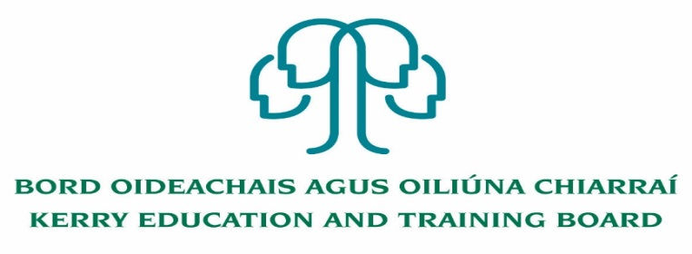

Kerry Education and Training Board (Kerry ETB) is a statutory education and training authority for County Kerry, established in accordance with the provisions of the Education and Training Boards Act 2013.

Kerry ETB is a provider of Primary, Post Primary and Further Education and Training services in Co. Kerry. The ETB has c. 1,300 employees, an annual budget of c. €82 million, c.37 Centres of Education and Training with the organisations Head Office located in Tralee, Co. Kerry.

**Resource Person Pool**

**Kerry ETB Youthreach Programmes Tralee, Killarney and Listowel**

Kerry Education and Training Board invites applications for inclusion on the above Resource Person Pool which may arise (all appointments are to Kerry ETB).

* Successful candidates will be placed on a Resource Person Pool for Youthreach Programmes in Tralee, Killarney and Listowel.
* Successful candidates may be assigned to schools, further education and training centres or other centres where Resource Persons may be required.
* An applicant’s inclusion on the pool is not an offer of employment. Hours will be assigned for Resource Person posts that may arise.
* Garda Vetting will take place prior to inclusion on the Resource Person Pool.

Application form for the above pool is available from our website [www.kerryetb.ie/opportunities.html](http://www.kerryetb.ie/opportunities.html).

No closing date applies for application.

-------------------------------------------------------------------------------------------------------------------------------------------

Please complete an application form and **return by email only** to jobs@kerryetb.ie.

*Colm Mc Evoy*

*Chief Executive*

**Kerry Education & Training Board services Gaeltacht areas.**

**Cuirfear fáilte roimh chomhfhreagras í nGaeilge.**

**Garda Vetting of successful candidates will take place prior to offer of employment.**

**Canvassing will automatically disqualify.**

**Short-listing will take place on the basis of the information provided in the application form. Depending on the qualifications and experience of applicants, short-listing thresholds may be higher than the minimum standards set out.**

###### Kerry Education & Training Board is an equal opportunities employer.

*“Creating a Learning Society in Kerry”*

