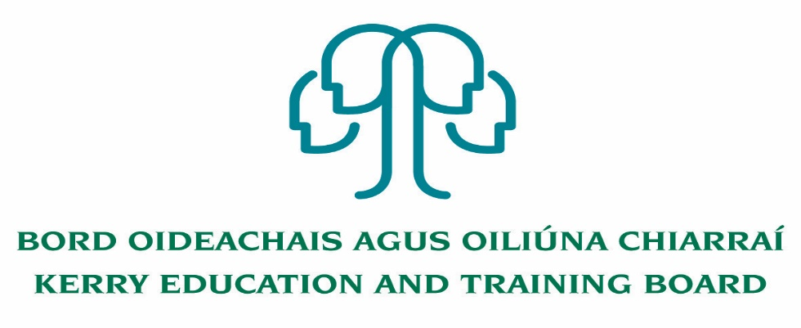

**Readvertisement**

**Communications Support Assistant Post**

**Kerry Education & Training Board**

Applications are invited for a Communications Support Assistant post under the aegis of Kerry Education & Training Board which may arise in the school year 2020/2021 (all appointments are to Kerry ETB – centre of first assignment is indicated here for the assistance of applicants). A panel may be formed from this competition from which appointments may be made in 2020/2021

**Kerry College**

Essential Criteria

* High Proficiency in ISL
* Ability to convert verbal instructions from teachers and peer contributions to sign language
* Ability to relay teacher instruction and curriculum to students
* Ability to communicate with staff and other students on curriculum issues on behalf of student
* Awareness and understanding of the post primary curriculum
* Ability to translate all verbal communications to Sign Language
* Ability to work as part of a team

Desirable Criteria

* Experience of working in FET environment
* Completed QQI Level 5 in a relevant area

Rate of pay: €23,587 - €39,110

--------------------------------------------------------------------------------------------------------------------------------------------------

Conditions of Service, Terms of Appointment, details regarding Qualifications and Salary Scale are in accordance with the regulations of the Department of Education & Skills.

Please complete application form which can be downloaded from this website www.kerryetb.ie/opportunities and return by email only to [jobs@kerryetb.ie](mailto:jobs@kerryetb.ie). No C.V.’s, only official application form will be accepted.

Applications by email only must be received not later than 12 noon Monday 9th November 2020.

**Kerry Education & Training Board services Gaeltacht areas.**

**Cuirfear fáilte roimh chomhfhreagras i nGaeilge.**

**Garda Vetting of successful candidates will take place prior to offer of employment.**

**Canvassing will automatically disqualify.**

**Short-listing will take place on the basis of the information provided in the application form. Depending on the qualifications and experience of applicants, short-listing thresholds may be higher than the minimum standards set out.**

###### Kerry Education & Training Board is an equal opportunities employer.

*“Creating a Learning Society in Kerry”*

