]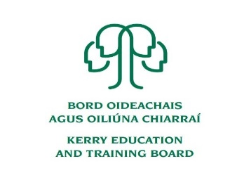

Kerry Education and Training Board (Kerry ETB) is a statutory education and training authority for County Kerry, established in accordance with the provisions of the Education and Training Boards Act 2013. Kerry ETB is a provider of Primary, Post Primary and Further Education and Training services in Co. Kerry. The ETB has over 1,100 employees, an annual budget of circa €52 million, 36 Centres of Education and Training, with the organisation’s Head Office located in Tralee, Co. Kerry.
Readvertised
Adult Educator Pool

Kerry Education and Training Board invites applications for inclusion on the above Pool which may arise (all appointments are to Kerry ETB – centre of first assignment is indicated here for the assistance of applicants). We are seeking applications from individuals who have qualifications and/or skills in a variety of disciplines:

Further Education & Training Centre
Cahersiveen and Causeway

- ICT 8. Biodiversity
- Beekeeping 9. Healthcare (Nursing Skills)
3. Garden design 10. Horticulture
4. Arts & Crafts 11. Woodwork
5. Start your own Business 12. Animal Care (Grooming)
6. Childcare 13. Train the Trainer
7. Sign Language 14. Payroll

An applicant’s inclusion on the pool is not an offer of employment. Hours will be assigned for casual part-time tutor posts that may arise.

Garda Vetting will take place prior to inclusion on the Pool.

---------------------------------------------------------------------------------------------------------------------------------------
Application forms can be downloaded from www.kerryetb.ie/opportunities or contact the H.R. Department, Kerry ETB, Centrepoint, John Joe Sheehy Road, Tralee, Co. Kerry. Tel. 066-7121488.
Please complete an application form and return by email only to jobs@kerryetb.ie. No C.V.’s, only official application form will be accepted.
Applications must be received not later than 12.00 noon Thursday 4th February 2021
Colm Mc Evoy
Chief Executive Officer

Kerry Education & Training Board services Gaeltacht areas.
Cuirfear fáilte roimh chomhfhreagras í nGaeilge.
Garda Vetting of successful candidates will take place prior to offer of employment.
Canvassing will automatically disqualify.
Short-listing will take place on the basis of the information provided in the application form. Depending on the qualifications and experience of applicants, short-listing thresholds may be higher than the minimum standards set out. Kerry Education & Training Board is an equal opportunities employer.
“Creating a Learning Society in Kerry”

