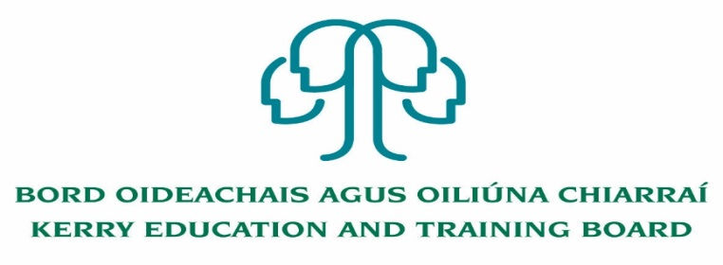

Principal (PWT)
Coláiste Na Ríochta
Roll No. 70500P
Category IX Principal Allowance

Kerry Education & Training Board invites applications for the post of Principal for Coláiste na Ríochta

This senior management post will afford the appointee an opportunity to lead teams to deliver and enhance quality education services in the Kerry area and to act as part of the senior management team in Kerry Education & Training Board.

To qualify for appointment candidates must have:
- A Recognised Post-Primary Teaching Qualifications.
- A qualification in Post Primary Teacher Education or equivalent.
- A minimum of five years’ whole-time satisfactory teaching service or its equivalent.
- Satisfactory experience of leadership, management and administration at a sufficiently high level.

Conditions of Service, Terms of Appointment, Qualifications, Salary Scales and Allowances are in accordance with the regulations of the Department of Education.

Colm Mc Evoy
Chief Executive Officer
-------------------------------------------------------------------------------------------------------------------------------------------

Application forms and full details may be obtained from the H.R. Department, Kerry ETB, Centrepoint, John Joe Sheehy Road, Tralee Tel. 066-7121488

Please complete an application form and return by email only to jobs@kerryetb.ie. No C.V.’s, only official application form will be accepted. Applications must be received not later than 12 noon Friday 11th September 2020.

Kerry Education & Training Board services Gaeltacht areas.
Cuirfear fáilte roimh chomhfhreagras i nGaeilge.
Garda Vetting of successful candidates will take place prior to offer of employment.
Canvassing will automatically disqualify.
Short-listing will take place on the basis of the information provided in the application form. Depending on the qualifications and experience of applicants, short-listing thresholds may be higher than the minimum standards set out.

Kerry Education & Training Board is an equal opportunities employer.
“Creating a Learning Society in Kerry”

