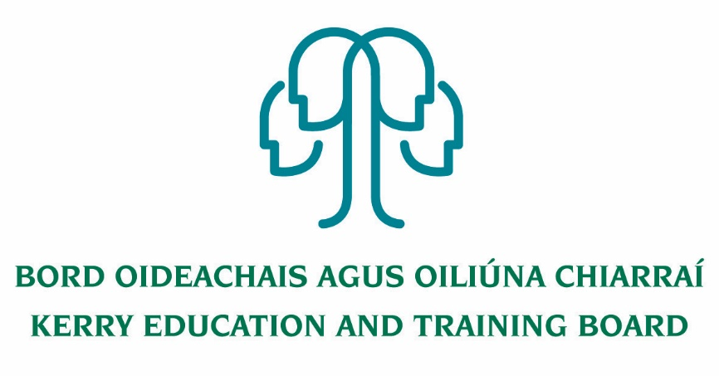
Person Specification
Deputy Principal (PWT)
Kerry College
Roll number: 76494H Category XVI

To qualify for appointment candidates must have:

Essential Criteria:
- A recognised post-primary teaching qualification.
- A minimum of five years’ whole time satisfactory teaching service or its equivalent.
- Registration in accordance with Section 30 of the Teaching Council Act 2001.
- Satisfactory experience of leadership, management and administration at a sufficiently high level.

Core Competencies Required:
Leader – Teaching and Learning
- Understands that high quality teaching and learning is the core business of the College and demonstrates the skills to act as the instructional leader.

Leader – College Development
- Demonstrates the ability to take a broad and long term view of the needs of the College’s purpose and objectives.

Leader – People and Teams
- Demonstrates the willingness and ability to develop individuals and teams throughout the College community and delegate leadership within those teams and individuals.

Organisational Management and Administrative Skills
- Uses a range of resources, supports and processes to ensure the effective and efficient running of the College.

Strategic Development and Management Skills
- Demonstrates the ability to take a broad and long term view of the needs of the College’s purpose and objectives and ability to manage change effectively.

Self-Awareness and Self-Management
- Is self-aware and has the capacity to self-manage and develop personally and professionally.

A clear vision for the development of Education in Kerry
- Shows understanding of current and education needs in the area and strategy to respond to education and training needs.

Commitment to Professional Development.
- Shows commitment to continuous professional development and will participate in regular professional development and has the ability to assess and respond to staff professional development needs.

Communication
- The capacity to clearly articulate views, opinions and attitudes through effective and appropriate and empathic interaction with all stakeholders in a variety of situations and contexts.

Commitment to Kerry ETB Core Values
- Shows commitment to the Core Values of Kerry ETB of Respect, Quality, Equality, Inclusion and Learning.
- Shows commitment to inclusive teaching practices and to ensuring that the College prevents and combats discrimination
- Create and maintain a climate of respect and fairness for all staff and students

Profile
The successful candidate will:
- have a clear vision for the development and expansion of modern College of Further Education and Training where all courses are delivered to the highest standards to meet leaner needs flexible manner
- be a leader, committed to the highest standards of education and training provision, administration and governance
- have a passion for education and training
- have strong people management and organisation skills
- be a visionary and have experience in delivering projects through team work
- be community minded and conscious of the role the college plays in the local community and the wider ETB
- have significant experience of leading change and change management

