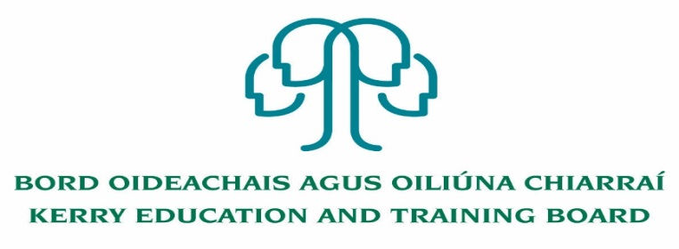

Person Specification
Special Needs Assistant Post

Nature of Post: CID Part time – 16 hours per week

Location: Kerry ETB Tahilla Community National School

To qualify for appointment, candidates must have:
- Practical work experience in Primary/Second level system

Candidates should possess:
- Organisational, good communication and interpersonal skills
- Familiarity with Primary /Second level curriculum.
- Ability to support and enhance educational experience for children with Special Educational Needs (SEN) who present in Kerry Education and Training Board Schools.
- A commitment to creating a safe supported environment for students with SEN needs
- A good understanding of recent developments in SEN in Ireland particularly the legislation as it pertains to the Education for persons with SEN Act 2004.
- Competency in the Irish Language will be a requirement in relevant schools.

Desirable
- Completed QQI Level 5 Major Award or equivalent in childcare or equivalent Special Needs qualification
- Medical experience
- Competency in the use and understanding of Sign Language

Conditions of Service, Terms of Appointment, details regarding Qualifications and Salary Scale are in accordance with the regulations of the Department of Education & Skills.

