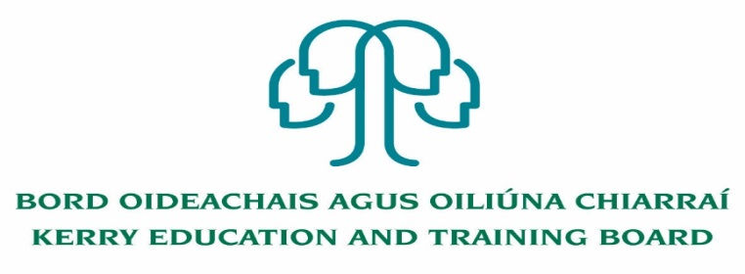

Person Specification Deputy Principal

Coláiste Gleann Lí

Essential Criteria:
To qualify for appointment candidates must:
- A recognised post-primary teaching qualification.
- A minimum of 5 years’ satisfactory teaching experience or equivalent.
- Registration in accordance with Section 30 of the Teaching Council Act 2001.
- A proven track record in Curriculum Leadership and Change Management.
- Evidence of commitment to the core values of Kerry Education and Training Board: respect, quality, equality inclusion and learning

Core Competencies Required:
Kerry ETB Core Values of Respect, Quality, Equality, Inclusion and Learning are the guiding principles of the organisation and underpin the competencies required to fulfil this role. See attached PDF Document.

The Deputy Principal, in collaboration with the Principal, shall have responsibility for the following key areas:

Leading Learning and Teaching
School leaders:
- promote a culture of improvement, collaboration, innovation and creativity in learning, teaching and assessment
- foster a commitment to inclusion, equality of opportunity and the holistic development of each student
- manage the planning and implementation of the school curriculum
- foster teacher professional development that enriches teachers’ and students’ learning
- shows commitment to their own continuous professional development

Managing An Organisation
School leaders:
- establish an orderly, secure and healthy learning environment, and maintain it through effective communication
- manage the school’s human, physical and financial resources so as to create and maintain a learning organisation
- manage challenging and complex situations in a manner that demonstrates equality, fairness and justice
- develop and implement a system to promote professional responsibility and accountability

Leading School Development
School leaders:
- communicate the guiding vision for the school and lead its realisation in the context of the school’s characteristic spirit
- lead the school’s engagement in a continuous process of self-evaluation
- build and maintain relationships with parents, with other schools, and with the wider community
- manage, lead and mediate change to respond to the evolving needs of the school and to changes in education

Developing Leadership Capacity
School leaders:
- critique their practice as leaders and develop their understanding of effective and sustainable leadership
- empower staff to take on and carry out leadership roles
- promote and facilitate the development of student voice, student participation, and student leadership
- build professional networks with other school leaders

Self-Awareness and Self-Management
- is self-aware and has the capacity to self-manage and develop personally and professionally
- is committed to Kerry ETB Core Values
The successful candidate will:
- be a leader, committed to the highest standards of education provision, administration and governance
- have a passion for education
- have strong people management and organisation skills
- be a visionary and have experience in delivering projects through team work
- be community minded and conscious of the role the school plays in the local community

