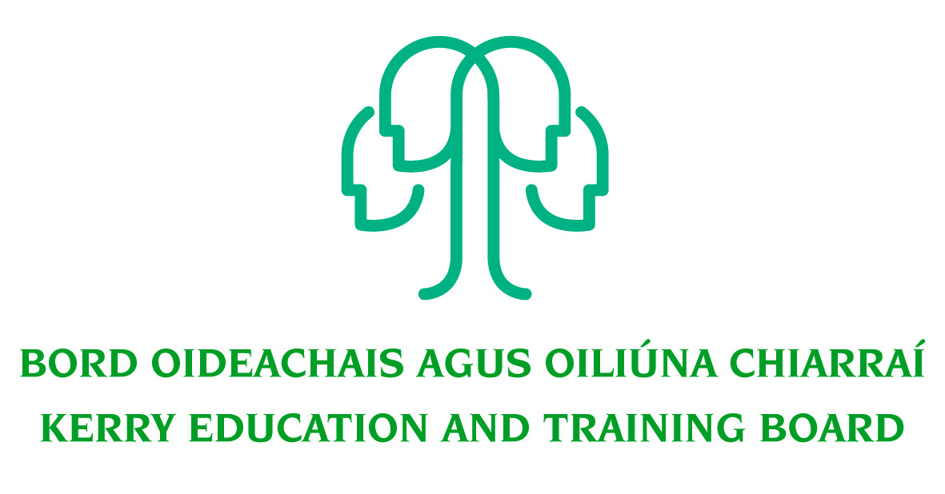
Job Description

Permanent Grade VI Human Resources Department
Head Office

Nature of Post
Full-time position 37 hours per week

Location
Appointment is to the Scheme – Kerry ETB reserves the right to assign a staff member to any other location, as the service exigencies require. Your centre of first assignment will be Kerry Education and Training Board Head Office, Centrepoint, John Joe Sheehy Road, Tralee.

Reporting/Accountability Relationship
The Grade VI reports to the Kerry ETB Head of HR.

Post Summary/Purpose:
This post is a supervisory position within Kerry ETB and will be assigned responsibility for the day to day operation and supervision of work areas, section or team.

The post holder will manage employee documentation, including contracts, recruitment/selection processes, staff allocation/utilisation and employee relations documentation.

The post holder will promote and maintain best practice throughout the HR Department to ensure a quality service is delivered at all times
The person appointed will be required to be flexible in this position and must be prepared to undertake such other duties as assigned to them by the HR Manager. Such duties can be outside the normal area of work.

Key Responsibilities
- Co-ordinate, manage and monitor staffing allocation, as prescribed by the Department of Education and Skills and other relevant organisations, ensuring notifications and updates are provided to relevant line managers in a timely manner.
- Update and monitor relevant systems to manage and monitor utilisation, to include but not limited to, teacher utilisation, CID register, SNA panel etc.
- Oversee and manage the issue of all employment contracts within the prescribed legislative requirements.
- Oversee all administrative arrangements relating to the recruitment and selection process such as;
- recruitment advertisements and competitions are in line with relevant legislative requirements and Circular Letters
- composition of shortlisting and interview board(s)
- preparation and issue of shortlisting and interview packs
- issue of relevant correspondence relating to each competition
- liaise with relevant members of the HR Team around letter(s) of offer, start date, induction etc.
- Develop good Employee Relations/Industrial Relations practices to support the HR function and the HR Manager and continue to develop open communication processes with trade union/staff representatives.
- Management of time and attendance of staff including management of the flexi system for Head Office staff.
- Under the guidance of the HR Manager/Deputy Head collect and collate data for Department of Education and Skills and other returns, as assigned.
- Develop, oversee the implementation of, and review all policies and procedures relevant to areas of responsibility, to ensure each area operates effectively and in accordance with legislation.
- Provide professional support and advice to all Line Managers in relation to areas of responsibility.
- Responsibility for keeping up to date on Circular Letters/legislative requirements/collective agreements relevant to areas of responsibility and ensuring, under the guidance of the HR Manager/Deputy Head, same are implemented efficiently.
- Undertake tasks in other areas of the HR Department as assigned by the HR Manager.
- Be accountable to the HR Manager in all matters relating to areas of responsibility.
- Assist in the planning, development and implementation of new systems as required with special reference to the introduction and development of computerised systems.
- Liaise with staff in other departments, the public and outside agencies in a confidential, courteous and professional manner.
- Ensure all information received within the Department remains confidential.
- Contribute to the setting of organisational tone through policies and the development and promotion of good internal controls in relevant areas of responsibility.
- Monitor and manage good communication protocols for dealing with managers, staff and other stakeholders to ensure the information delivered is relevant, appropriate and timely, and ensure they are in line with Kerry ETB policies and procedures.
- Support Performance Management development for staff, and identify the requirements needed to ensure the organisation can deliver a high quality service to staff and learners.
- Develop capability of others through supportive feedback, coaching and creating opportunities for skills development.
- Bring a focus and drive to building and sustaining high levels of performance, addressing any performance issues as they arise.
- Attend and contribute to working groups and committees of Kerry ETB, as requested.
- Represent the HR Department of Kerry ETB at meetings, if required, with external agencies/bodies/groups that are necessary for the proper discharge of the post.
- Maintain a strong focus on self-development, seeking feedback and opportunities for growth.
- Research issues thoroughly, consult appropriately to gather all information needed on an issue.
- Plan and prioritise work in terms of importance, timescales and other resource constraints, re-prioritising in light of changing circumstances for self and relevant staff teams.
- Carry out lawful orders of the Chief Executive.
- Carry out any other duties appropriate to the grade which may be assigned from time to time.

The above list of accountabilities may be varied having regard to the changing needs of the Scheme and the terms of the post can include delivery of responses to unpredictable work demands as they arise.

Person Specification
This post is open to existing members of Kerry ETB administration and caretaking staff.

As per CL 0008/2017, candidates for a Grade VI post must (by closing date for receipt of application):
- have the requisite knowledge, skills and competencies to carry out the role. Competencies will be informed by best practice Public Appointment Service competency frameworks for the Irish Public Service;
- be capable and competent of fulfilling the role to a high standard;
- have obtained at least Grade D3 in five subjects in the Leaving Certificate Examination (higher, ordinary, applied or vocational programmes) or equivalent or have passed an examination at the appropriate level within the QQI qualifications framework which can be assessed as being comparable to Leaving Certificate standard or equivalent or higher or have appropriate relevant experience which encompasses equivalent skills and expertise;
- have at least two years in a Grade III post, or equivalent, or higher, in the Education and Training Sector. ETB Caretaker Grade will also be considered valid.
- Have successfully completed their probation period, or have successfully completed a probation period at a lower eligible grade.

Desirable Criteria
- Achieved or be at an advanced stage of working towards a Level 6 qualification or higher in a relevant area
- Experience in the application of employment law in the workplace
- Knowledge and familiarity with the practices and institutions relevant to the orderly conduct of ER\IR
- Excellent administrative and IT Skills
- Strong Communication Skills, both written and oral.
- Demonstrable initiative
- Strong attention to detail

Competencies Required

Kerry ETB Core Values of Respect, Quality, Equality, Inclusion and Learning are the guiding principles of the organisation and underpin the competencies required to fulfil this role.
The appointee to the Grade VI post will be required to show evidence of the following competencies:

Specialist Knowledge, Expertise and Self Development
- Clearly understands the role, objectives and targets and how they fit into the work of the Organisation.
- Develops the expertise necessary to carry out the role to a high standard and has a thorough understanding of the Code of Practice for the Governance of Education and Training Boards
- Is proactive in keeping up to date on issues and key developments that may impact on the Department and/or wider ETB service
- Consistently reviews own performance and sets self-challenging goals and targets

Leadership Potential
- Is flexible and willing to adapt, positively contributing to the implementation of change
- Contributes to the development of policies in the Department/Organisation
- Seeks to understand the implications of taking a particular position on issues and how interdependencies need to be addressed in a logical and consistent way
- Maximises the contribution of the team, encouraging ownership, providing support and working effectively with others
- Formulates a perspective on issues considered important and actively contributes across a range of settings

Analysis & Decision Making
- Is skilled in policy analysis and development, challenging the established wisdom and adopting an open-minded approach
- Quickly gets up to speed in a complex situation, rapidly absorbing all relevant information/data (written and oral
- Uses numerical data skilfully to understand and evaluate service issues
- Identifies key themes and patterns in and across different sources of information, drawing sound and balanced conclusions
- Sees the logical implications of taking a particular position of an issue

Delivery of Results
- Assumes personal responsibility for and delivers on agreed objectives/goals
- Manages and progresses multiple projects and work activities successfully
- Accurately estimates time parameters for projects and manages own time efficiently, anticipating obstacles and making contingencies for overcoming these
- Maintains a strong focus on meeting the needs of customers at all times
- Ensures all outputs are delivered to a high standard and in an efficient manner
- Use resources effectively, at all times challenging processes to improve efficiencies

Interpersonal & Communication Skills
- Communicates in a fluent, logical, clear and convincing manner verbally and in writing
- Is able to listen effectively and develop a two-way dialogue quickly
- Maintains a strong focus on meeting the needs of internal and external customers
- Effectively influences others to take action
- Works to establish mutual understanding to allow for collaborative working

Drive & Commitment to Public Service Values
- Consistently strives to perform at a high level
- Maintains consistent effort under pressure and is resilient to criticism or setbacks at work
- Demonstrates high levels of initiative, taking ownership for projects and demonstrating self sufficiency
- Is personally trustworthy and can be relied upon
- Places the citizen at the heart of all process and systems.

