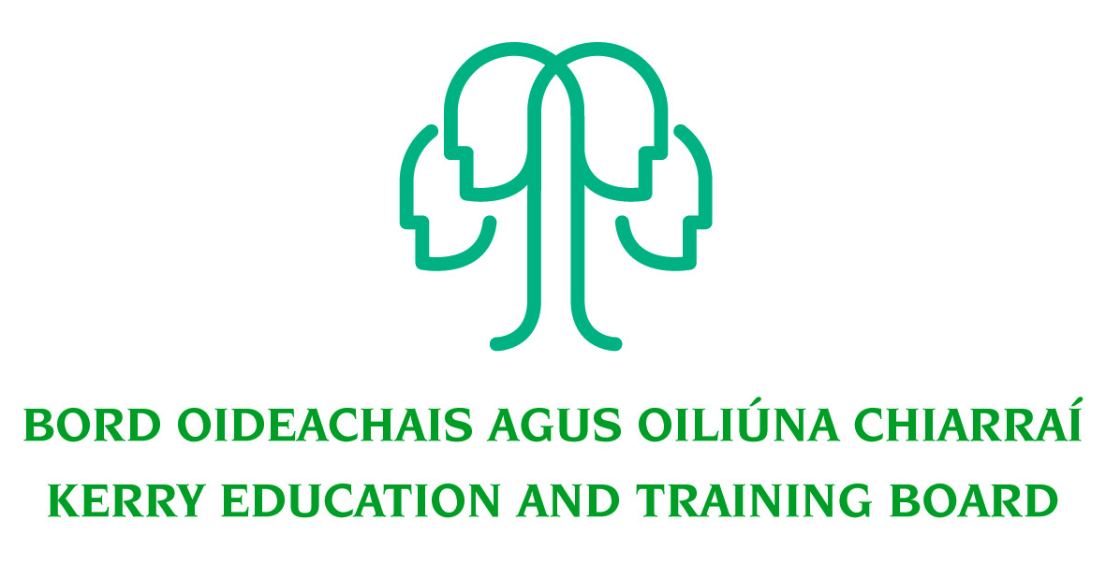
Job Description

PWT Grade V Post
Finance Department

Nature of Post
Permanent position 37 hours per week.

Location
Appointment is to the Scheme – Kerry ETB reserves the right to assign a staff member to any other location, as the service exigencies require. Your centre of first assignment will be Kerry Education and Training Board Head Office, Centrepoint, John Joe Sheehy Road, Tralee, Co. Kerry.

Reporting/Accountability Relationship
The Grade V reports to the Grade VI/Head of Finance.

Post Summary/Purpose:
This post is a supervisory position within Kerry ETB and will be assigned responsibility for the day to day operation and supervision of work areas, section or team.

The post holder will be responsible for coordinating the efficient day to day work and supervision of the Payroll Section (including Travel and Subsistence) ensuring that targets and service levels are achieved and that work undertaken or information being given is accurate and in compliance with Legislation, Circular Letters, best practice guidelines and Internal Procedures.

The person appointed will be required to be flexible in this position and must be prepared to undertake such other duties as assigned to them by the Head of Finance. Such duties can be outside the normal area of work.
Key Responsibilities
- Responsibility for the supervision of pay projects and any other duties as directed by the Grade VI /Head of Finance.
- Support the Head of Finance and other relevant senior staff with the interpretation and application of pay and travel and subsistence regulations and related legislation.
- Process and/or check the full range of pay related and travel and subsistence related calculations and data provided in accordance with defined procedures.
- Responsibility for the control of pay and travel and subsistence related data, ensuring the submission of timely and accurate data for payment within set deadlines.
- Maintain an efficient and effective filing system to ensure any and all data, records or information required by all interested parties including Internal and External Audit is readily available.
- Assist with preparatory work for transition to Payroll Shared Services (Data Cleansing etc.).
- Work with other relevant staff to ensure the smooth roll out of the DCS System across the scheme.
- Oversee DCS weekly download and circulation of DCS Submission Dates.
- Update System Parameters throughout the year as necessary.
- Calculation of Bank Holidays for Part-Time Teachers.
- Review rates on fortnightly/monthly claim forms.
- Checking of Control Reports, Gross to Net Reports, Payment Analysis Reports etc. for all payroll and Travel and Subsistence payment runs.
- Maternity/Paternity Benefit Transactions and Disability/Illness Benefit Transactions
- Completion of Salary Certificates/Social Welfare Forms, etc. for employees.
- Children’s Allowance Payments.
- Oversee the preparation and updating of monthly and annual main scheme Pay Estimates.
- Review Travel and Subsistence claims and preparation and calculation of Interview Board Fees/Travel Expenses.
- Responsibility for the preparation and timely submission of Revenue Returns
- Manage the End of Year Process - balancing of deductions to Salary Card etc. and co-ordinate
the ESI End of Year process.
- Assist with the preparation of the Annual Financial Statements in area of responsibility to include preparation of pay liabilities/T&S liabilities etc.
- Assist with the preparation of the audit file and respond to audit queries as required.
- Preparation of Quarterly EHECS Return for CSO.
- Ensure efficient administration and communication in relation to pay and travel and subsistence as they pertain to staff of Kerry ETB.
- Assist in the planning, development and implementation of new systems as required with special reference to the introduction and development of computerised systems
- Contribute to the setting of organisational tone through policies and the development and promotion of good internal controls in relevant areas of responsibility.
- Undertake relevant training and development activities and respond positively to new and alternative systems.
- Undertake tasks in other areas of the Finance Department as assigned by the Head of Finance.
- Plan and prioritise work in terms of importance, timescales and other resource constraints, re-prioritising in light of changing circumstances for self and relevant staff teams.
- Carry out lawful orders of the Chief Executive.
- Carry out any other duties appropriate to the grade which may be assigned from time to time.

The above list of accountabilities may be varied having regard to the changing needs of the Scheme and the terms of the post can include delivery of responses to unpredictable work demands as they arise.

Person Specification
As per Circular Letter 8/2017 and 46/2017 candidates must (by closing date for receipt of applications):

- have the requisite knowledge, skills and competencies to carry out the role. Competencies will be informed by best practice Public Appointment Service competency frameworks for the Irish Public Service;
- be capable and competent of fulfilling the role to a high standard;
- have obtained at least Grade D3 in five subjects in the Leaving Certificate Examination (higher, ordinary, applied or vocational programmes) or equivalent or have passed an examination at the appropriate level within the QQI qualifications framework which can be assessed as being of a comparable to Leaving Certificate standard or equivalent or higher or have appropriate relevant experience which encompasses equivalent skills and expertise;
- have at least two years in a Grade III post, or equivalent, or higher, in the Education and Training Sector. For the purposes of filling vacancies in Grades IV, V, VI and VII in ETBs only, at least two years’ service in an ETB Caretaker Grade will also be considered valid.
- have successfully completed their probation period or have successfully completed a probation period at a lower eligible grade.

Desirable:
- A third level qualification (Level 6 or higher on the National Framework of Qualifications)
- A good level of experience or knowledge of the designated area of work
- Excellent administrative and IT skills
- Strong Communication Skills, both written and oral.
- Demonstrable initiative
- Strong attention to detail

Competences required
Kerry ETB Core Values of Respect, Quality, Equality, Inclusion and Learning are the guiding principles of the organisation and underpin the competencies required to fulfil this role.

The person appointed to the above post will be required to show evidence of the following competences:

Specialist Knowledge, Expertise and Self Development
- Clearly understands the role, objectives and targets and how they fit into the work of the Organisation.
- Develops the expertise necessary to carry out the role to a high standard and has a thorough understanding of the Code of Practice for the Governance of Education and Training Boards
- Is proactive in keeping up to date on issues and key developments that may impact on the Department and/or wider ETB service
- Consistently reviews own performance and sets self-challenging goals and targets

Leadership Potential
- Is flexible and willing to adapt, positively contributing to the implementation of change
- Contributes to the development of policies in the Department/Organisation
- Seeks to understand the implications of taking a particular position on issues and how interdependencies need to be addressed in a logical and consistent way
- Maximises the contribution of the team, encouraging ownership, providing support and working effectively with others
- Formulates a perspective on issues considered important and actively contributes across a range of settings

Analysis & Decision Making
- Is skilled in policy analysis and development, challenging the established wisdom and adopting an open-minded approach
- Quickly gets up to speed in a complex situation, rapidly absorbing all relevant information/data (written and oral
- Uses numerical data skilfully to understand and evaluate service issues
- Identifies key themes and patterns in and across different sources of information, drawing sound and balanced conclusions
- Sees the logical implications of taking a particular position of an issue

Delivery of Results
- Assumes personal responsibility for and delivers on agreed objectives/goals
- Manages and progresses multiple projects and work activities successfully
- Accurately estimates time parameters for projects and manages own time efficiently, anticipating obstacles and making contingencies for overcoming these
- Maintains a strong focus on meeting the needs of customers at all times
- Ensures all outputs are delivered to a high standard and in an efficient manner
- Use resources effectively, at all times challenging processes to improve efficiencies

Interpersonal & Communication Skills
- Communicates in a fluent, logical, clear and convincing manner verbally and in writing
- Is able to listen effectively and develop a two-way dialogue quickly
- Maintains a strong focus on meeting the needs of internal and external customers
- Effectively influences others to take action
- Works to establish mutual understanding to allow for collaborative working

Drive & Commitment to Public Service Values
- Consistently strives to perform at a high level
- Maintains consistent effort under pressure and is resilient to criticism or setbacks at work
- Demonstrates high levels of initiative, taking ownership for projects and demonstrating self sufficiency
- Is personally trustworthy and can be relied upon
- Places the citizen at the heart of all process and systems

