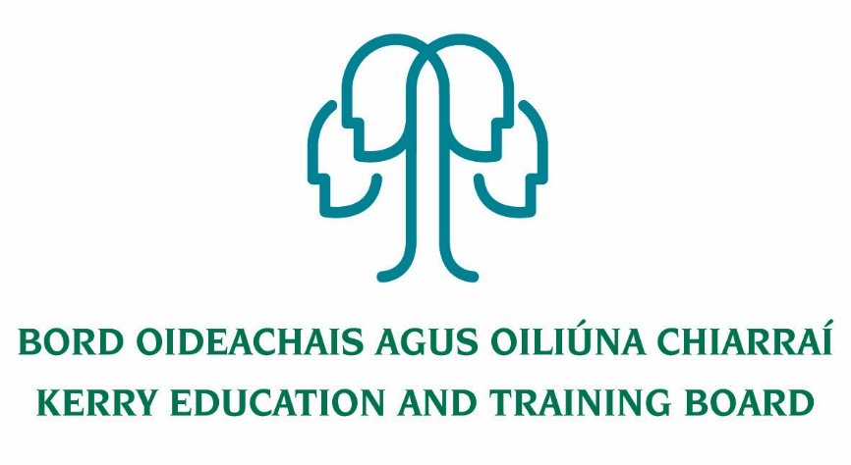

**Permanent Part time Grade III Clerical Officer Post** (18.5 hours per week)

**Coláiste na Sceilge**

Applications are invited for Permanent Part time Grade III Clerical Officer post (18.5 hour per week) which may arise. This post is Part time. A panel may be formed from this competition from which appointments may be made.

**And**

**Specific Purpose Part Time (1/2 day per week) Grade IV Assistant Staff Officer**

**Killarney Community College**

Application form and full details for these posts can be downloaded from www.kerryetb.ie/opportunities and return **by email only** to [jobs@kerryetb.ie](mailto:jobs@kerryetb.ie). No C.V.’s only official application form will be accepted.

Applications by email only must be received not later than 12 noon Friday 4th September 2020.

**Kerry Education & Training Board services Gaeltacht areas.**

**Cuirfear fáilte roimh chomhfhreagras i nGaeilge.**

**Garda Vetting of successful candidates will take place prior to offer of employment.**

**Canvassing will automatically disqualify.**

**Short-listing will take place on the basis of the information provided in the application form. Depending on the qualifications and experience of applicants, short-listing thresholds may be higher than the minimum standards set out.**

###### Kerry Education & Training Board is an equal opportunities employer.

*“Creating a Learning Society in Kerry”*

