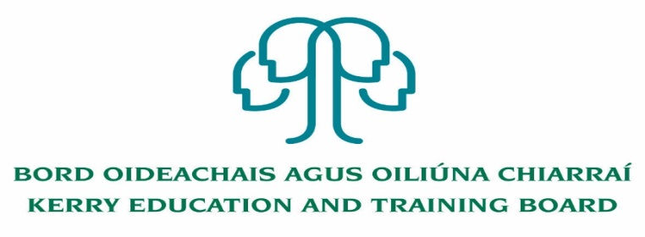

**Permanent Deputy Principal Post - Coláiste Gleann Lí**

**Roll no. 70550H Category XI Deputy Principal Allowance**

**And**

**Permanent Deputy Principal Post - Castleisland Community College**

**Roll no. 70520V Category X Deputy Principal Allowance**

Kerry Education & Training Board invites applications for the posts of Permanent Deputy Principal for Coláiste Gleann Lí and Castleisland Community College.

These senior management posts will afford the appointee an opportunity to lead teams to deliver and enhance quality education services in the Kerry area and to act as part of the senior management team in Kerry Education & Training Board.

**To qualify for appointment candidates must have:**

* A recognised post-primary teaching qualification.
* A minimum of 5 years’ satisfactory teaching experience or equivalent.
* Registration in accordance with Section 30 of the Teaching Council Act 2001.
* A proven track record in Curriculum Leadership and Change Management.
* Evidence of commitment to the core values of Kerry Education and Training Board: respect, quality, equality inclusion and learning

*Colm Mc Evoy*

*Chief Executive Officer*

-------------------------------------------------------------------------------------------------------------------------------------------

Conditions of Service, Terms of Appointment, Qualifications, Salary Scales and Allowances are in accordance with the regulations of the Department of Education & Skills.

Please complete an application form and **return by email only** to [jobs@kerryetb.ie](mailto:jobs@kerryetb.ie). No C.V.’s, only official application form will be accepted. Applications must be received not later than 4pm Thursday 3rd February 2022.

**Kerry Education & Training Board services Gaeltacht areas.**

**Cuirfear fáilte roimh chomhfhreagras i nGaeilge.**

**Garda Vetting of successful candidates will take place prior to offer of employment.**

**Canvassing will automatically disqualify.**

**Short-listing will take place on the basis of the information provided in the application form. Depending on the qualifications and experience of applicants, short-listing thresholds may be significantly higher than the minimum standards set out.**

###### Kerry Education & Training Board is an equal opportunities employer.

*“Creating a Learning Society in Kerry”*

