Kerry ETB Website – Data Protection Page
https://www.kerryetb.ie/organisational-support-development/corporate-support-and-capital-development/data-protection-gdpr/

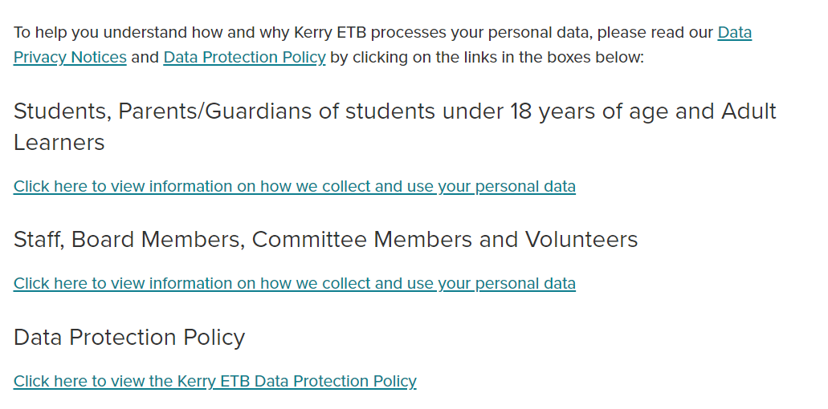
Documents

- Combined Privacy Notices

- Privacy Notice to Learners, Students (and their parents/guardians) Revision 2.

- Privacy Notice to Staff, Board Members, Committee Members, Volunteers, Revision 1

- Data Protection Policy.
5
4
3
2
1

