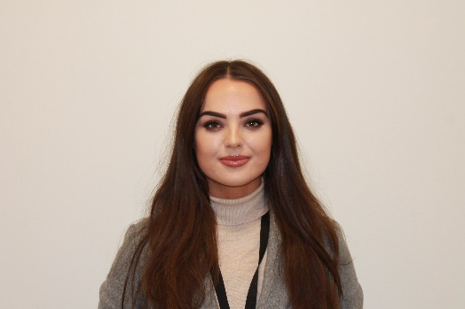
Kerry ETB Female Staff Election 2021
Nominee: Michelle Quinlan

My name is Michelle Quinlan and I work in the HR Department of Kerry ETB
I began my journey with Kerry ETB when I completed an ECDL and Business Administration course in Kerry College, Monavalley campus in 2018/2019. I have always wanted to work with people and the work experience that I gained in HR, as part of my course, ignited my interest further. Following the conclusion of my course I secured employment in the HR Department as a Clerical Officer and I have gained valuable experience and knowledge in the area of customer service, policies, procedures and the importance of the valued service we provide to the County of Kerry. My time in HR has also given me an opportunity to support management and staff across the entire organisation at all grades.
I understand that Kerry ETB plays a major role in the rapidly changing world of education and training. I would love the opportunity to be a voice for staff, to ensure that their views are represented. I believe that I have the ability to be a strong advocate for staff and understand the importance of working together to get the job done.
I am running in the election because I am proud to be a staff member of Kerry ETB. Kerry ETB’s staff are essential to ensuring that Kerry ETB continues to provide high quality education and training and therefore it is vital that they are represented in decisions taken at Board level.
You matter. Your opinion matters. Choose someone who will be your spokesperson.
I hope you put your trust in me when you vote.

