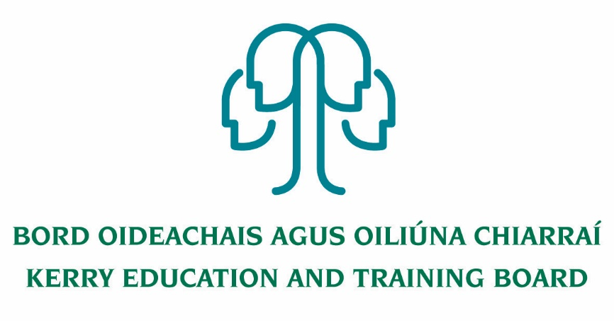
Job Description
Deputy Principal (PWT)
Kerry College
Roll number: 76494H Category XVI

Nature of Post
The post is whole-time and permanent.

Location
Centre of first assignment is Kerry College of Further Education and Training.
The person appointed to this post may be transferred to another post under Kerry ETB, provided that in the opinion of Kerry ETB and the Minister for Further, Higher Education, Research, Innovation and Science such other post is of similar status.

Commencement Date
Appointment to commence at the start of the 2020/21 academic year

Remuneration
Category of Deputy Principal Allowance payable – XVI

Reporting/Accountability Relationship
The Deputy Principal shall report to the Principal/Director of Further Education and Training

Post Summary
The overall responsibility of the Deputy Principal is to assist the Principal in the day to day management of the College.
Besides the discharge of specific administrative and management duties, the Deputy Principal also exercises a leadership and motivational role in the direction of the College enterprise. Together the Principal and Deputy Principal form the senior management team of the College, he/she must work in tandem to fulfil the aims and objectives of the College. That teamwork is also broadened to include the post holders to form part of the management team and the staff whose co-operation and commitment are also vital to the achievement of the goals of the College.
The Deputy Principal is required to deputise for the Principal in his/her absence in all matters organisational/administrative and in relation to discipline within the College.
The Deputy Principal will work in conjunction with/under the direction of the Principal.
The Deputy Principal shall engage in teaching the number of hours specified by the Department of Further, Higher Education, Research, Innovation and Science, the Deputy Principal will be required to be in attendance in the College throughout the College day.
The Deputy Principal will be required to be present in the College for periods during all QQI and other FET awarding bodies examinations and for other periods outside the normal opening hours and days of the College such as may be necessary from time to time. The Deputy Principal must be at the College from 8.15 a.m. to 5 p.m. Programme delivery in Kerry College of Further Education and Training spans the entire calendar year and the Deputy Principal will be required to fully participate in the management of all courses delivered by the College.
Key Areas of Responsibility
The Deputy Principal, in collaboration with the Principal, shall have responsibility for the following key areas:
Leader of Teaching & Learning
- Assist the Principal in developing a College environment which is supportive of learning and high achievement among the students.
- Develop and provide appropriate learning and curriculum programmes and methods of instruction that meet the needs of all learners in the College and timetabling to support them. Promote effective teaching and learning practices across the College.
- Assist in the development of the College curriculum and assessment policies.
- Develop and implement systems for recording individual pupils’ progress
- Assist the Principal in supporting the monitoring and evaluation of teaching and learning across the College and contribute to College self-evaluation and the development of improvement plans.
Leader – College Development
- Assist the Principal in the re-evaluation of the purpose, objectives and activities of the College in line with College Self-Evaluation Guidelines.
- Assist the Principal in developing the education aims and objectives of the College and devising strategies to achieve them.
- Assist the Principal in co-ordinating the College plan and policies for approval by the Board of Management. (Board of Governance)
- Assist the Principal in maintaining effective relationships with the stakeholders involved including learners, local employers, other education and training bodies and agencies
- Assist the review and development of Courses in conjunction with the wider Kerry ETB FET Services, Local employers, other ETB Training Providers and agencies.
- Support and assist the Principal in the development of an extensive part time evening programme for the College
- Fully participate in the implementation of the learner enrolments systems, including during traditional learner holiday periods
- Assist the Principal in the development and implementation of an extensive and detailed annual college promotion and recruitment plan for approval by the Board of Management each year
- Assist the Principal in the establishment of relevant clubs and societies (including sporting) in the college to enhance the learner experience
Leader – People & Teams
- Develop a good working relationship with the Principal, teaching staff and ancillary staff.
- Treat all staff with respect and develop positive relationships.
- Assist the Principal in promoting ongoing staff development and in-service and in the identification of the staffing needs of the College – i.e. teaching and support staff.
- Co-ordinate Staff Development and organise Staff Days.
- Assist the Principal in advising the Board of Management as to a probationary teacher’s suitability for continued employment in the College.

Organisational Management and Administrative Skills
- Assist the Principal in the day to day management of the College, including the planning, preparation and overseeing of the daily timetabling of classes in accordance with the approved annual curricular plan
- Assist the Principal in the promotion of good order and general supervision.
- Be responsible for the day today management of staff and learners.
- Establish, maintain and review effective data management systems such as student records, teacher records, attendance, purchasing procedures and timetables.
- Assist the Principal with rostering for supervision.
- Assist the Principal with morning supervision prior to College opening.
- Be present in the College for periods during all QQI and other FET awarding bodies examinations
- Prepare a summary of results of QQI and other FET awarding bodies examinations for Kerry ETB and Kerry ETB Board of Management.
- Assist at open days and nights and award nights.
- Assist in ensuring the security of the College building and safe keeping of property.
- Conduct the ordinary activities of correspondence, producing reports and returns of information as required by the Department of Further, Higher Education, Research, Innovation and Science /SOLAS and Kerry ETB and Kerry ETB Board of Management. Meet all administrative and reporting requirements as directed by Kerry ETB.
- Comply with the lawful orders of the ETB/Chief Executive Officer/BOM and with the rules and requirements of the Minister for Further, Higher Education, Research, Innovation and Science.
Self-Awareness and Self-Management
- Appreciate the importance of the Principal/Deputy Principal relationship, the relationship with other members of the College community and the importance and overall impact of effective working relationships.
- Set a good standard of professional interactions and ensure professional relationship boundaries are in place.
- Be aware of his/her skill set and be willing to seek help and advice when required.
- Uphold professional integrity at all times, e.g. discretion, confidentiality, loyalty and trust.
Communication
- Develop effective communication systems with pupils, staff and the wider community.
- Maintain effective relationships with the stakeholders involved including learners, local employers, other education and training bodies and agencies including representing Kerry ETB on Boards and Committees.
- Communicate with students, staff in a positive, friendly and professional manner.
- Implement the Code of Behaviour and all College policies with an understanding of their rationale.
- Liaising with the College union representatives on matters relating to the College.

To undertake such other work as may be assigned from time to time.

