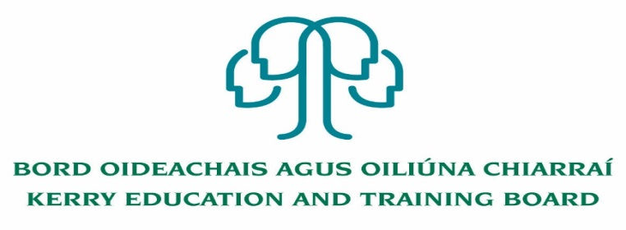

Job Description - Principal
Coláiste Na Ríochta
Nature of Post
The post is whole-time and permanent.

Location
Appointment is to the scheme - Centre of first assignment is Coláiste Na Ríochta. The person appointed to this post may be transferred to another post under Kerry ETB, provided that in the opinion of Kerry ETB and the Minister for Education, such other post is of similar status.

Remuneration
Category of Deputy Principal Allowance Payable –IX

Reporting/Accountability Relationships
Reporting to the Director of Schools Youth and Music/Chief Executive Officer

Functional Relationships
- Staff and Learners – Partners in Education
- Chief Executive Officer, Director of Schools Youth and Music/Staff of Kerry Education & Training Board
- Department of Education/Other external agencies e.g. National Educational Psychological Service, TUSLA, An Garda Siochána, Health Service Executive, Central Applications Office, local and national employers etc.
- The wider community

Key Areas of Responsibility
- To be responsible, under the Director of Schools Youth and Music for the management, organisation, discipline and administration of the School.

- To engage in teaching the number of hours per session specified by the Department of Education

  - To comply with the lawful orders of the Board, and its Chief Executive Officer, and with the rules and requirements of the Minister of Education

  - To effectively carry out the professional duties appropriate to a Principal Teacher as outlined in the Provisions of the Education Act 1998, Part V – which include

(a) be responsible for the day-to-day management of the School, including guidance and direction of the teachers and other staff of the school, and be accountable to the board for that management,
      - provide leadership to the teachers and other staff and the learners of the School
      - be responsible for the creation, together with the board and the teachers, of a School environment which is supportive of learning among the learners and which promotes the professional development of the teachers,
      - under the direction of the board and, in consultation with the teachers, to the extent appropriate to their age and experience, the learners, set objectives for the School and monitor the achievement of those objectives, and
      - encourage the involvement of learners in the School in the education of those learners and in the achievement of the objectives of the School

  - To carry out any other duties appropriate to the position.

  - To be responsible for the development and performance of staff in line with Kerry ETB Core Values and to foster a culture of continuous improvement and development.

Attendance of the Principal
- The Principal will be required to be in attendance for days during the school year when the CEO/Board of Management determines that the school should be open for pupils and in accordance with Department of Education and Skills regulations.
- The Principal will be required by the CEO/Board of Management to be present in the school for periods during the State Examinations and for other reasonable periods outside of the normal opening hours and days of the school such as may be necessary from time to time. The Principal shall enter into an agreement with the CEO/Board of Management in respect of arrangements for such attendances.
- Before the beginning of the school year the Principal shall be available as reasonably required to ensure that all necessary preparations are carried out for the re-opening of the school and shall inform the CEO/Chairperson of the Board of Management of the preparations involved.
- The Principal shall ensure that appropriate arrangements are in place for the reception and distribution of Leaving Certificate examination results and for consultation with students and parents.
- The Principal will normally be required to be in attendance from 8:15 am to 5:00 pm each day and at other times as required by the Director of Schools Youth and Music/CEO/ Board of Management of the School.

Key Areas of Responsibility
The Principal shall have responsibility for the following key areas:

Leading Learning and Teaching
- promote a culture of improvement, collaboration, innovation and creativity in learning, teaching and assessment
- foster a commitment to inclusion, equality of opportunity and the holistic development of each student
- manage the planning and implementation of the school curriculum
- foster teacher professional development that enriches teachers’ and students’ learning

Managing the Organisation
- establish an orderly, secure and healthy learning environment, and maintain it through effective communication
- manage the school’s human, physical and financial resources so as to create and maintain a learning organisation
- manage challenging and complex situations in a manner that demonstrates equality, fairness and justice
- develop and implement a system to promote professional responsibility and accountability

Leading School Development
- communicate the guiding vision for the school and lead its realisation in the context of the school’s characteristic spirit
- lead the school’s engagement in a continuous process of self-evaluation
- build and maintain relationships with parents, with other schools, and with the wider community
- manage, lead and mediate change to respond to the evolving needs of the school and to changes in education

Developing Leadership Capacity
- critique their practice as leaders and develop their understanding of effective and sustainable leadership
- empower staff to take on and carry out leadership roles
- promote and facilitate the development of student voice, student participation, and student leadership
- build professional networks with other school leaders

To undertake such other work as may be assigned from time to time.

