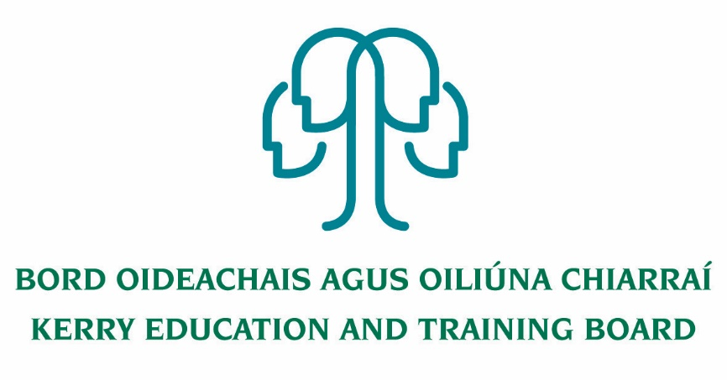

|  |
| --- |
| **Job Description** |

**Title:** Permanent Assistant Manager Kerry College, Monavalley Campus

**Salary scale: €**53,323 - €82,540

**Reporting to**: Campus Manager

**Nature of Post**: Permanent Full Time - 37 hours per week

**General Information**

Kerry ETB is an equal opportunities employer and is committed to the ongoing development of all staff through training, the provision of development opportunities and the rotation of staff from time to time.

The post of Assistant Manager is an integral part of the management team and the duties assigned will encompass a broad range.

**Function of Job**

* + - * The effective management of staff performance, financial and other resources.
* The efficient and effective delivery of agreed and appropriate services and programmes as required by customers and stakeholders
* Delivery of targets through the annual business planning process

**Duties and Responsibilities will include:**

1. Participate in the Business Planning and Budgeting process. Manage activity plans while adhering to budgets and achieving the Key Performance Indicators in the Business Plans.
2. Assist in the selection and development of suitably qualified and competent staff to perform their assigned duties. Manage an effective work team, communicate with and motivate staff, to meet the changing needs of the Kerry College Monavalley Campus internal and external environment.
3. Ensure appropriate management information systems, which integrate into wider Kerry ETB systems, are monitored, maintained and fully utilized as a management tool.
4. Establish and maintain effective internal and external communication/linkages with appropriate bodies, organisations and agencies including representing Kerry ETB on boards and committees as appropriate.
5. Promote continuous improvement and innovation.
6. Provide a safe and healthy work environment in compliance with Health & Safety Legislation and regulations.
7. Manage administration systems and processes throughout the Campus.
8. Manage staff relations and HR administration at local level in accordance with Kerry ETB HR Policies and Procedures.
9. Approve purchase of services/goods and recommend/authorise payment in accordance with Kerry ETB Financial Authority Levels and Procurement Policies and Procedures. Ensure that the assets of the organisation are properly protected.
10. Manage and organise the development and start-up of new Training Programs and apprenticeships for the centre as required.
11. Assist in the delivery of the Kerry ETB Further Education & Training Strategy and assist in the supervision and co-ordination of Training Standards System, Quality Assurance, Risk Management, Corporate Governance and Performance Management System.
12. Deputise for the Manager in the Manager’s absence.
13. Undertake any and all such other duties and responsibilities as assigned by the Manager from time to time.



|  |
| --- |
| **Person Specification & Competency Profile.** |

|  |  |  |
| --- | --- | --- |
|  | ***ESSENTIAL*** | ***DESIRABLE*** |
| ***WORK EXPERIENCE & PERSONAL PROFILE*** | * A work history which demonstrates initiative and the ability to accept change & new challenges  * A flexible approach with the ability to work independently or in a team  * A knowledge of the different functions of Kerry ETB and an understanding of the responsibilities of the Assistant Manager role.  * Demonstrate an understanding of the strategic challenges for Kerry ETB  * Demonstrate an understanding of the linkage between strategy and business plans with operational goals and targets | * Previous management/supervisory experience  * Have worked in more than one functional area of Kerry ETB Training Centre/Monavalley Campus  * Experience in implementing Kerry ETB Training Centre/Monavalley Campus initiatives (for eg Business Planning, Quality Assurance, Training Standards System, QQI, etc)  * Experience of managing multiple projects |
|
|
|
| ***EDUCATION & TRAINING/ DEVELOPMENT*** | * Diploma/Degree level qualification in a relevant discipline |  |
| ***MANAGEMENT INFORMATION SYSTEMS*** | * High proficiency in ICT applications and systems | * ECDL qualification.  * Experience in using Kerry ETB Management Information Systems (MIS). |
| ***CIRCUMSTANCES/ SPECIAL REQUIREMENTS*** | * Is able to meet the travel requirements of the position  * Willing to work flexible hours from time to time as required. |  |
|
|
|

| **Competency** | **Indicator** |
| --- | --- |
| ***Planning and Achieving Results*** | Provides direction as to what will contribute to the success of the team |
| Sets SMART goals & objectives in line with business plans/strategy and communicates a clear vision of what is to be achieved to the team. |
| Breaks goals & objectives down into discrete and achievable tasks and sets priorities. |
| Makes decisions having considered and evaluated alternative options |
| Reviews progress against KPIs, responds to change and provides feedback to the team |
| Takes responsibility to address team and/or individual underperformance, as required |
| Overcomes obstacles and perseveres to achieve results |
| Takes responsibility for responding to change as necessary and for the overall success or failure of the group |
| Identifies and manages risk. |
| Makes effective use of communications and team facilitation in planning and organising work. |
| ***Directing & Delegating*** | Directions and instructions provided are clear and unambiguous. |
| Provides staff with the scope to take responsibility for how they complete assigned tasks |
| Makes effective use of communications and team facilitation in delegating tasks. |
| ***Communications and Influencing*** | Embraces a partnership approach by ensuring group members feel valued, empowered and have common goals. |
| Facilitates dialogue to understand the ideas, concepts and feelings of others. |
| Gains support for ideas, strategies and values. |
| Presents ideas clearly, with ease and interest, so that others understand what is being communicated. |
| ***Team Facilitation*** | Involves others and builds co-operative teams. |
| Works effectively with others to achieve common objectives. |
| Effectively manages team members to ensure team success. |
| Encourages and facilitates cross-divisional communication and co-operation by team members. |
| ***Developing Staff Performance (Coaching)*** | Promotes a positive climate in which mutual support and a willingness to learn are encouraged |
| Ensures staff increase their awareness of their own strengths and development needs. |
| Coaches staff on the job to enhance individual capability and performance. |
| Follows through and supports transfer of learning from training and development. |
| Monitors ongoing progress and coaches those under their direction. |
| Makes effective use of communications and team facilitation in developing staff performance. |
| ***Personal Management Skills*** | Has an awareness of strengths and addresses development needs |
| Takes responsibility for the management of own personal development |
| Reflects, learns and builds on past experience. |
| Continuously seeks to improve their communications and teamworking skills. |
| ***Continuous Improvement or Innovation*** | Evaluates the impact of evolving events, issues, opportunities and challenges and identifies an appropriate course of action. |
| Creates and promotes the environment that encourages initiative and creativity. |
| Looks for new and better ways of doing things. |
| Adapts to unforeseen circumstances that might effect the achievement of goals. |
| Takes responsibility for changing plans. |
| Finds communication channels to short-circuit ineffective processes. |
| ***Customer Focus*** | Knows the customers and their broad needs/ concerns. |
| Builds trust/long-term relationships with internal/external customers to better understand their needs/concerns. |
| Makes a conscious effort to understand customer differences and establish common interests with customers. |
| Knows the stakeholders within the range of the job. |
| Develops relationships with internal/external stakeholders to understand their interests. |
| Uses stakeholder knowledge to promote organisational goals. |
| Makes effective use of communications and team working in helping to meet the requirements and expectations of stakeholders. |

