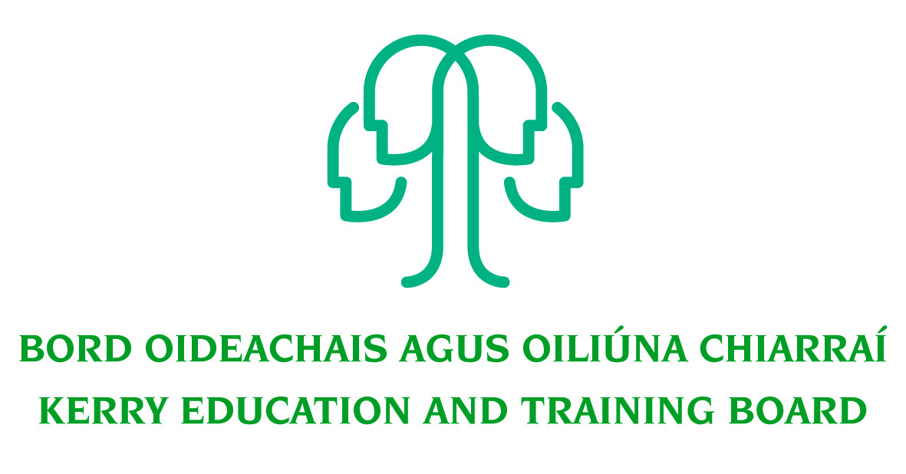
Job Description
Grade VI – Capital and Buildings Officer
Permanent Wholetime
Head Office

Nature of Post
Permanent Wholetime – 37 hours per week

Location
Appointment is to the Scheme – Kerry ETB reserves the right to assign a staff member to any other location, as the service exigencies require. Your centre of first assignment will be Kerry Education and Training Board Head Office, Centrepoint, John Joe Sheehy Road, Tralee, Co. Kerry.

Reporting/Accountability Relationship
The Grade VI reports to the relevant Head of Department/Director of Organisation Support & Development.

Post Summary/Purpose:
The post holder will be responsible for the day-to-day administration and management of Capital and Building Projects including capital balances. To provide specialist/technical support and advice on capital and buildings matters and relevant legislation to management in Kerry ETB. To ensure that Kerry ETB complies with the current capital, buildings, procurement legislation, and other appropriate legislation, having regard to Department of Education and Skills and Kerry ETB regulations

Key areas of responsibility:

Capital and Building Projects
- To liaise with the ETB legal advisors re building contract matters ensuring the effective risk management of such contracts.
- To liaise between school/centres, professional services, Department of Education and Skills, SOLAS and others in relation to capital and building projects.
- Liaise with Kerry ETB Health and Safety advisors in relation to Capital and Building projects.
- To develop and implement Kerry ETB Capital and Buildings policies and procedures.
- Ensure compliance with OGP Regulations, DES Circular Letters, Kerry ETB Procurement policies and procedures and relevant legislation.
- To initiate, develop and administer major and minor capital projects for Kerry ETB.
- To ensure that Capital Projects are progressed and kept to schedule.
- To provide an audit trail for all decisions on Capital Projects and Building Works.
- To make sure that DES/SOLAS regulations are followed in all aspects of building operations and capital purchases.
- Organising emergency works as necessary to ensure the uninterrupted and efficient running of Kerry ETBs educational and related functions.
- Co-ordination of building projects outside of the scheme as requested by the DES/SOLAS and provided for in the Education Act 2013
- Acquiring DES approval for new projects.
- Ensure paperwork relating to on-going projects are kept up to date.
- Ensure files are audited for completeness at the end of each project.
- All documentation relating to works are held in an appropriate format.
- All documentation is available for audit.

- Insurances
- Assist with building insurance related issues and accommodation strategy.

- Capital Balances
- Monitoring and maintaining up to date records of capital payments.
- Originating, preparing, issuing and tracking capital correspondence.
- Ensure paperwork relating to ongoing projects are up to date and all monies are requested appropriately from the Department of Education & Skills.
- Ensuring certificates of payment are paid on time with DES approval.
- Ensuring fee and other invoices are approved and paid promptly
- Monitoring cash-flow and ensuring that projects are kept within budget.

- Estate Management/Maintenance
- Set up and maintain a register of Kerry ETB leases.
- Carry out the final review of all leases before presentation for Board approval
- Proactively manage leases ensuring terms are fully understood and adhered to.
- Advise the Senior Management of lease expiry dates etc. in a timely manner.
- Develop and maintain property portfolios, drawing registers, safety files and other records as required.
- Monitor and maintain Kerry ETB Register of Land and Buildings
- Ensuring compliance with national register and reporting relating to Public land and buildings.

Energy Efficiency
- Drive the delivery of energy efficiencies and energy savings across the Scheme
- Contribute to the implementation of the Kerry ETB Sustainability Strategy
- Manage projects and budgets on behalf of Kerry ETB, monitoring expenditures and costs against deliverables as projects are implemented, resolving issues and initiating corrective action as appropriate
- Report to the Kerry ETB Board, when required, on capital projects etc.
- Advise on/promote/organise/participate in, as appropriate, staff development programmes
- Contribute to the development and implementation of appropriate management information systems.
- Promote teamwork within the section.
- Maintain a strong focus on self-development, seeking feedback and opportunities for growth.
- Research issues thoroughly, consult appropriately to gather all information needed on an issue.
- Plan and prioritise work in terms of importance, timescales and other resource constraints, re-prioritising in light of changing circumstances for self and relevant staff teams.
- Carry out the lawful orders of the Chief Executive.
- Carry out any other duties appropriate to the grade which may be assigned from time to time.

The above list of accountabilities may be varied having regard to the changing needs of the Scheme and the terms of the post can include delivery of responses to unpredictable work demands as they arise.
Person Specification

As per Circular Letter 8/2017 candidates must:
- have the requisite knowledge, skills and competencies to carry out the role. Competencies will be informed by best practice Public Appointment Service competency frameworks for the Irish Public Service;
- be capable and competent of fulfilling the role to a high standard;
- have obtained at least Grade D3 in five subjects in the Leaving Certificate Examination (higher, ordinary, applied or vocational programmes) or equivalent or have passed an examination at the appropriate level within the QQI qualifications framework which can be assessed as being of a comparable to Leaving Certificate standard or equivalent or higher or have appropriate relevant experience which encompasses equivalent skills and expertise.

Desirable:
- Achieved or be at an advanced stage of working towards a Level 8 qualification or higher in the relevant area
- Experience of staff supervision
- Excellent administrative and IT Skills
- Strong Communication Skills, both written and oral.
- Demonstrable initiative
- Strong attention to detail

Competences required
Kerry ETB Core Values of Respect, Quality, Equality, Inclusion and Learning are the guiding principles of the organisation and underpin the competencies required to fulfil this role.

The person appointed to the above post will be required to show evidence of the following competences:

Specialist Knowledge, Expertise and Self Development
- Clearly understands the role, objectives and targets and how they fit into the work of the Organisation.
- Develops the expertise necessary to carry out the role to a high standard and has a thorough understanding of the Code of Practice for the Governance of Education and Training Boards
- Is proactive in keeping up to date on issues and key developments that may impact on the Department and/or wider ETB service
- Consistently reviews own performance and sets self-challenging goals and targets

Leadership Potential
- Is flexible and willing to adapt, positively contributing to the implementation of change
- Contributes to the development of policies in the Department/Organisation
- Seeks to understand the implications of taking a particular position on issues and how interdependencies need to be addressed in a logical and consistent way
- Maximises the contribution of the team, encouraging ownership, providing support and working effectively with others
- Formulates a perspective on issues considered important and actively contributes across a range of settings

Analysis & Decision Making
- Is skilled in policy analysis and development, challenging the established wisdom and adopting an open-minded approach
- Quickly gets up to speed in a complex situation, rapidly absorbing all relevant information/data (written and oral
- Uses numerical data skilfully to understand and evaluate service issues
- Identifies key themes and patterns in and across different sources of information, drawing sound and balanced conclusions
- Sees the logical implications of taking a particular position of an issue

Delivery of Results
- Assumes personal responsibility for and delivers on agreed objectives/goals
- Manages and progresses multiple projects and work activities successfully
- Accurately estimates time parameters for projects and manages own time efficiently, anticipating obstacles and making contingencies for overcoming these
- Maintains a strong focus on meeting the needs of customers at all times
- Ensures all outputs are delivered to a high standard and in an efficient manner
- Use resources effectively, at all times challenging processes to improve efficiencies

Interpersonal & Communication Skills
- Communicates in a fluent, logical, clear and convincing manner verbally and in writing
- Is able to listen effectively and develop a two-way dialogue quickly
- Maintains a strong focus on meeting the needs of internal and external customers
- Effectively influences others to take action
- Works to establish mutual understanding to allow for collaborative working

Drive & Commitment to Public Service Values
- Consistently strives to perform at a high level
- Maintains consistent effort under pressure and is resilient to criticism or setbacks at work
- Demonstrates high levels of initiative, taking ownership for projects and demonstrating self sufficiency
- Is personally trustworthy and can be relied upon
- Places the citizen at the heart of all process and systems
- Upholds high standards of Respect, Quality, Equality, Inclusion and Learning

