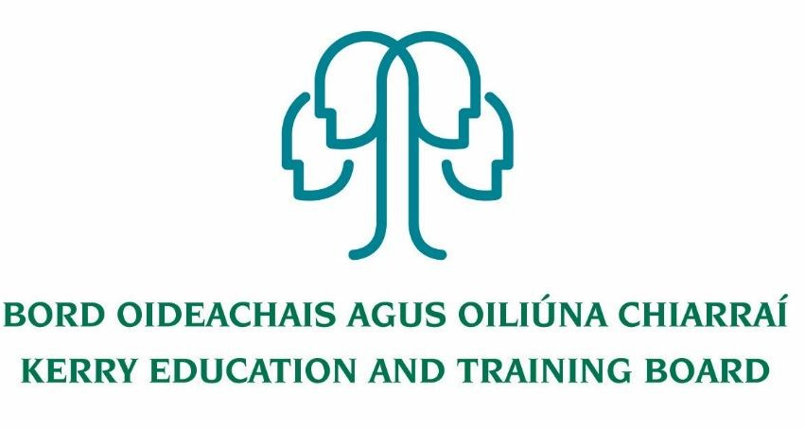

Community Education Facilitator

initial responsibility for Management of

Tech Amergin Further Education and Training Centre, Waterville

Fixed Term Contract up to 31st August 2023

Job Description

Nature of Post:
Full Time - 37 hours per week

Location

Appointment is to the Scheme – Kerry Education and Training Board (Kerry ETB) reserves the right to assign a staff member to any other location, as the service exigencies require. Your centre of first assignment will be Tech Amergin Further Education and Training Centre, Waterville, Co Kerry.

Reporting/Accountability Relationship
Adult Education Officer /Director of Further Education and Training

Salary Scale: €41,077 - €64,575

Post Summary
Kerry ETB is an equal opportunities employer and is committed to the ongoing development of all staff through training, the provision of development opportunities and the rotation of staff from time to time. The Community Education Facilitator post has initial responsibility for the management of Tech Amergin Further Education and Training Centre. It is an integral part of the Further Education and Training management team and the duties assigned will encompass a broad range.

Key Areas of Responsibility:

This role will include, but is not limited to, the following:

- Appropriate leadership, management and administration of the functional areas
- Manage activity plans while adhering to budgets and achieving the Key Performance Indicators in the Business Plans.
- Manage an effective work team, communicate with and motivate staff, to meet the changing needs of the Kerry ETB Further Education and Training Centre internal and external environment.
- Ensure appropriate management information systems, which integrate into wider Kerry ETB systems, are monitored, maintained and fully utilised as a management tool.
- Establish and maintain effective internal and external communication/linkages with appropriate bodies, organisations and agencies including representing Kerry ETB on boards and committees as appropriate.
- Promote continuous improvement and innovation.
- Provide a safe and healthy work environment in compliance with Health & Safety Legislation and regulations.
- Manage administration systems and processes throughout the Further Education and Training Centre.
- Manage staff relations and HR administration at local level in accordance with Kerry ETB HR Policies and Procedures.
- Approve purchase of services/goods and recommend/authorise payment in accordance with Kerry ETB Financial Authority Levels and Procurement Policies and Procedures. Ensure that the assets of the organisation are properly protected.
- Manage and organise the development and start-up of new full-time and part-time Programs and for the Centre as required.
- Assist in the delivery of the Kerry ETB Further Education & Training Strategy and assist in the supervision and co-ordination of Training Standards System, Quality Assurance, Risk Management, Corporate Governance and Performance Management System.
- Responsible for all aspects of the day to day organization and facility management of the FET Centre
- The effective management of staff performance, financial and other resources.
- Responsibility for scheduling and timetabling
- The efficient and effective delivery of agreed and appropriate services and programmes as required by customers and stakeholders
- Delivery of targets through the annual business planning process
- Responsible for risk management register for the Further Education and Training Centre
- Mange theFurther Education and Training Centre health and safety register and all aspects of safety within the Centre
- Responsible for building maintenance and all associated certification required associated to this
- Work with the local community to identify needs which Kerry ETB can address through educational provision.
- To undertake such other work, appropriate to the post, as may be assigned by Kerry ETB.

Person Specification

Qualifications, Skills and Experience
- Diploma/Degree level qualification in a relevant discipline e.g. Management, Business, Administration, Education etc.
- Strong Marketing and Promotional Skills
- Management Experience
- Good working knowledge of Social Media
- Excellent interpersonal and communication skills
- Strong planning and organisational skills
- Experience with external groups integration and management, in particular arts groups (art performance etc…)

Competencies Required
A number of key competencies have been identified as being essential for the effective performance of the role and function of this position

These competencies are as follows:

Leadership and Management
- Ability to work with and in a team environment
- Ability to support team members to work to their full potential
- Experienced in the development and implementation of strategic plans

Specialist Knowledge, Expertise and Self Development
- A high level of understanding and awareness regarding Further Education and Training Courses in a robust quality assured environment.
- A strong level of understanding and awareness regarding national developments, e.g. validation systems, new course development, self-evaluation, etc.
- Knowledge and experience of curriculum and programme delivery and assessment
- Knowledge of information and management data systems
- Knowledge of Kerry ETB full time and part-time programmes and learner entry requirements.
- A high level of computer literacy

Management and Delivery of Results
- Structures and organises their own work effectively
- Proactively identifies areas for improvement and develops corresponding initiatives
- Applies appropriate systems/processes to enable quality checking of all activities and outputs.
- Practices and promotes a strong focus on delivering high quality customer service, for internal and external customers of the ETB

Interpersonal and Communication Skills
- Builds and maintains contact with colleagues and other stakeholders to assist in performing role.
- Ability to create and maintain strong networks with Employers and Industry
- Prepares documentation to a very high standard
- Acts as an effective link between staff and senior management.
- Treats others with diplomacy, tact, courtesy and respect, even in challenging circumstances.
- Presents information clearly, concisely and confidently when speaking and in writing
- Strong working knowledge of Social Media, PR and General Marketing

Drive and Commitment to Kerry ETB and Public Service Values
- Strives to perform at a high level, investing significant energy to achieve agreed objectives.
- Is flexible and open to change.
- Is resilient and perseveres to achieve objectives despite obstacles or setbacks.
- Is personally trustworthy and can be relied upon.
- Behaves with integrity and encourages this in others.
- Places emphasis on Kerry ETB Core Values of Respect, Quality, Equality, Inclusion and Learning.

