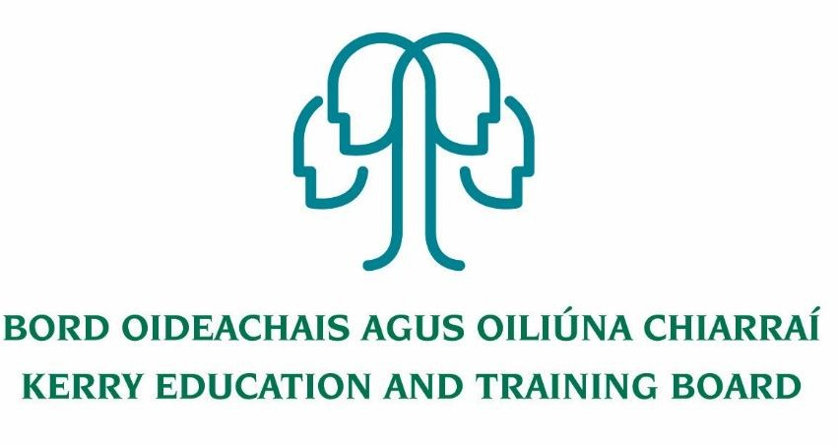

Job Description
Community Education Facilitator
with initial responsibility for Management of O’Connell FET Centre, Cahersiveen

Hours of Work:
Total weekly working hours: 35 hours per week.

Reporting/Accountability Relationships
Reporting to the Adult Education Officer and the Director of FET.

Nature of Post
This is a Permanent Post.

Areas of Responsibility
The Community Education Facilitator post with initial responsibility for O’Connell FET Centre Management, is an integral part of the FET centre management team and the duties assigned will encompass a broad range.

Function of Job

- Responsible for day to day management of the FET centre
- The effective management of staff performance, financial and other resources.
- Manage the scheduling of courses and tutors/teachers within the remit of the centre.
- The efficient and effective delivery of agreed and appropriate services and programmes as required by stakeholders
- Delivery of targets through the annual business planning process
- Responsible for risk management register for the FET centre
- Responsible for health and safety register for the FET
- Responsible for all Programme and Learner Support Systems (PLSS) data
- Responsible for all learner payment-related activity within the centre.
- Accountable for Contract of Indefinite Duration (CID) management of relevant staff within the centre.
- Responsible for course scheduling/input for Funding Allocations Requests and Reporting (FARR) as requested by AEO.

Duties and Responsibilities will include:
- Manage activity plans while adhering to budgets and achieving the Key Performance Indicators in the Business Plans.
- Manage an effective work team, communicate with and motivate staff, to meet the changing needs of the Kerry ETB FET Centre internal and external environment.
- Ensure appropriate management information systems, which integrate into wider Kerry ETB systems, are monitored, maintained and fully utilized as a management tool.
- Establish and maintain effective internal and external communication/linkages with appropriate bodies, organisations and agencies including representing Kerry ETB on boards and committees as appropriate.
- Promote continuous improvement and innovation.
- Provide a safe and healthy work environment in compliance with Health & Safety Legislation and regulations.
- Manage administration systems and processes throughout the FET Centre.
- Manage staff relations and HR administration at local level in accordance with Kerry ETB HR Policies and Procedures.
- Approve purchase of services/goods and recommend/authorise payment in accordance with Kerry ETB Financial Authority Levels and Procurement Policies and Procedures. Ensure that the assets of the organisation are properly protected.
- Manage and organise the development and start-up of new full-time and part-time Programs and for the centre as required.
- Assist in the delivery of the Kerry ETB Further Education & Training Strategy and assist in the supervision and co-ordination of Training Standards System, Quality Assurance, Risk Management, Corporate Governance and Performance Management System.
- To undertake such other work as may be assigned by their Kerry ETB Line Management as required.
- Contribute to the setting of organisational tone through policies and the development and promotion of good internal controls in relevant areas of responsibility.
- To carry out the lawful orders of the Chief Executive Officer, and to fulfill the rules and requirements of the Minister for Further and Higher Education Research Innovation and Science.
- Carry out any other duties appropriate to the grade which may be assigned from time to time.
- The above list of accountabilities may be varied having regard to the changing needs of the Scheme and the terms of the post can include delivery of responses to unpredictable work demands as they arise

Person Specification

Qualifications, Skills and Experience
Diploma/Degree level qualification in a relevant discipline
Good Marketing and Promotional Skills
Management Experience
Good working knowledge of Social Media
Excellent interpersonal and communication skills
Good planning and organisational skills
Full clean driving license

COMPETENCIES REQUIRED
A number of key competencies have been identified as being essential for the effective performance of the role and function of this position

These competencies are as follows:

LEADERSHIP & MANAGEMENT
- Ability to work with and in a team environment
- Ability to support team members to work to their full potential
- Experienced in the development and implementation of strategic plans

SPECIALIST KNOWLEDGE, EXPERTISE AND SELF DEVELOPMENT
- A high level of understanding and awareness regarding Further Education and Training Courses in a robust quality assured environment.
- A strong level of understanding and awareness regarding national developments, e.g. validation systems, new course development, self-evaluation, etc.
- Knowledge and experience of curriculum and programme delivery and assessment
- Knowledge of information and management data systems
- Knowledge of Kerry ETB full time and part-time programmes and learner entry requirements.
- A high level of computer literacy

MANAGEMENT AND DELIVERY OF RESULTS
- Structures and organises their own work effectively
- Proactively identifies areas for improvement and develops corresponding initiatives
- Applies appropriate systems/processes to enable quality checking of all activities and outputs.
- Practices and promotes a strong focus on delivering high quality customer service, for internal and external customers of the ETB

INTERPERSONAL AND COMMUNICATION SKILLS
- Builds and maintains contact with colleagues and other stakeholders to assist in performing role.
- Ability to create and maintain strong networks with Employers and Industry
- Prepares documentation to a very high standard
- Acts as an effective link between staff and senior management.
- Treats others with diplomacy, tact, courtesy and respect, even in challenging circumstances.
- Presents information clearly, concisely and confidently when speaking and in writing
- Strong working knowledge of Social Media, PR and General Marketing

DRIVE & COMMITMENT TO KERRY ETB AND PUBLIC SERVICE VALUES
- Strives to perform at a high level, investing significant energy to achieve agreed objectives.
- Is flexible and open to change.
- Is resilient and perseveres to achieve objectives despite obstacles or setbacks.
- Is personally trustworthy and can be relied upon.
- Behaves with integrity and encourages this in others.
- Places emphasis on Kerry ETB Core Values of Respect, Quality, Equality, Inclusion and Learning.

