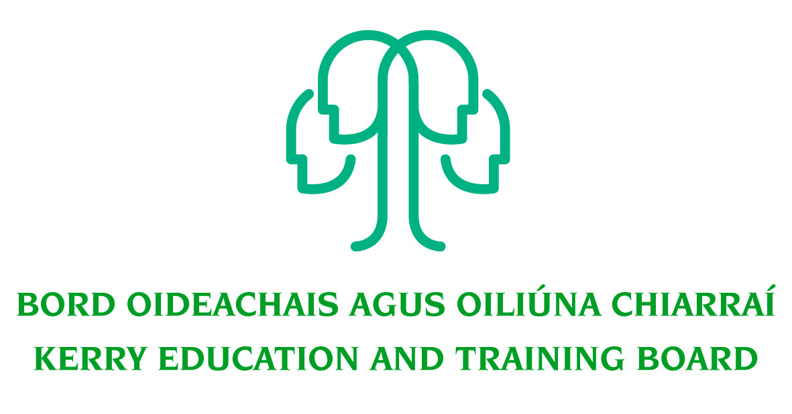
Job Description

Permanent Grade VII
Initial Responsibility: Capital Projects/Buildings
Centre of initial assignment: Corporate, Capital & Technology Department
Centrepoint, John Joe Sheehy Road, Tralee

Nature of Post
Permanent full-time position 37 hours per week (35 from 1st July)

Location
Appointment is to the Scheme – Kerry ETB reserves the right to assign a staff member to any other location, as the service exigencies require. Your centre of first assignment will be Kerry Education and Training Board Head Office, Centrepoint, John Joe Sheehy Road, Tralee.

Reporting/Accountability Relationship
The Grade VII reports to the Kerry ETB Head of CCT.

Post Summary/Purpose:
Under general supervision of the head of CCT the successful candidate will perform a wide variety of buildings estate management including the management of Buildings, Property and projects. They will play a strategic role in supporting and developing the buildings functions within Kerry ETB.

The successful applicant may have a large, multilevel staff and will be expected to take responsibility for decision making in the area.

The person appointed will be required to be flexible in this position and must be prepared to undertake such other duties as assigned to them by the Head of CCT or senior management team. Such duties can be outside the normal area of work.

Key Responsibilities
- Support the Head of CCT through the development and implementation of best practices in Buildings Estate Management.
- Manage and Maintain the Kerry ETB Estate
- Oversight of Frameworks for Maintenance Contracts
- Compliance with DPER and statutory Approvals
- Support Kerry ETB in their engagement with procurement initiatives, ensuring a consistent ETB wide approach
- Ensure national procurement requirements are adhered to
- Management of the Kerry ETB property register
- Develop a strong working relationship with stakeholders in relation to all building related matters ensuring that Kerry ETB needs are represented
- Assist in the preparation of documentation for Section 44 and Section 45 committees and attend these meetings when required
- Provide advice to Kerry ETB on issues arising in capital projects, project management and other technical issues
- Support the building of capacity in ETBs in respect of their buildings’ management and construction functions
- Assist the ETB in pursuing a sustainability agenda, in terms of capital projects
- Engage with DFHERIS, SOLAS and other capital programme funding agents and
represent the ETB, as appropriate
- Support the ETB in achieving appropriate governance and compliance standards etc
- Assist and advise the ETB in relation to the establishment of suitable facilities management functions
- Gather the necessary financial and statistical information on an ongoing basis and prepare reports as required
- Develop in conjunction with ETB management Key Performance Indicators (KPIs) appropriate to the capital projects within the ETB and assist in the achievement of same
- Develop and review, in conjunction with the Head of CCT, the Internal Controls/Standard Operating Procedures for the efficient and effective administration of the CCT Department.
- Contribute to the setting of organisational tone through policies and the development and promotion of good internal controls.
- Attend, as required, working groups and committees of Kerry ETB.
- Represent the Head of CCT of Kerry ETB at meetings, if required, with external agencies/bodies/groups that are necessary for the proper discharge of the post.
- Bring a focus and drive to building and sustaining high levels of performance, addressing any performance issues as they arise.
- Develop capability of others through supportive feedback, coaching and creating opportunities for skills development.
- Maintain a strong focus on self-development, seeking feedback and opportunities for growth.
- Research issues thoroughly, consult appropriately to gather all information needed on an issue.
- Plan and prioritise work in terms of importance, timescales and other resource constraints, re-prioritising in light of changing circumstances for self and relevant staff teams.
- Carry out lawful orders of the Chief Executive.
- Carry out any other duties appropriate to the grade which may be assigned from time to time.

The above list of accountabilities may be varied having regard to the changing needs of the Scheme and the terms of the post can include delivery of responses to unpredictable work demands as they arise.

Person Specification

This post is open to existing members of Kerry ETB administration and caretaking staff.
As per CL 0008/2017, candidates for a Grade VII post must:
- have the requisite knowledge, skills and competencies to carry out the role. Competencies will be informed by best practice Public Appointment Service competency frameworks for the Irish Public Service;
- be capable and competent of fulfilling the role to a high standard;
- have obtained at least Grade D3 in five subjects in the Leaving Certificate Examination (higher, ordinary, applied or vocational programmes) or equivalent or have passed an examination at the appropriate level within the QQI qualifications framework which can be assessed as being comparable to Leaving Certificate standard or equivalent or higher or have appropriate relevant experience which encompasses equivalent skills and expertise;
- have at least two years in a Grade III post, or equivalent, or higher, in the Education and Training Sector. ETB Caretaker Grade will also be considered valid.
- have successfully completed their probation period, or have successfully completed a probation period at a lower eligible grade.

Desirable Criteria
- Achieved or be at an advanced stage of working towards a Level 8 qualification or higher in a relevant area
- Experience of staff supervision
- Knowledge and familiarity with the practices in Building Estates Management
- Experience in delivering minor and major capital projects
- Ability to analyse complex issues and articulate clearly the organisations position on particular issues
- Excellent administrative and IT Skills
- Strong Communication Skills, both written and oral.
- Demonstrable initiative
- Strong attention to detail

Competencies Required
Kerry ETB Core Values of Respect, Quality, Equality, Inclusion and Learning are the guiding principles of the organisation and underpin the competencies required to fulfil this role.

The appointee to the Grade VII post will be required to show evidence of the following competencies:

Specialist Knowledge, Expertise and Self Development
- Has a clear understanding of the roles objectives and targets of self and the team and how they fit into the work of the ETB and effectively communicates this to others.
- Displays high level of skills/expertise in the area and provides guidance to colleagues.
- Has a high level of expertise and broad Kerry ETB sector knowledge and has a thorough understanding of the Code of Practice for the Governance of Education and Training Boards
- Is focused on self-development and strives to improve performance.
- Has the required level of knowledge and expertise to undertake the technical aspects of the role.

Analysis & Decision Making
- Gathers and analyses information from relevant sources, whether financial, numerical or otherwise weighing up a range of critical factors.
- Draws accurate conclusions and makes balanced and fair recommendations backed up with well-reasoned rationale and stands by these.
- Has capacity to work on own initiative to support other staff and to deal with unexpected problems that can arise.
- Understands the practical implications of information in relation to the broader context in which s/he works – procedures, service objectives, etc.

Management & Delivery of Results
- Takes ownership of tasks and sees them through to a satisfactory conclusion.
- Is logical and pragmatic in approach, setting objectives and delivering the best possible results with the resources available through effective prioritisation.
- Delegates work effectively, providing clear information and evidence as to what is required.
- Minimises errors, reviewing learning and ensuring, remedies are in place.
- Proactively identifies areas for improvement and develops practical suggestions for their implementation.
- Demonstrates enthusiasm for new developments/changing work practices and strives to implement these changes effectively.
- Applies appropriate systems/processes to enable quality checking of all activities and outputs.
- Practices and promotes a strong focus on delivering high quality customer service, for internal and external customers.

Team Leadership
- Works with the team to facilitate high performance, developing clear and realistic objectives and addressing any performance issues if they arise.
- Provides clear information and advice as to what is required of the team.
- Strives to develop and implement new ways of working effectively to meet objectives.
- Leads the team by example, coaching and supporting individuals as required.
- Places high importance on staff development, training and maximising skills & capacity of team.
- Is flexible and willing to adapt, positively contributing to the implementation of change.
- Deals with any tensions within the team in a pro-active manner.
- Encourages, listens to and acts on feedback from the team to make improvements.
- Actively shares information, knowledge and expertise to help the team to meet agreed objectives.

Interpersonal & Communication Skills
- Builds and maintains contact with colleagues and other stakeholders to assist in performing role.
- Acts as an effective link between staff and senior management.
- Encourages open and constructive discussions around work issues.
- Projects conviction, gaining buy-in by outlining relevant information and selling the benefits.
- Treats others with diplomacy, tact, courtesy and respect, even in challenging circumstances.
- Presents information clearly, concisely and confidently when speaking and in writing.

Drive & Commitment to Public Service Values
- Strives to perform at a high level, investing significant energy to achieve agreed objectives.
- Is flexible and open to change.
- Is resilient and perseveres to achieve objectives despite obstacles or setbacks.
- Is personally trustworthy and can be relied upon.
- Behaves with integrity and encourages this in others.

