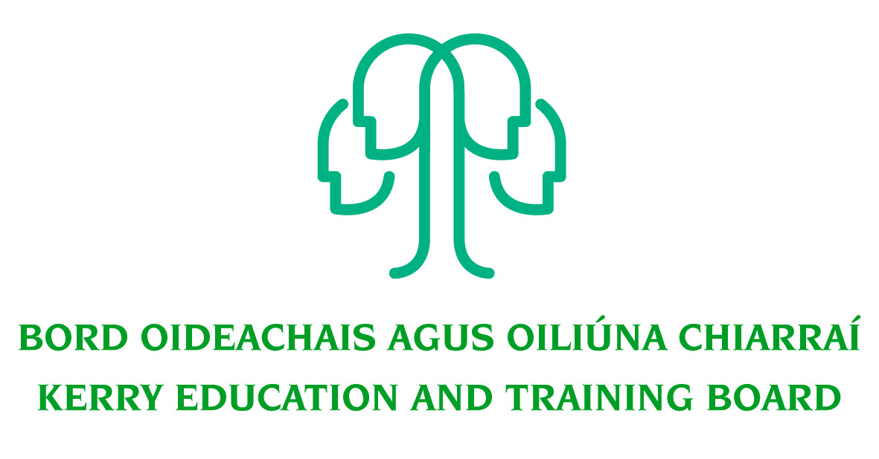

Job Description

Assistant Staff Officer (Grade lV)
Initial Responsibility for ICT in Kerry College Campus locations

Nature of Post
Two Year Fixed Term- Full time (37 hours)

Location
Appointment is to the Scheme – Kerry ETB reserves the right to assign a staff member to any other location, as the service exigencies require. Centre of first assignment will be
Kerry College Campus locations in Tralee and Listowel

Reporting/Accountability Relationship
The Assistant Staff Officer reports to the Principal/Centre Manager/Director of Further Education and Training

Post Summary/Purpose
To provide the ICT support requirements for MS Office 365 to staff and learners in Kerry College and support the general day to day network and hardware support needs arising across the Campuses e.g. addressing issues arising with PCs, peripheral devices, learner log on registrations, account management, software deployment etc

Key Responsibilities:
- Managing work and service desk tickets in accordance with the college procedures.
- Creating user accounts for Kerry College learners
- Providing ICT support for Kerry College learners when required
- Providing ICT support for Kerry College staff and tutors when required
- Escalating where needed issues to the ICT team as required.
- Resolving confirming and closing ICT tickets for incidents as per the team's Service Level Agreement.
- Providing Helpdesk cover as required.
- Flexible around working out of office hours on short notice due to business needs.
- Providing 1st/2nd level ICT support to resolve or escalate ICT incidents as appropriate.
- Providing information systems and telephony administration support.
- Providing escalation’s support to ICT Teams and Vendor Teams as required.
- Contribute to the enhancing of Service Desk procedures and policies.
- Life cycle management of ICT equipment within Kerry College via asset register.
- Be accountable to the Line Manager in all matters relating to areas of responsibility.
- Liaise with staff in other sections, the public and outside agencies in a confidential, courteous and professional manner.
- Ensure all information received remains confidential.
- Contribute to the setting of organisational tone through policies and the development and promotion of good internal controls in relevant areas of responsibility.
- Ensure the information delivered to managers, staff and other stakeholders is relevant, appropriate and timely, and in line with Kerry ETB policies and procedures.
- Attend, as required, working groups and committees of Kerry ETB.
- Represent Kerry ETB at meetings, if required, with external agencies/bodies/groups that are necessary for the proper discharge of the post.
- Maintain a strong focus on self-development, seeking feedback and opportunities for growth.
- Has a solution orientated approach to problem solving
- Continually keeps updated on any key developments in the area of ICT
- Research issues thoroughly, consult appropriately to gather all information needed on an issue.
- Plan and prioritise work in terms of importance, timescales and other resource constraints, re-prioritising in light of changing circumstances for self and relevant staff teams.
- Carry out lawful orders of the Chief Executive.
- Carry out any other duties appropriate to the grade which may be assigned from time to time.

The above list of accountabilities may be varied having regard to the changing needs of the Scheme and the terms of the post can include delivery of responses to unpredictable work demands as they arise.

Person Specification

The following are the essential requirements for appointment to this post:

Essential requirements:
As per CL 0008/2017 and CL 46/2017, candidates for a Grade 1V post must:
- Have the requisite knowledge, skills and competencies to carry out the role. Competencies will be informed by best practice Public Appointment Service competency frameworks for the Irish Public Service;
- Be capable and competent of fulfilling the role to a high standard;
- Have obtained at least Grade D3 in five subjects in the Leaving Certificate Examination (higher, ordinary, applied or vocational programmes) or equivalent or have passed an examination at the appropriate level within the QQI qualifications framework which can be assessed as being comparable to Leaving Certificate standard or equivalent or higher or have appropriate relevant experience which encompasses equivalent skills and expertise;

Desirable Criteria
- Achieved or be at an advanced stage of working towards a relevant Level 6 qualification or higher on the National Framework of Qualifications
- Relevant experience in ICT Support with an organization of 50+ users.
- Extensive experience supporting MS Windows workstations, printers, and standard end-user applications e.g. MS Office 365.
- Experience in an ICT Service Desk and incident management processes – for example Active Directory.
- Knowledge of LAN, TCP/ IP, Ethernet switch basic configuration inc. IP Phones, PC’s
- Strong Communication Skills, both written and oral
- Demonstrable initiative
- Strong attention to detail

Competences required
Kerry ETB Core Values of Respect, Quality, Equality, Inclusion and Learning are the guiding principles of the organisation and underpin the competencies required to fulfil this role.

The person appointed to the above post will be required to show evidence of the following competences:

People Management
- Consults and encourages the full engagement of the team, encouraging open and constructive discussions around work issues
- Gets the best out of individuals and the team, encouraging good performance and addressing any performance issues that may arise
- Values and supports the development of others and the team
- Encourages and supports new and more effective ways of working
- Deals with tensions within the team in a constructive fashion
- Encourages, listens to and acts on feedback from the team to make improvements
- Actively shares information, knowledge and expertise to help the team to meet it’s objectives
- Acts as an effective link between staff and other managers

Information Management and Decision Making
- Follow procedures and ensures they are implemented in own area, understanding the rationale behind them
- Reviews completed work regularly and acts on learning points
- Evaluates current work practices to identify changes that could be made to improve efficiencies
- Can work effectively on a number of tasks at the same time
- Is comfortable working with and manipulating a range of data, e.g. numerical, written etc.
- Makes sound appropriate decisions in a confident manner and can justify and stand by them

Delivery of Results
- Assumes personal responsibility for and delivers on agreed objectives/goals
- Strong attention to detail
- Manages and progresses multiple projects and work activities successfully
- Accurately estimates time parameters for projects and manages own time efficiently, anticipating obstacles and making contingencies for overcoming these
- Maintains a strong focus on meeting the needs of customers at all times
- Ensures all outputs are delivered to a high standard and in an efficient manner
- Use resources effectively, at all times challenging processes to improve efficiencies

Interpersonal & Communication Skills
- Shows respect, tact and maintains composure when dealing with customers or staff members
- Demonstrates the ability to be assertive and negotiate when necessary, communicating in a fluent, logical, clear and convincing manner whilst remaining approachable and polite
- Is able to listen effectively and develop a two-way dialogue quickly
- Maintains a strong focus on meeting the needs of internal and external customers
- Influences others by actively listening and clearly expressing their position
- Produces written letters/reports in a clear and concise manner

Specialist Knowledge, Expertise and Self Development
- Displays high level of skills/expertise in own area and provides guidance to colleagues
- Has a clear understanding of the role, objectives and targets and how they support the service delivered by the Department/ETB and can communicate this to the team.
- Leads by example, demonstrating the importance of development by setting time aside for development initiatives for self and the team.
- Is proactive in keeping up to date on issues and key developments that may impact on own area, the Department and/or wider ETB service

Drive & Commitment to Public Service Values
- Consistently strives to perform at a high level, demonstrating flexibility and finding solutions to overcome obstacles or setbacks
- Serves the Government and people of Ireland
- Can work independently without excessive guidance or support
- Demonstrates resilience in the face of significant demands and challenges
- Ensures that customer service is at the heart of own/team work
- Is personally honest and trustworthy
- Acts with integrity and encourages this in others

.

Respect, Quality, Equality, Inclusion and Learning

