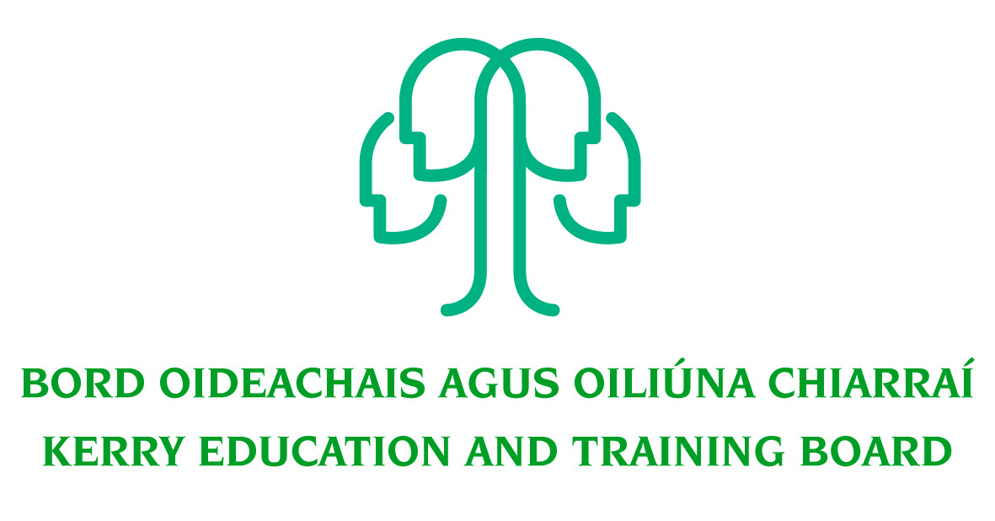
Job Description
Adult Literacy Organiser (ALO) – South & Mid Kerry

Nature of post
Permanent Full time

Location:
The appointment is to the Scheme – Kerry ETB reserves the right to assign a staff member to any other location, as the service exigencies require. The centres of the first assignment will be Kerry Education and Training Board, Adult Literacy and Basic Education Centre
Killarney.

Hours of Attendance:
The post is a full time 5 days per week (35 Hours). Attendance shall be at such times as necessary for the service delivery, including attendance outside of normal office hours as required.

Reporting/Accountability Relationships:
The post holder will report to the Adult Education Officer/Director of Further Education and Training.

Combination of daytime and evening hours: Post Holder must be prepared to work some evenings and occasional weekends as the work will require visits to various locations including various outreach locations where adult literacy and basic education are delivered.

Post Holder must have their own transport and a full driving license.

Role and responsibilities of the ALO:

Leadership
• Plan, develop and manage the provision of basic education services, including Adult Literacy, ESOL and digital literacy skills in consultation with the Adult Education Officer/Director of Further Education and Training
• Maintain and develop an ethos appropriate to adult learning
• Promote effective teaching, learning and assessment strategies across the service
• Manage the recruitment, initial assessment and placement of learners in suitable programmes
• Manage and/or support the delivery of initial and ongoing training and CPD for staff
• Recruit, support, develop and manage tutors and service staff.
• Manage the certification process for relevant awarding bodies and ensure the maintenance of national standards, agreed policy and procedure.

Communication
• Promote the ABE Service of Kerry ETB through networking, awareness raising and publicity
Liaise with relevant voluntary, statutory and community bodies
• Maintain effective relationships with internal and external stakeholders
• Present information, both written and verbal, clearly and concisely to a wide variety of audiences
• Act as an effective link between staff and senior management

Organisational management and administrative skills
• Manage resources, e.g. finance, materials, premises, etc.
• Keep records and prepare reports and submissions in consultation with the AEO/Directors/CE, as appropriate
• Implement an organisational plan to meet the deadlines per internal and external reporting requirements
• Establish and maintain effective data management systems such as student records using internal and external data management ICT systems

Self-awareness and self-management
• Enhance own expertise through training, development, and networking with relevant bodies
• Reflect on own actions with a view to continuous learning and self-development
• Set a good standard of professional interactions and ensure excellent relationship boundaries are in place
• Be aware of own skill set and traits and seek help and advice when required
• Always uphold professional integrity for example, in showing discretion and in maintaining confidentiality.

Profile:
• Embody the person-centred ethos of adult education
• Be a leader committed to the highest standards of education provision, administration and governance.
• Have strong people management, organisation and administration skills.
• Be a visionary and have experience in delivering projects through teamwork.
• Understand and value a community-based approach.
• Be a problem solver.
• Be a strong team player who develops and maintains strong relationships with stakeholders

Contribute to the setting of organisational tone through policies and the development and promotion of good internal controls in relevant areas of responsibility.
To carry out the lawful orders of the Chief Executive Officer, and to fulfill the rules and requirements of the Minister for Further and Higher Education Research Innovation and Science.
Carry out any other duties appropriate to the grade which may be assigned from time to time.

The above list of accountabilities may be varied having regard to the changing needs of the Scheme and the terms of the post can include delivery of responses to unpredictable work demands as they arise

The list is not exhaustive, and may from time to time be determined by the regulations of the Department of Education/SOLAS.

Person Specification

Essential requirements:

The following are essential requirements for appointment to this post:

• A qualification at Level 7 on the National Framework of Qualifications or its equivalent, or significant relevant work experience
• A high level of expertise in the area of the Further Education and Training Sector, 3 years working in Further Education and Training desirable
• Broad Public Sector knowledge is relevant to the area of work.

Desirable Criteria
- Experience in Microsoft Office (Word, Excel, Access & PowerPoint etc.)
- Experience of communication via information technology
- Experience of maintaining accurate paper and electronic record systems

Other Relevant Desirable Experience:
Literacy Tutor Training, Education Management, Management and participation in Adult Literacy in-service training or other equivalent education/training experience in adult, youth or community work.

Competences required:

Kerry ETB Core Values of Respect, Quality, Equality, Inclusion and Learning are the guiding principles of the organisation and underpin the competencies required to fulfil this role.

The appointee to the permanent Adult Literacy Organiser post will be required to show evidence of the following competencies:

Leader – Education and Learning
Understanding high-quality teaching and learning is the core business of the Adult Basic Education Service and demonstrates the skills to act as the instructional leader.

Leader – Service/Programme Development
Demonstrates the ability to take a broad long-term view of the needs of the service’s purpose and objectives

Leader – People and Teams
Demonstrates the willingness and ability to develop individuals and teams throughout the Adult Basic Education Service and delegate leadership within those teams.

Communication
Has the capacity to articulate views, opinions and attitudes through effective and appropriate and empathic interaction with all stakeholders in a variety of situations and contexts.

Organisational Management and Administrative Skills
Is organized and efficient and can have procedures and appropriate structures in place to deliver.

Self-Awareness and Self-Management
Is self-aware and has the capacity to self-manage and develop personally and professionally.

Specialist Knowledge, Expertise & Self Development
Clearly understands the role, objectives and targets and how they fit into the work of the organisation.

Understands the boundaries of professional practice
Develops the expertise necessary to carry out the role to a high standard and shares this with others

Demonstrates knowledge of child protection policy and practice
Understands and shows commitment to the purpose of Kerry Education and Training Board and to work within the values, policies and procedures of the organisation and in the context of current legislation and regulations

Has expertise in his/her field that is recognised and utilised by colleagues

