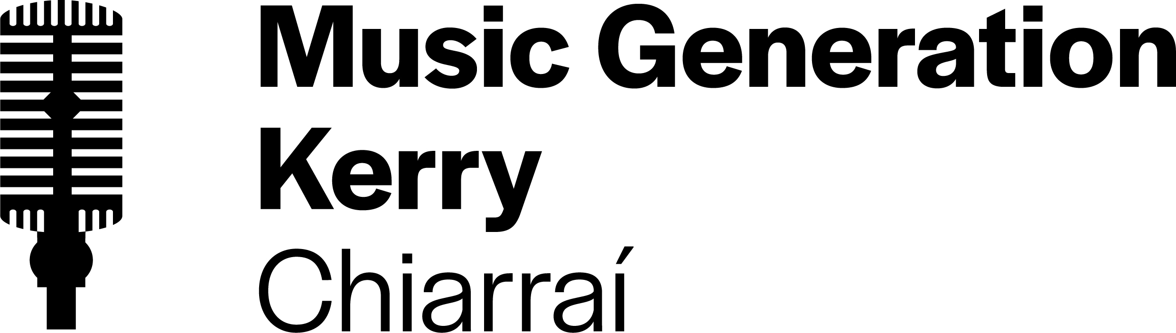 | 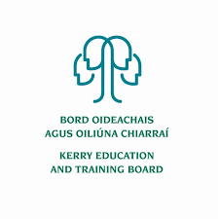

Music Generation Kerry Musician Educator

PERSON SPECIFICATION & JOB DESCRIPTION

Kerry Education and Training Board (Kerry ETB), on behalf of Music Generation Kerry, wishes to employ Musician Educators to add to a pool.
Person profile
We are seeking Musician Educators who:
- Are able to motivate and inspire children and young people about music
- Demonstrate an understanding of effective group performance music education pedagogy
- Work effectively as an individual and as part of a team
- Demonstrate a passion for high quality performance music education and a commitment to their own continuing professional development
- Show an understanding of the Music Generation local and national programme and are prepared to work positively to promote its goals.

Essential criteria
To qualify for appointment candidates must:
- Be a motivated, accomplished, reflective musician with demonstrable skills in at least one instrument/voice
- Have a proven track record in delivering to a high standard in at least one group performance music education context or genre
- Have a full current driving licence with access to own transport.

Desirable criteria
- An appropriate third level qualification in music and/or music education and/or equivalent quantifiable experience
- Experience in leading and developing instrumental and/or vocal ensembles in any genre
- An ability to play an additional instrument(s) to a good standard
- An ability to deliver through Irish is an advantage
- Experience in delivering online music tuition

JOB DESCRIPTION

About Music Generation Kerry
Music Generation Kerry is a performance music education programme in County Kerry providing access to a range of vocal and instrumental music opportunities for children and young people in their local area.

Initiated by Music Network, Music Generation is co-funded by U2, The Ireland Funds, The Department of Education and Local Music Education Partnerships (LMEPS). Locally, Music Generation Kerry is supported and funded by Kerry ETB, Kerry County Council and Munster Technological University Kerry Campus.

Kerry ETB, as Lead Partner for Music Generation Kerry, now wishes to recruit suitably qualified and experienced musician educators to deliver the following programme strands.

- Early Years Music Programmes
- Group Percussion/Drums (Primary and Post-Primary Schools)
- Group Guitar/Ukulele (Primary and Post-Primary Schools)
- Classical Ensemble (Strings/Woodwind/Brass)
- Traditional Irish Instrumental and Group Programmes

Musician Educators will work with children and young people in (small and large) group contexts and may be required to work on one or more programmes at any given time. Musician Educators may be required to deliver programmes in person and/or online, as required.

Terms and Conditions of Employment
Tenure

Successful applicants will be a Fixed Term Contract when opportunities arise for their particular area of expertise. All contracts are subject to sufficient uptake by participants and the continuation of Music Generation funding.

Hours

Hours of working vary and will be discussed and notified in advance. Tuition and rehearsals may take place within school hours. outside of school hours, during weekends and/or school holidays.

Tuition, Meetings and Professional Development

The role of a Musician Educator working on Music Generation programmes will require:
- Delivery of high quality performance music education (in person and/or online as required);
- Attendance at and engagement with Continuing Professional Development and training;
- Participation in planning and other such meetings as may be required from time to time;
- Any other reasonable duties as may be determined from time to time.

The Musician Educator role may also require;
- Collaboration with the Musician Educator team on the creation of programmes;
- Creation of online content to support the delivery of work.

Gárda Vetting and Child Protection Policies
Garda Vetting will be sought in accordance with the National Vetting Bureau Act, 2014, and there being no disclosure of convictions which Kerry ETB considers would render the candidate unsuitable to work with children/vulnerable adults. This process will commence prior to appointment.

All successful candidates must participate in Music Generation Kerry’s induction Process and Child Protection Training.

Remuneration
- €40.57 per hour, inclusive of holiday pay
- Rate of remuneration may be adjusted from time to time in line with Government pay policy

Recruitment process
A shortlisting process will operate. Shortlisted candidates will be invited to attend for interview before a panel. This will comprise a formal interview, a short informal musical performance on your primary instrument of voice and a short sample demonstration of your approach to a performance music education session for children and young people. Interviews may be conducted in person and/or online.

Driving Licence

Successful applicants will require access to own transport and a full clean driving licence.

How to apply

Complete the Music Generation Kerry Musician Educator Application Form and submit to jobs@kerryetb.ie by 12.00 noon Wednesday 31st August 2022.

If you have any queries, please contact the Music Generation Kerry office djohnson@kerryetb.ie or contact Kerry ETB HR Department Email: recruitment@kerryetb.ie

Notes
- Late and/or incomplete applications will not be accepted
- The selection decision of Kerry Education and Training Board is final
- Kerry Education & Training Board/Music Generation Kerry reserves the right to pursue other selection processes at its discretion
- Selected musicians may not sub-contract work to third parties
- Canvassing will disqualify
- Kerry Education and Training Board is an equal opportunities employer.

